
Final Site Report

Evaluation of Travel
Time Methods to Support
Mobility Performance
Monitoring

World Trade Bridge

To
Office of Freight Mgt. and Operations
Federal Highway Administration
U.S. Department of Transportation
Washington, DC 20590

April 2002
Border Crossing Freight Delay Data Collection and Analysis
FY 2001 Data Collection − Laredo Crossing

Site Description
The World Trade Crossing (International Bridge 4) in Laredo, Texas is the most important truck crossing on the United States/Mexican border. Texas border crossings account for most of the truck traffic and the Laredo crossing alone represents over 60% of the truck traffic crossing the border between Texas and Mexico. Table 1 shows truck traffic for 2000 crossing the border from Mexico to the United States. The World Trade bridge crosses the Rio Grande River that separates Laredo, Texas from Nuevo Laredo, Tamaulipas, Mexico and provides a link between I-35 in the United States with such Mexican cities as Monterrey and Mexico City. Most (up to 90%) of the truck traffic at the World Trade Bridge in Laredo consists of “drayage.” That is, short distance shipments between warehouses in Laredo and Nuevo Laredo. Typically, long distance trucks in either Mexico or the United States unload their cargos at a warehouse where it is transferred to a short haul truck for the trip across the border. Other shipments move directly from a factory near the border in Mexico to a warehouse across the border in Texas or from a warehouse in Texas to a factory in Mexico. These short haul trucks usually make up to three trips a day across the border. Figure 1 shows a map of the general region in Texas and Mexico that provides access to the border. Figure 2 shows the location of the World Trade Bridge within the city of Laredo.

Data collection activities took place at the World Trade Bridge border crossing on Tuesday October 30th, Wednesday October 31st and Thursday November 1st, 2001 for approximately ten hours each day. The times of data collection were selected to correspond to the daylight hours of operations at the bridge. The World Trade Bridge operates from 8:00 AM to 12:00 Midnight.

Inbound trucks (northbound) traveling towards the United States, leave Mexico pass through the export booths and proceed across the bridge into Texas and towards U.S. Customs. At Customs, the vehicles pass through primary inspection and after a secondary inspection, either proceed to special inspections (about 15% to 20% of the trucks) or leave Customs through the final inspection booths.

Outbound trucks (southbound) traveling towards Mexico, use Loop 20, which provides access to the World Trade Bridge. It can be accessed directly from I-35 or from the south from Mines Road. Loop 20 approaching the bridge is a new divided highway built specifically as an access road for the World Trade Bridge. Close to the border, the number of lanes expands to eight to enable the vehicles to proceed through the toll booths. The trucks cross the bridge and enter Mexico through import booths. Ordinarily, the Mexicans have up to ten booths operating. Most trucks pass through the import booths without much delay (no more than 90 seconds) and a small percentage are diverted to the secondary inspection facilities. At secondary inspection, trucks can undergo further papers checks and/or physical inspection at truck bays or in the parking area.

2

Table 1. Truck Crossings from Mexico into the United States for 2000

Incoming Truck Crossings, US-Mexican Border for 2000
PORT NAME | January | February | March | April | May | June | July | August | September | October |  |  | November | December | Total
Arizona, Total | 35,979 | 35,995 | 38,278 | 33,418 | 32,354 | 25,502 | 19,328 | 21,160 | 20,325 | 24,608 |  |  | 28,051 | 29,267 | 344,265
Douglas, AZ | 2,868 | 2,913 | 2,563 | 2,171 | 2,696 | 2,983 | 2,534 | 2,946 | 2,712 | 3,051 |  |  | 3,158 | 2,999 | 33,594
Lukeville, AZ | 269 | 295 | 363 | 383 | 401 | 331 | 342 | 257 | 269 | 349 |  |  | 298 | 283 | 3,840
Naco, AZ | 683 | 912 | 1,183 | 725 | 713 | U | 704 | 814 | 718 | 995 |  |  | 980 | 710 | 9,137
Nogales, AZ | 27,659 | 27,525 | 29,066 | 26,509 | 25,386 | 19,266 | 13,075 | 14,359 | 13,595 | 16,448 |  |  | 20,151 | 21,655 | 254,694
Sasabe, AZ | 269 | 235 | 184 | 185 | 174 | 186 | 178 | 208 | 271 | 211 |  |  | 430 | 121 | 2,652
San Luis, AZ | 4,231 | 4,115 | 4,919 | 3,445 | 2,984 | 2,736 | 2,495 | 2,576 | 2,760 | 3,554 |  |  | 3,034 | 3,499 | 40,348
California, Total | 76,230 | 82,463 | 90,509 | 80,585 | 88,938 | 98,319 | 87,890 | 92,603 | 85,122 | 89,017 |  |  | 83,549 | 76,321 | 1,031,546
Andrade, CA | 105 | 159 | 181 | 126 | 152 | 136 | 111 | 92 | 82 | 117 |  |  | 125 | 131 | 1,517
Calexico, CA* | U | U | U | U | U | U | U | U | U | U |  |  | U | U | U
Calexico East, CA | 22,405 | 23,372 | 25,684 | 21,026 | 22,962 | 29,155 | 22,182 | 24,003 | 21,297 | 23,137 |  |  | 22,285 | 21,303 | 278,811
Otay Mesa/San Ysidro, CA | 49,378 | 53,898 | 58,836 | 54,239 | 59,955 | 63,547 | 60,484 | 62,780 | 58,640 | 60,034 |  |  | 56,122 | 50,427 | 688,340
Tecate, CA | 4,342 | 5,034 | 5,808 | 5,194 | 5,869 | 5,481 | 5,113 | 5,728 | 5,103 | 5,729 |  |  | 5,017 | 4,460 | 62,878
New Mexico, Total | 2,282 | 2,711 | 3,009 | 3,373 | 3,072 | 3,036 | 2,880 | 3,672 | 3,767 | 3,438 |  |  | 2,906 | 2,345 | 36,491
Columbus, NM | 193 | 212 | 243 | 233 | 315 | 206 | 316 | 916 | 956 | 601 |  |  | 197 | 157 | 4,545
Santa Teresa, NM | 2,089 | 2,499 | 2,766 | 3,140 | 2,757 | 2,830 | 2,564 | 2,756 | 2,811 | 2,837 |  |  | 2,709 | 2,188 | 31,946
Texas, Total | 242,935 | 256,127 | 282,616 | 241,863 | 277,312 | 272,753 | 247,327 | 293,468 | 257,554 | 271,225 |  |  | 249,431 | 220,666 | 3,113,277
Brownsville, TX | 24,915 | 25,223 | 26,860 | 24,993 | 27,771 | 27,756 | 25,248 | 27,689 | 23,784 | 23,902 |  |  | 22,183 | 18,914 | 299,238
Del Rio, TX | 4,979 | 5,117 | 5,689 | 4,768 | 5,420 | 5,436 | 4,691 | 5,525 | 4,984 | 5,444 |  |  | 5,120 | 4,055 | 61,228
Eagle Pass, TX | 8,402 | 9,164 | 9,481 | 8,549 | 9,876 | 8,941 | 8,361 | 9,610 | 8,616 | 9,281 |  |  | 9,289 | 7,322 | 106,892
El Paso, TX | 56,688 | 59,433 | 64,553 | 55,632 | 64,942 | 63,225 | 55,185 | 77,419 | 59,470 | 63,671 |  |  | 51,107 | 49,081 | 720,406
Fabens, TX | 24 | 26 | 37 | 24 | 8 | 10 | 8 | 12 | 23 | 20 |  |  | 9 | 13 | 214
Hidalgo, TX | 28,647 | 30,544 | 36,420 | 30,726 | 32,856 | 31,603 | 30,371 | 33,627 | 29,833 | 31,938 |  |  | 31,226 | 26,359 | 374,150
Laredo, TX | 114,829 | 121,675 | 133,952 | 112,419 | 131,385 | 131,162 | 119,027 | 134,678 | 126,296 | 132,267 |  |  | 125,273 | 110,110 | 1,493,073
Presidio, TX | 889 | 830 | 991 | 707 | 764 | 617 | 465 | 466 | 538 | 693 |  |  | 960 | 814 | 8,734
Progreso, TX | 719 | 963 | 1,147 | 815 | 1,043 | 1,062 | 1,101 | 1,317 | 881 | 751 |  |  | 1,168 | 1,034 | 12,001
Rio Grande City, TX | 1,722 | 2,036 | 2,139 | 2,205 | 1,931 | 1,860 | 1,775 | 1,958 | 2,128 | 2,189 |  |  | 2,048 | 2,074 | 24,065
Roma, TX | 1,121 | 1,116 | 1,347 | 1,025 | 1,316 | 1,081 | 1,095 | 1,167 | 1,001 | 1,069 |  |  | 1,048 | 890 | 13,276
U.S. - Mexico Border Total |  |  |  |  |  |  |  |  |  |  |  |  |  |  | 4,525,579
Key: U = Data are unavailable; Data for the port of Calexico are typically reported as a combined total with Calexico East.
Source: U.S. DOT, BTS based on data from US Customs Service, Mission Support Services, Office of Field Operations, Operations Management Database.

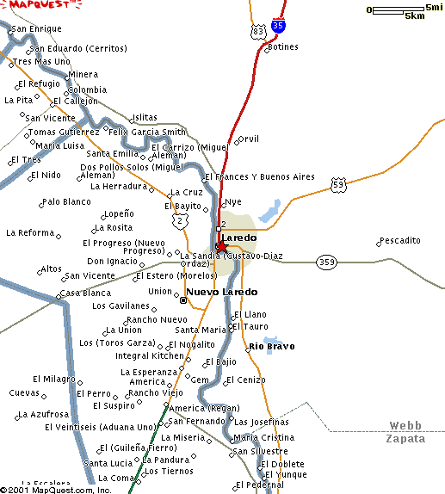

Figure 1. The Laredo Border Crossing Region

Figure 2. Laredo and the Location of the World Trade Bridge

Data Collection Process
For this study, two data collection locations were used in each direction. The “number 1” locations were located to the north or south of where the truck cues were anticipated to form due to backups at the primary Customs location or export booths. The “number 2” location was immediately after the primary inspection booths. For consistency among all border crossings visited for the overall project, the data collection positions were distinguished by whether they were leaving the United States (outbound) or entering the United States (inbound). For the Laredo border crossing, outbound was designated as southbound indicating that the trucks were traveling into Mexico. Inbound was designated as northbound indicating that the trucks were traveling into the United States.

Each data collector would use a handheld computer to record partial license plate information of all commercial vehicles that passed their location. The computer would also store the time that each license plate was entered. The data from the two locations in each direction would be combined, allowing the determination of the travel time for each vehicle that was recorded at both locations.
For the data collection, the on-site team included four data collectors and two supervisors. Thus, three team members were located in each country. The hours during which data were collected were selected to encompass the greatest number of daylight hours after the 8:00 AM World Trade Bridge opening. They were selected from discussions with knowledgeable officials. Table 2 shows the data collection hours for each day during the site visit. Data collection extended about 10 hours and included the periods when the supervisor collected data during break periods and the meal period.

Figure 3 shows the Laredo, Texas portion of the World Trade Complex. The data collection points are marked on the map. OB-1 is the location of the data collector recording data on trucks moving into Mexico. OB-1A is the location that the collector moved to when there was a backup from the Mexican side. IB-2 is the data collection location for trucks coming from Mexico and leaving the U.S. Primary Customs booths.

On the Mexican side of the border, trucks approach the World Trade Bridge on a divided highway with two lanes in each direction. The inbound trucks pass through the export booths of the Douanas (Customs). A small percentage of trucks may be stopped for an additional export inspection but the great majority proceeds through the bridge tollbooths across the bridge to the U.S. side of the border. Trucks moving south into Mexico pass the primary import booths, a small fraction are diverted through an import inspection area then all trucks pass through a secondary inspection booth before preceding on to the divided highway. Figure 4 shows the location of the data collection points for both the inbound and outbound directions. The IB-1 location was located at the point where the trucks turned to head to the export booths. The OB-2 location was established to provide the best view of the front of the trucks as they passed through the Mexican Customs import booths. Figures 5 through 9 show pertinent views of the U.S. and Mexican sides of the World Trade Bridge.

For both directions in Mexico, there was a special lane for empty vehicles. These included both bobtails and tractors pulling empty trailers. The study team hypothesized that travel times could differ between empty and full vehicles. Consequently the characters SC (Sin Carga) were included to denote empty vehicles and to enable comparisons of travel delay times between the loaded and unloaded trucks.

6
Figure 3. Laredo, Texas Layout
and Data Collection Locations

IB-1
OB-2
7

Figure 4. Nuevo Laredo Layout and Data Collection Locations
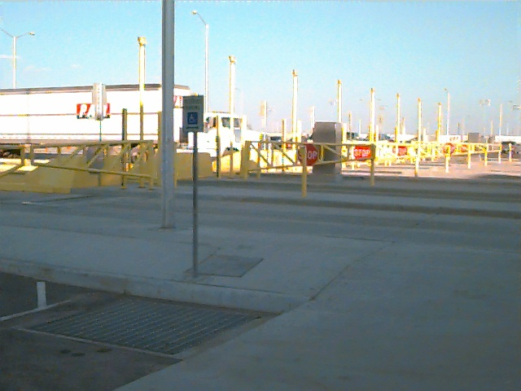

Figure 5. Outbound Toll Booths at the World Trade Bridge

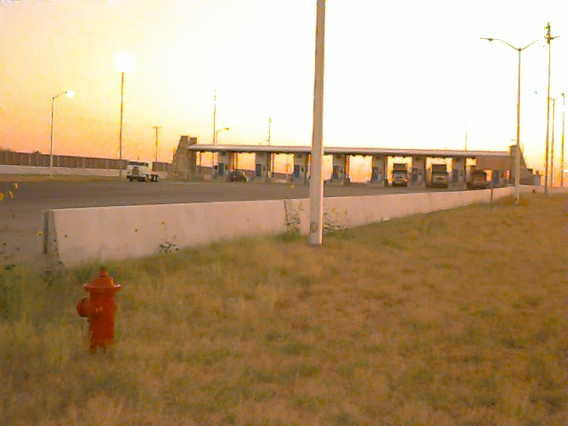
Figure 6. Primary Customs Viewed from the IB-2 Data Collection Location

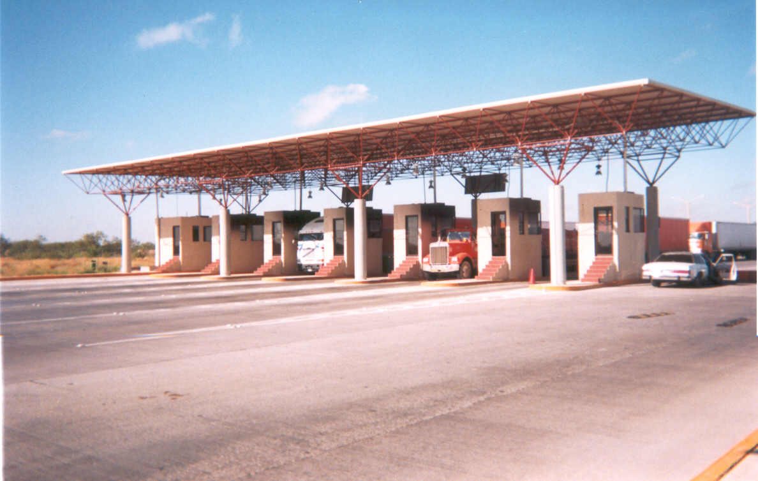
Figure 7. Inbound Access Booths (Export Booths) in Nuevo Laredo

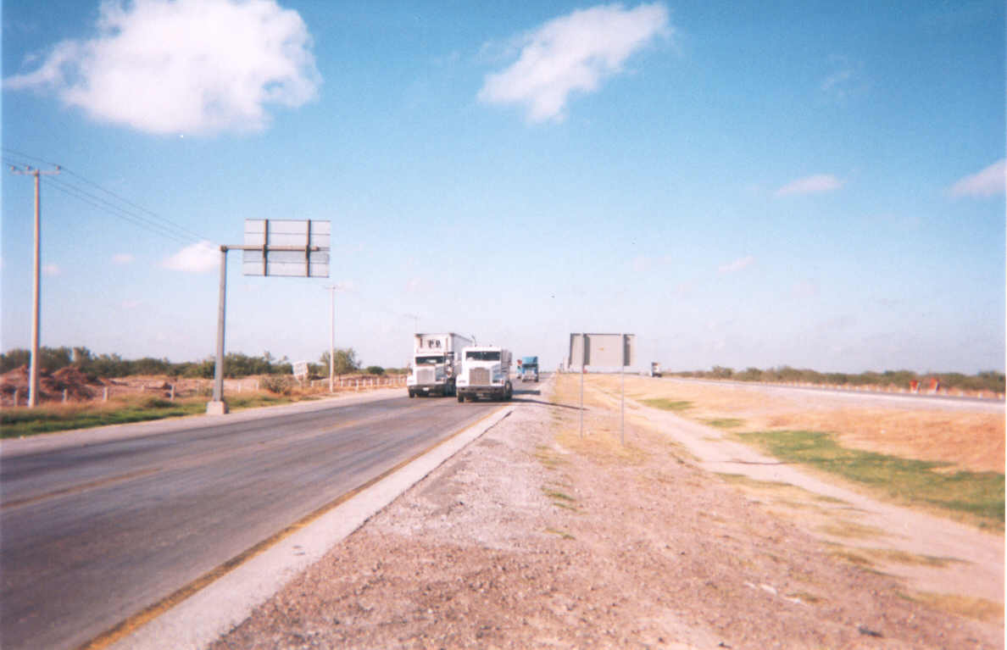
Figure 8. Access Road Approaching the World Trade Bridge in Nuevo Laredo
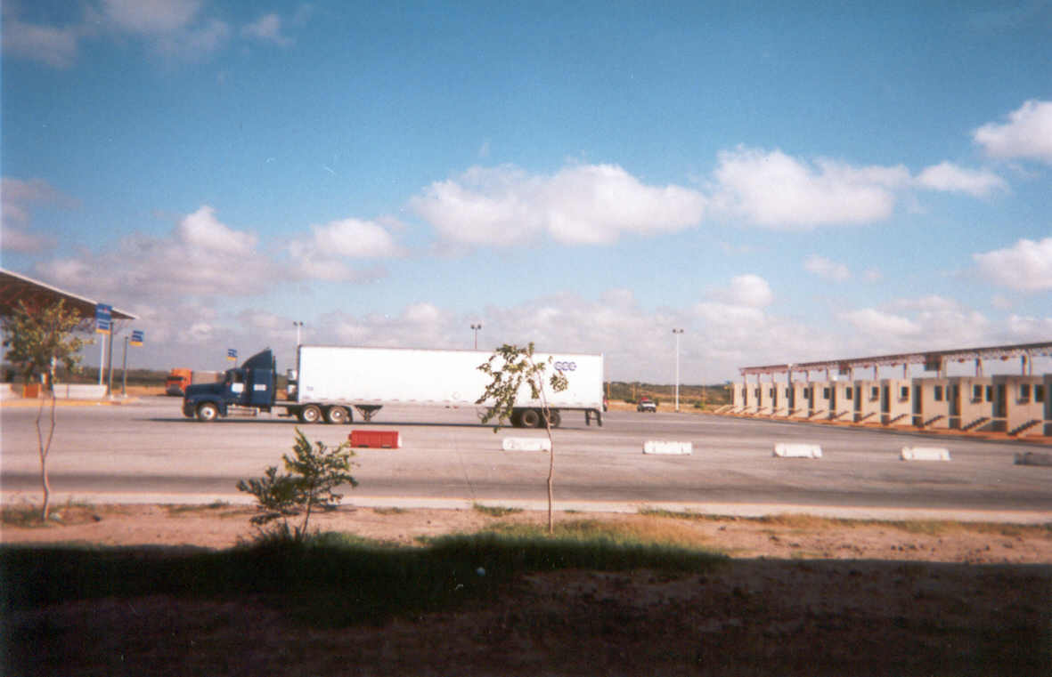
Figure 9. Outbound Import Booths in Nuevo Laredo

Table 2. Hours of Data Collection
Date | Start | End
10/30/01 | 8:30 am | 7:00 pm
10/31/01 | 8:30 am | 7:00 pm
11/01/01 | 8:30 am | 7:00 pm

The arrangements that led to the data collection activities required a considerable number of phone calls, e-mail correspondence, and a site visit. A meeting was held at Laredo, Texas in June 2001 with representatives of Mexican and U.S. Immigration, U.S. Customs, the City of Laredo, the Mexican and American Consuls, and Battelle. In addition, the Battelle representative toured the border area and potential data collection sites with local officials. Table 3 contains a list of those who attended the initial truck travel time delay orientation meeting.

Table 4 contains a list of the key individuals in Mexico who were contacted and their telephone and e-mail information. A separate table is included for contacts in Mexico and the United States. Table 5 includes information on contacts in the United States.

Table 3. June 2001 Meeting Agency Contacts
Laredo Border Crossing Coordination Meeting Attendees
Contact | Agency
Daniel Hernandez Joseph | Mexican Consul, Laredo
Thomas Hart Ambruster | American Consul, Nuevo Laredo
Gabriel Cortes Sanchez | Mexican Immigration
Jose Escamilla | Laredo Bridge System, City of Laredo
Rafael Garcia | Laredo Bridge System, City of Laredo
Eugenio Garza Jr. | U.S. Customs Port Director, Laredo
Francisco Garcia | Chief Inspector, U.S. Customs, World Trade Bridge
Rene Leyendecker | U.S. Customs, South Texas Customs Management Center

Table 4. Contacts in Mexico
Border Crossing Contacts in Mexico at the Federal and State Levels
Contact | Agency | Phone/Fax | E-mail
Claude Cortez Papi | Secretaría de Comunicaciones y Transportes (SCT) | (52) 55 19 64 84 | ccortezp@sct.gob.mx
Victor Rodriguez Baggio | Central de Planeación Aduanera  Servicios de Administración Tributaria  Secretaría de Hacienda y Crédito Público | (52) 52 28 33 82
Enrique Garza González | Subgerencia de Innovación y Calidad  Nuevo Laredo II Bridge | (52) 87 55 07 12 (Cellular)
Lic. Beatriz Bautista Morgan  Subadministradora Nuevo Laredo III | Subadministradora Nuevo Laredo III  Nuevo Laredo III Bridge

Table 5. Contacts in the United States
Border Crossing Contacts in the United States
Contact | Agency | Phone/Fax | E-mail
Ana Einohosa | U.S. Customs, Assistant Port Director, Laredo | (956) 718-4179 | Ana.hinojosa@  Customs.treas.gov
J.J. Castillo | U.S. Customs | (956) 726-2397
Rene Leyendecker | U.S. Customs | (956) 718-4161 ext. 4184 | RENE.LEYENDECKER@Customs.treas.gov
Rafael Garcia | Laredo Bridge System, City of Laredo | (956) 791-2200 | Rgarcia0@ci.Laredo.  TX.US
Gabriella Salinas | Laredo Bridge System, City of Laredo | (956) 791-2200
Frank Garcia | U.S. Customs, Assistant Port Director, Laredo | (956) 794-9401
Alex Agular | U.S. Customs Supervisor | (956) 794-9423

Data Collection Details
Historical data was evaluated for an assessment of the variability in travel conditions at the Laredo border crossing. The goal of this analysis process was to obtain statistically useful data with as few data collection days as possible. In order to customize the data collection activities to Laredo, the following steps were conducted:

- Define significant “seasonal” variations,
- Define significantly different days of the week,
- Identify traffic streams that experience significantly different conditions, and
- Estimate the number of days needed for the data collection survey.

Both the Mexican and U.S. Customs official provided some data on past traffic flows at the border. Unfortunately, to date, the data collected has been inconsistent. There weresufficient data to permit some analysis and conclusions upon which data collection decisions were based. Daily truck data from the U.S. Customs and the City of Laredo were provided for first ten months of 2001. Table 6 shows that there is no clear seasonal fluctuation in traffic volumes. As shown in the table, there is not much variation is the commercial traffic by month for the data presented. However, December for which data were not available from U.S. Customs, likely exhibits a lower volume due to the holiday season. Due to project constraints, data collection needed to occur between late October and early November 2001.

The greatest fluctuations occur during the week. Sunday has the lowest volume of truck flows and represents about ten percent of the average weekday volumes. Saturday volumes are next lowest and represent about one third of the average weekday volumes. Consequently, Tuesday, Wednesday and Thursday were selected as data collection days because they represent typical weekday truck volumes. There were no 2001 data available for selecting sampling hours for the data collection at the border. Interviews with U.S. Customs and Laredo Bridge personnel and traffic counts taken by the Texas Transportation Institute (TTI) on August 15th and 16th 2000, indicated that traffic volumes during the day are somewhat different for each direction. For the outbound direction, traffic volumes build slowly after the 8:00 AM bridge opening increase until about 2:00 PM and peak about 6:00 PM before gradually declining until about 7:00 PM and then sharply declining afterwards. In the inbound direction, volumes rise rapidly in the morning, remain high until about 6:00 PM when numbers of trucks crossing into the U.S. falls off sharply. The goal of this analysis process is to obtain statistically useful data with as few data collection days as possible. As indicated above, a decision was made to collect only three days of data from Tuesday through Thursday and that this would provide an adequate number of data samples to represent “typical” conditions. Due to availability of daylight, data collection began early in the morning and continued until lighting conditions rendered data collection impossible.

Table 6. 2001 Truck Traffic at the World Trade Bridge
Source: U.S. Customs

2001 Truck Traffic at the World Trade Bridge: Laredo, Texas
Month | Inbound Trucks | Outbound Trucks
January | 84,762 | 90,190
February | 79,617 | 88,224
March | 92,601 | 94,287
April | 82,581 | 79,228
May | 93,987 | 85,584
June | 87,098 | 94,435
July | 89,808 | 97,971
August | 98,965 | 103,404
September | 87,970 | 89,710
October | 101,514 | 103,928

Because the study team anticipated that travel times could differ for loaded and unloaded trucks, data for loaded and unloaded trucks was examined for the month of October. Table 7 shows that, at least for inbound traffic from Mexico into the United States, slightly less that half of the trucks are carrying loads.

Table 7. Movement of Loaded and Unloaded Trucks into the U.S.

Inbound Truck Traffic at the
World Trade Bridge
Oct-2001 | Loads | Empties | Tractors | TOTAL
MON 1 | 1,539 | 1,080 | 1,084 | 3,703
TUE 2 | 2,364 | 1,095 | 1,433 | 4,892
WED 3 | 2,314 | 861 | 1,138 | 4,313
THU 4 | 2,151 | 951 | 1,225 | 4,327
FRI 5 | 1,897 | 1,137 | 1,416 | 4,450
SAT 6 | 654 | 179 | 538 | 1,371
SUN 7 | 129 | 100 | 94 | 323
MON 8 | 1,899 | 909 | 1,188 | 3,996
TUE 9 | 2,071 | 821 | 1,074 | 3,966
WED 10 | 2,082 | 980 | 1,185 | 4,247
THU 11 | 1,987 | 889 | 1,190 | 4,066
FRI 12 | 1,973 | 942 | 1,297 | 4,212
SAT 13 | 656 | 188 | 451 | 1,295
SUN 14 | 163 | 68 | 109 | 340
MON 15 | 1,641 | 836 | 1,488 | 3,965
TUE 16 | 2,003 | 979 | 1,194 | 4,176
WED 17 | 1,882 | 971 | 1,290 | 4,143
THU 18 | 1,785 | 893 | 1,145 | 3,823
FRI 19 | 1,902 | 946 | 1,044 | 3,892
SAT 20 | 715 | 269 | 686 | 1,670
SUN 21 | 176 | 54 | 89 | 319
MON 22 | 1,857 | 1,157 | 1,230 | 4,244
TUE 23 | 2,031 | 1,042 | 1,341 | 4,414
WED 24 | 2,107 | 892 | 1,115 | 4,114
THU 25 | 2,013 | 1,078 | 1,176 | 4,267
FRI 26 | 1,717 | 656 | 822 | 3,195
SAT 27 | 757 | 396 | 433 | 1,586
SUN 28 | 135 | 68 | 84 | 287
MON 29 | 1,681 | 1,198 | 1,172 | 4,051
TUE 30 | 1,994 | 797 | 960 | 3,751
WED 31 | 2,006 | 937 | 1,173 | 4,116
TOTAL | 48,281 | 23,369 | 29,864 | 101,514

Data Collection Procedures
The data collection stations selected for the crossing were chosen because of the particular actions that occur at each site. Segments defined by the data collection stations were used to determine the commercial vehicle travel times and freight delay. As illustrated in Figures 2 through 9, the data collection sites were located at:

- An advance station located upstream of the commercial vehicle queue – IB-1 and OB-1.
- The import station (primary inspection booths before detailed, or secondary, inspection) – IB-2 and OB-2.

Data collection was conducted by recording commercial vehicle license plates as vehicles crossed fixed points within the data collection sites. Survey individuals or teams, were placed at each of the four data collection sites to record commercial vehicle license plate data.

Collectors at these locations would record the last five characters of the front, lower-right license plate of as many trucks as possible that passed their location. When trucking firms register many vehicles at once, they often get assigned sequential license plate numbers. Using the last five characters helps to ensure that as different trucks operated by the same firm travel across the bridge that they are uniquely identified. License plate information was entered into handheld computers with a special application designed for this project. Each entry was time-stamped with the current date and time. Prior to each day’s collection, all handheld computers were synchronized to the same time. Prior experience indicated that recording the entire license plate was too time consuming and that entering only the last four characters did not provide adequate distinction between different vehicles, so the project team chose to record the last five characters.
Typically, the queue of trucks crossing the border in outbound direction (towards Mexico) did not extend beyond OB-1 as shown in Figure 3. However, when the queue would extend northward the data collector at the OB-1 location would have to move to the OB-1A to a point that was beyond the end of the queue. In this way, the collector could continue to record trucks before they began their wait at the end of the line. When this or any other event of interest occurred, the collectors would use an “EVENT” feature of the PDA software to record it. A similar process was followed for the data collector at the inbound location (IB-1). Where the queue of trucks backed up from the export booths, the data collector would move south along the divided access road and resume data collection at a point about 1.5 kilometers (.9 miles) south of the Mexican export booths. The access road is shown in Figure 8. As was the case for the data collector on the U.S. side of the border, when any event of interest occurred, the collector would use the “EVENT” feature to record it.

The data collection team used cell phones and hand-held 2-way radios to communicate. This was particularly important when the queues lengthened such that a collector had to move farther upstream. The supervisors could be kept informed without repeated trips to each data collection location. This was also useful at the end of the day when the #1 collectors would inform the #2 collectors of the last truck they recorded, so the #2 collectors would know when to stop.

Data Collection Sample Size

Sample sizes are typically not a concern with videotape or handheld data entry devices, because the data collection includes a large number of vehicles. However, minimum sample sizes should be verified with variability values from field data. Early research found that sample sizes from 25 to 100 license matches were necessary for a given roadway segment and time period (Turner, et. al.). In most cases, there were sufficient records to meet this requirement.
Data Collection Equipment
As outlined in the “Data Collection Procedures” section above, Handspring Visor PDAs were used as the data entry device and proved adequate to the task. Low-end models with 2 Mb of storage capacity were selected as the application and data size were projected to be well below this limit. The Handspring Visors use the Palm OS (operating system) and have faster processing speeds (at least in side-by-side comparison with this application) and larger screen sizes than comparable models from Palm Computing.

A custom application was developed for the Palm OS which allowed the data collectors to identify their locations (e.g., IB-1, OB-2), the number of open booths (primarily used for the Customs inspection booths), special events or other comments, and license plate information. A screen shot of the application interface is shown in Figure 10.

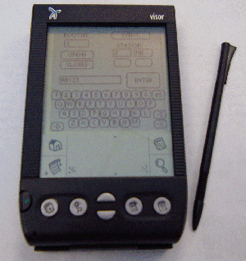
Figure 10. Data Collection Device and Software Application

The data were downloaded via a serial cable directly from the application into a text file on the field laptop computer, which was a Dell Latitude CPx H running with a 500 MHz Pentium III processor.
Data Collection Summary
Table 8 shows the number of commercial vehicle license plates recorded for each of the stations on each of the data collection days. On October 30, 2001, data was lost at the IB-1 data collection point due to a PDA malfunction. Table 9 shows the matches for each direction for the data collection days. Table 10 shows the average daily traffic volume as recorded by the U.S Customs (inbound direction) and the city of Laredo (outbound direction). Hourly volumes are used in the calculation of delay; those are shown with the delay calculations in Tables 11 through 16.

Table 8. Number of Commercial Vehicle License Plates Collected
Data Collection Site: Laredo, TX
 | 10/30/2001 | 10/31/2001 | 11/01/2001 | Data Collection Period
IB-1 | NA | 1,354 | 1,570 | 2,924
IB-2 | 1,078 | 1,197 | 1,617 | 3,892
OB-1 | 1,091 | 1,374 | 1,352 | 3,817
OB-2 | 1,442 | 1,825 | 1,746 | 5,013
Grand Total |  |  |  | 15,646
Table 9. Number of Matched License Plates Utilized
Station | 10/30/01 | 10/31/01 | 11/1/01
IB | NA | 532 | 820
OB | 512 | 620 | 519
Total | 512 | 1,152 | 1,339

Table 10. Average Daily Traffic at the World Trade Bridge Crossing
Direction | 10/30/01 | 10/311/01 | 11/1/01
Inbound | 3,751 | 4,116 | 4,012
Outbound | 4,293 | 4,429 | 4,312
Total | 8,044 | 8,545 | 8,324

Data Quality Steps
At the end of each day of data collection, the supervisor would collect the PDAs and download the data into the field laptop computer where it was stored on the hard drive. The data would be examined for any anomalies and transferred across the Internet to a secondary location for backup purposes. The IB-1 and IB-2 data would be merged together and license plates from the two locations would be “matched” using a spreadsheet developed in Microsoft Excel. As it is easy to mistake certain characters, particularly letters that looked like numbers, the license plate data was pre-processed. All ‘I’s were replaced with ‘1’s; all ‘O’s, ‘D’s, and ‘Q’s were replaced with ‘0’s; all ‘S’s were replaced with ‘5’s; and all ‘Z’s were replaced with ‘2’s. In addition, the data collectors were instructed to always use ‘1’s for ‘I’s and ‘0’s for ‘O’s (i.e., to use the digit, rather than the letter).

Occasionally, collectors would be unsure about a license plate and would append “QQQ” to their entry. This would typically occur when several trucks passed the collector in rapid succession or if one truck blocked the license plate of another and he or she could only manage a quick glimpse. This would allow the supervisor to search the downloaded data for a potential match by using the travel times of other trucks that were recorded in the same general time frame. During this process, the supervisor could also identify the few records in which the data collector forgot to press “ENTER” after recording a license plate before recording the next one. These ten-character entries could be split into two and the time for the first interpolated from the adjacent entries if they were less than a minute or so apart.

Data post-processing also included a step to identify any anomalies in the data, including outliers. Outliers, records that indicated travel times significantly greater than typical for that time period, were most often caused by recording the license plate of a vehicle only some of the time as it made repeated trips across the border during a single day. This is because the matching algorithm uses the most recent time at the #1 position when matching to a record from a #2 location. For example, if the vehicle was recorded as it headed from Mexico to the U.S. early in the morning, later returned to Mexico, was missed as it re-entered the U.S. later in the day, and then recorded on its subsequent return to Mexico, the #1 time from its first trip would be matched with it #1 time from the first trip (for a valid travel time) an also matched to the #2 time from its second trip (an invalid travel time). This invalid travel time would be easily identified by manual inspection of the data, aided by highlighting those travel times about a certain, variable threshold.

Freight Delay Analysis
The measure for the freight transportation system at international roadway border crossings is travel delay per truck trip through the first inspection point in the import country. Delay is measured relative to the travel time at low volume conditions, which will allow the processing time of the inspection to be accommodated outside of the measure. Estimating the average delay per truck for each hour where congestion is present, and then applying the average hourly truck volume produces an estimate of total delay.

The average delay per truck for each hour is the difference between the travel time at low volume conditions and the travel time each hour. Travel time is also affected by the number of open inspection booths and this information was recorded on all days as it changed. To determine the average travel time for each road segment, the matched license plate data in the database is used. The number of matches are noted for statistical analysis and the travel time is noted for each hour. The travel time for each truck was assigned to the hour when they passed through the primary Customs inspection location.

The data are presented in Tables 11 through 15. The columns illustrate the key elements for estimating delay:

- No Delay Travel Time – The time through the system at low volume conditions. For this report, the value used was that of the lowest hourly travel time in that direction for each three-day data collection period.
- Average Number of Open Booths – The average number of primary Customs commercial vehicle inspection booths open and available for processing trucks. This figure is not used to compute delay but is useful to help understand the relationship between booths, traffic volume, and delay.
- Number of Matched Vehicles – The number of vehicle observation used to estimate the travel time for each hour.
- Average Travel Time – The amount of travel time from entry to exit for trucks entering the system each hour (use the time the vehicle passes the advance point as the determinant of the time period label).
- Delay per Trip – The difference between the average travel time and the “no delay” time.
- Average Traffic Volume – The average hourly truck volume for the period being analyzed.
- Total Delay – The product of the hourly truck volume and delay per trip.

Note, as mentioned above, that inbound data for October 30, 2001 are not available due to a problem with the data collection devices that could not be corrected.

Table 11. Total Delay – 10/31/2001 – Inbound
Time Period |  |  | (a)  "No Delay" Travel Time | (b)  Average No. of Open Booths | (c)  Number of "Matched" Vehicles | (d)  Average Travel Time | (e)  Delay Per Trip  (d - a) | (f)  Average Traffic Volume* | (g)  Total Delay  (f x e)
8:00 | – | 9:00 AM | 12.23 | 6.00 | 23 | 35.67 | 23.44 | 309 | 138.00
9:00 | – | 10:00 AM | 12.23 | 6.00 | 71 | 44.68 | 32.45 | 329 | 426.00
10:00 | – | 11:00 AM | 12.23 | 5.54 | 46 | 32.83 | 20.60 | 288 | 254.84
11:00 | – | 12:00 PM | 12.23 | 6.00 | 46 | 38.35 | 26.12 | 309 | 276.00
12:00 | – | 1:00 PM | 12.23 | 6.00 | 66 | 29.38 | 17.15 | 329 | 396.00
13:00 | – | 2:00 PM | 12.23 | 6.00 | 69 | 14.65 | 2.42 | 391 | 4140
14:00 | – | 3:00 PM | 12.23 | 4.43 | 69 | 19.47 | 7.24 | 309 | 305.67
15:00 | – | 4:00 PM | 12.23 | 5.00 | 70 | 26.38 | 14.15 | 288 | 350.00
16:00 | – | 5:00 PM | 12.23 | 5.94 | 57 | 14.78 | 2.55 | 247 | 338.58
17:00 | – | 6:00 PM | 12.23 | 6.00 | 15 | 12.23 | 0.00 | 309 | 0.00
18:00 | – | 7:00 PM | 12.23 | 5.67 | 23 | 35.67 | 23.44 | 370 | 130.41

* Average traffic volume estimated by applying TTI traffic count hourly inbound truck traffic percentages from 8/15/00 and 8/16/00 to U.S. Customs data for 10/31/01

Table 12. Total Delay – 11/1/2001 – Inbound
Time Period |  |  | (a)  "No Delay" Travel Time | (b)  Average No. of Open Booths | (c)  Number of "Matched" Vehicles | (d)  Average Travel Time | (e)  Delay Per Trip  (d - a) | (f)  Average Traffic Volume* | (g)  Total Delay  (f x e)
8:00 | – | 9:00 AM | 12.23 | 6.00 | 91 | 22.50 | 10.27 | 301 | 546.00
9:00 | – | 10:00 AM | 12.23 | 5.05 | 102 | 20.35 | 8.12 | 321 | 515.10
10:00 | – | 11:00 AM | 12.23 | 5.00 | 90 | 37.68 | 25.45 | 281 | 450.00
11:00 | – | 12:00 PM | 12.23 | 5.00 | 80 | 55.02 | 42.79 | 301 | 400.00
12:00 | – | 1:00 PM | 12.23 | 5.81 | 97 | 58.63 | 46.40 | 321 | 563.57
13:00 | – | 2:00 PM | 12.23 | 5.99 | 79 | 53.32 | 41.09 | 381 | 473.21
14:00 | – | 3:00 PM | 12.23 | 5.99 | 77 | 36.25 | 24.02 | 301 | 461.23
15:00 | – | 4:00 PM | 12.23 | 5.44 | 89 | 29.13 | 16.90 | 281 | 484.16
16:00 | – | 5:00 PM | 12.23 | 5.00 | 78 | 17.73 | 5.50 | 241 | 390.00
17:00 | – | 6:00 PM | 12.23 | 5.00 | 37 | 20.75 | 8.52 | 301 | 185.00
18:00 | – | 7:00 PM | 12.23 | 6.00 | 91 | 22.50 | 10.27 | 361 | 546.00

* Average traffic volume estimated by applying TTI traffic count hourly inbound truck traffic percentages from 8/15/00 and 8/16/00 to U.S. Customs data for 11/1/01

Table 13. Total Delay – 10/30/2001 – Outbound
Time Period |  |  | (a)  "No Delay" Travel Time | (b)  Average No. of Open Booths | (c)  Number of "Matched" Vehicles | (d)  Average Travel Time | (e)  Delay Per Trip  (d - a) | (f)  Average Traffic Volume* | (g)  Total Delay  (f x e)
8:00 | – | 9:00 AM | 2.22 | 2.90 | 16 | 3.07 | 21:16 | 64 | 46.40
9:00 | – | 10:00 AM | 2.22 | 3.65 | 30 | 4.97 | 20:16 | 129 | 109.50
10:00 | – | 11:00 AM | 2.22 | 4.00 | 43 | 5.60 | 19:16 | 193 | 172.00
11:00 | – | 12:00 PM | 2.22 | 4.00 | 56 | 7.60 | 18:16 | 236 | 224.00
12:00 | – | 1:00 PM | 2.22 | 3.04 | 39 | 8.35 | 17:16 | 236 | 118.56
13:00 | – | 2:00 PM | 2.22 | 3.00 | 46 | 17.37 | 16:16 | 301 | 138.00
14:00 | – | 3:00 PM | 2.22 | 3.33 | 41 | 25.63 | 15:16 | 343 | 136.53
15:00 | – | 4:00 PM | 2.22 | 5.91 | 102 | 33.03 | 14:16 | 386 | 602.82
16:00 | – | 5:00 PM | 2.22 | 7.00 | 89 | 20.48 | 13:16 | 386 | 623.00
17:00 | – | 6:00 PM | 2.22 | 7.00 | 50 | 19.45 | 12:16 | 408 | 350.00
18:00 | – | 7:00 PM | 2.22 | 2.90 | 16 | 3.07 | 11:16 | 472 | 46.40

*Average traffic volume estimated by applying TTI traffic count hourly outbound truck traffic percentages from 8/15/00 and 8/16/00 to City of Laredo data for 10/30/01

Table 14. Total Delay – 10/31/2001 – Outbound
Time Period |  |  | (a)  "No Delay" Travel Time | (b)  Average No. of Open Booths | (c)  Number of "Matched" Vehicles | (d)  Average Travel Time | (e)  Delay Per Trip  (d - a) | (f)  Average Traffic Volume* | (g)  Total Delay  (f x e)
8:00 | – | 9:00 AM | 2.22 | 3.58 | 37 | 2.22 | 0 | 66 | 0.00
9:00 | – | 10:00 AM | 2.22 | 3.85 | 50 | 5.83 | 3.61 | 133 | 480.13
10:00 | – | 11:00 AM | 2.22 | 4.00 | 79 | 17.10 | 14.88 | 199 | 2961.12
11:00 | – | 12:00 PM | 2.22 | 4.00 | 60 | 29.42 | 27.2 | 244 | 6636.80
12:00 | – | 1:00 PM | 2.22 | 4.00 | 34 | 39.43 | 37.21 | 244 | 9079.24
13:00 | – | 2:00 PM | 2.22 | 3.73 | 62 | 45.33 | 43.11 | 310 | 13364.10
14:00 | – | 3:00 PM | 2.22 | 4.17 | 77 | 61.00 | 58.78 | 354 | 20808.10
15:00 | – | 4:00 PM | 2.22 | 7.28 | 106 | 44.42 | 42.2 | 399 | 16837.80
16:00 | – | 5:00 PM | 2.22 | 8.98 | 85 | 10.87 | 8.65 | 399 | 3451.35
17:00 | – | 6:00 PM | 2.22 | 8.00 | 30 | 13.88 | 11.66 | 421 | 4908.86
18:00 | – | 7:00 PM | 2.22 | 3.58 | 37 | 2.22 | 0 | 487 | 0.00

* Average traffic volume estimated by applying TTI traffic count hourly outbound truck traffic percentages from 8/15/00 and 8/16/00 to City of Laredo data for 10/31/01

Table 15. Total Delay – 11/1/2001 – Outbound
Time Period |  |  | (a)  "No Delay" Travel Time | (b)  Average No. of Open Booths | (c)  Number of "Matched" Vehicles | (d)  Average Travel Time | (e)  Delay Per Trip  (d - a) | (f)  Average Traffic Volume* | (g)  Total Delay  (f x e)
8:00 | – | 9:00 AM | 2.22 | 2.78 | 25 | 2.50 | 0.28 | 65 | 180.70
9:00 | – | 10:00 AM | 2.22 | 2.96 | 39 | 4.30 | 2.08 | 129 | 381.84
10:00 | – | 11:00 AM | 2.22 | 3.00 | 40 | 10.70 | 8.48 | 194 | 582.00
11:00 | – | 12:00 PM | 2.22 | 4.01 | 46 | 20.52 | 18.3 | 237 | 950.37
12:00 | – | 1:00 PM | 2.22 | 4.30 | 62 | 8.72 | 6.5 | 237 | 1019.10
13:00 | – | 2:00 PM | 2.22 | 4.32 | 54 | 4.37 | 2.15 | 302 | 1304.64
14:00 | – | 3:00 PM | 2.22 | 4.26 | 55 | 14.42 | 12.2 | 345 | 1469.70
15:00 | – | 4:00 PM | 2.22 | 6.85 | 78 | 17.85 | 15.63 | 388 | 2657.80
16:00 | – | 5:00 PM | 2.22 | 7.85 | 87 | 5.05 | 2.83 | 388 | 3045.80
17:00 | – | 6:00 PM | 2.22 | 8.00 | 33 | 6.98 | 4.76 | 410 | 3280.00
18:00 | – | 7:00 PM | 2.22 | 2.78 | 25 | 2.50 | 0.28 | 474 | 1317.72

* Average traffic volume estimated by applying TTI traffic count hourly outbound truck traffic percentages from 8/15/00 and 8/16/00 to City of Laredo data for 11/1/01

As mentioned above, data was collected all trucks and for trucks without cargo because they were specifically treated differently at the Mexican import and export booths. When delay times are compared for unloaded trucks (including bobtails) and loaded trucks average delay time do vary. Table 16 summarizes the weighted average travel times between empty trucks and loaded flights.

Table 16. Delay Time for Empty and Loaded Trucks
Direction | Loaded or Empty | Weighted Travel Time
Inbound | Empty Trucks | 21.50 minutes
Outbound | Empty Trucks | 2.63 minutes
Inbound | Loaded Trucks | 32.39 minutes
Outbound | Loaded Trucks | 19.28 minutes

Statistics

Table 17 shows the baseline or “no delay” travel time, the average travel time, and three other measures that indicate the reliability of the travel time estimates. The baseline time (in minutes) is the time needed to travel the study distance (between the starting point in the exporting country and the initial inspection point in the importing country) in free-flow traffic conditions. The average time is computed from all vehicles measured during the data collection period over the study distance. The 95th percentile time is the time (in minutes) within which 95 percent of all trucks can cross the border. The buffer time is the additional time above the average crossing time (in minutes) that it takes for 95 percent of all trucks to cross. The buffer index expresses the buffer time in terms of the average time and is the percentage of extra time that must be budgeted to cross the border within the 95th percentile time. For example, if the average time was 10 minutes and the buffer time was 5 minutes, the buffer index would be 50 percent.

Table 17. Crossing Times

 | Baseline  Time | Average Crossing Time | 95th Percentile Time | Buffer Time | Buffer Index
Outbound | 1.8 | 17.2 | 45.0 | 27.8 | 161.6
Inbound | 12.2 | 31.2 | 54.9 | 23.7 | 76.0

From the table, it is apparent that the average travel time is more favorable for outbound traffic than for inbound traffic but that the inbound traffic has higher reliability.

Figure 11 illustrates the average travel time experienced for different truck volumes per lane per hour in each direction.
Figure 11. Average Travel Time for Different Hourly Volumes

Figures 12 and 13 show typical average hourly traffic volumes per booth for the study period as well as the measured average hourly travel times. In addition, the average number of open primary Customs booths in each direction is shown.

Figure 12. Typical Inbound Traffic

Figure 13. Typical Outbound Traffic

Conclusions

Lessons learned during data collection activities in this project at this site and at others along the Canadian and Mexican borders with the U.S. have identified several issues that should be taken into consideration to assist future data collection efforts. Some apply to advance planning and the initial site visit and others apply more specifically to the data collection activities themselves.
Planning and Site Visits

- Prior to conducting any data collection project, all jurisdictional and cooperating agencies should be made explicitly aware of the purpose and objectives of the study as well as all the details associated with the data collection project (e.g. dates, times, procedures to be followed during the data collection period, etc.). Failure to do so may result in confusion and possible delay of the study. This has been very time-consuming at some ports and should be adequately accounted for in the schedule. For some agencies, including U.S. Customs, it is important to contact both the federal and local levels. Some entities that should be contacted might not be readily apparent and can include construction companies working on public rights-of-way, state police and city officials. Some agencies provide verbal approval for the data collection and may even provide supporting documentation to their field staff, yet are reluctant to provide documentation for the data collectors to carry. Every effort should be made to obtain written authorization that can be carried by the data collectors, particularly from bridge authorities and immigration officials. In addition contacts with officials should be maintained between initial site visits and data collection if delays are encountered. At Laredo, although we met with representatives of the city of Laredo, who operate the World Trade Bridge, at the initial visit, by the time data collection was scheduled, a key individual had forgotten details of the earlier contacts. Consequently, the supervisor made additional contacts in order to receive the needed approvals for data collection activities on the bridge in an outbound (southbound) direction.

- Prior to data collection activities, a general idea of traffic peak periods and conditions should be understood to optimize collection of appropriate traffic data and coverage of the appropriate times. This information should be obtained from discussions with knowledgeable officials and by examining historical traffic data.

- Any additional data needs should be discussed explicitly with the appropriate officials. At some crossings, for example, average hourly truck volumes are not normally recorded and maintained, but can be if special arrangements are made in advance. Alternatively, it may be appropriate to use other means to measure truck volumes, such as roadway counters or having the data collectors indicate the vehicles that pass without their license plates being recorded (assuming continuous data collection during each day). These additional traffic volumes could be used to corroborate data provided by the local authorities or used if their planned data collection did not occur or there was some other problem in providing the data.

- It is also important to be aware of special federal or local holidays on both sides of the border when scheduling data collections as these could affect traffic flows. Some minor holidays that occur on Mondays and Fridays, might not significantly affect traffic for a Tuesday through Thursday data collection period, but may increase the likelihood that key local officials will be on vacation and unavailable should any problems arise.

- When scheduling the data collection times, consider the availability of sunlight or high-powered lighting. It becomes increasingly difficult to read license plates at night as trucks approach with their headlights on (also a problem during rain) and entering the data into the PDAs also becomes more difficult when it is dark. This was especially true in Laredo where during data collection, the sun set about 6:30PM and it became extremely difficult to collect data after that time.

- Photographs of the border facilities and data collection locations should be taken during the site visits to assist in documenting the collection effort and to better inform the data collectors prior to their arrival on-site.

- Processing, data quality, and analysis of all traffic data require the largest portion of the study time.
Data Collection Activities
- Prior to data collection activities, an explanation and understanding of the procedures to be followed and logistics should be made clear to all members of the study team (e.g., number and location of license plate characters to be recorded, all commercial vehicles should be recorded, when and how to contact the on-site supervisor, etc.).

- Proper identification for all survey members and written documentation of authorization from all jurisdictional agencies should be carried at all times by all members of the study team, especially when conducting business in a foreign country.

- The supervisor should assess all conditions upon arrival for data collection to note any changes from the site visit or prior collection activities. Sometimes unplanned construction or other events may alter the preferred data collector locations or the truck flow patterns.

- While only one supervisor was originally planned for each data collection visit, it was determined that installing one supervisor on each side of the border was highly desired. One supervisor would be designated the overall site supervisor. This presented several benefits, the most important being added safety and security for the data collectors, particularly for a collector who needed to move to a remote location upstream from the border when the queue extended beyond their original location. Other benefits were increased awareness of current conditions and the origin of backups, the increased ability to relieve data collectors for breaks and lunch while maintaining continuous data collection, and assisting with data collection during exceptionally high-volume times or in difficult locations (such as remote spots along a highway when the vehicles were passing at free-flow speeds). Without the extra supervisor, a single supervisor would make repeated trips across the border to check on the collectors, relieve them, and provide them with food and drink if they were not conveniently located nearby. Border delays would often make this an extremely time-consuming process.

- For Mexican data collection, it is recommended that Mexican nationals be used, both as supervisors and as data collectors. This helps to enhance coordination with national, state, and local officials and to minimize the likelihood of immigration or other problems with federal, state, or local agencies. A Mexican supervisor and data collectors were for the Laredo border data collection and resulted successful data collection on the Mexican side of the border.

- As mentioned above, the supervisors should be used to maintain nearly constant data collection during breaks. This improves data quality by ensuring the supervisors repeatedly observe each collector and can identify and correct any problems they might be having. Further, this improves the number of trucks matched at both the #1 and #2 locations, improving the sample size for analysis.

- Communication between the data collectors and their supervisors is crucial to an efficient and successful effort, particularly when one of the data collectors must move upstream past the end of a growing queue. Communication with the supervisor is also important when a data collector is having a problem with an official questioning their authority to do their work or when some other unexpected event occurs. For example, occasionally, there may be an anomaly with the data collection equipment and the collector can receive immediate instructions on how to proceed rather than having to wait until the supervisor next visits their location. Two-way radios (FRS-type with up to a two-mile range) and cell phones work adequately in most situations, but interference and range can limit their effectiveness. Cell phone service can be spotty near border areas. Additional longer-range communication options that do not require FCC approval should be considered for future collections. Obviously, when using cell phones, ensure that long-distance charges and roaming fees will not be significant costs.

- It is important to ensure that the data collectors are safe and comfortable during their long periods of collection. If their data collection locations cannot provide adequate cover from severe rains or heat, additional vehicles should be considered. Comfortable sport chairs with attachable beach umbrellas served to protect the collectors well during light rain and moderate sun. Ensure that the collectors have an adequate supply of water and that facilities are conveniently accessible. This becomes more difficult for the remote locations upstream from the border crossing.

REFERENCES

Turner, S.M., W.L. Eisele, R.J. Benz, and D.J. Holdener. Travel Time Data Collection Handbook.Report. No. FHWA-PL-98-035. Federal Highway Administration, Texas Transportation Institute, March 1998

