
Final Site Report

Evaluation of Travel
Time Methods to Support
Mobility Performance
Monitoring

Zaragoza Bridge

To
Office of Freight Mgt. and Operations
Federal Highway Administration
U.S. Department of Transportation
Washington, DC 20590

April 2002

Border Crossing Freight Delay Data Collection and Analysis

FY 2001 Data Collection – Zaragoza Bridge

Site Description

The Bridge. The Zaragoza Bridge (figure 1) connects outlying areas of El Paso, Texas and Juarez, Mexico. Officially - and on the Mexican side - it is known as Zaragoza; however, the U.S. side often refers to it as the Ysleta Bridge after a nearby community of that name. It spans the Rio Grande River approximately seven miles southeast of the Bridge of the Americas, another major border crossing between downtown El Paso and Juarez. The Zaragoza Bridge handles auto, truck, and pedestrian traffic, although autos and pedestrians have separate tollbooths and Customs inspections facilities from trucks and are physically separated on the bridge. The bridge operates from 8:00 A.M. to midnight Monday through Friday, and 9:00 A.M. to 5:00 P.M. on Saturday. The crossing is closed to commercial vehicle traffic on Sunday. In the El Paso – Juarez metropolitan area, other bridges that also handle truck traffic include the Bridge of the Americas (known in Mexico as the Cordova Bridge) and the Santa Teresa Bridge (a crossing primarily for agricultural commerce, about twenty miles from El Paso in New Mexico).

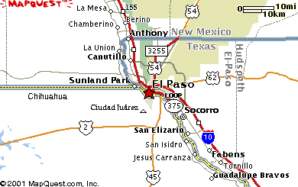
Zaragoza Bridge

Figure 1. Area Map – The Zaragoza Bridge.

The Zaragoza Bridge is jointly owned by the cities of El Paso and Juarez. The GSA owns the U.S. border crossing facility, which is operated by U.S. Customs. The City of El Paso Street Department owns and operates the tollbooths for trucks heading for Mexico. The Mexican federal agency “CABIN” owns the Mexican Customs facilities, and the tollbooths for U.S.-bound trucks are owned and operated by CAPUFEZE, the Mexican national highway and tollway agency. Duty free operations on either side of the Zaragoza Bridge do not appear to be as visible as some of the other crossings at which we collected data and do not affect traffic flow.

U.S. and Mexican Customs operate the facilities and control the property where their Customs facilities are located. Data collectors who were operating beside the primary Customs checkpoint and tollbooths in either country had to have permission to be on property operated by the Customs organization of that country. The GSA needs to be notified of the presence of collectors on the U.S. side. For our operations in Juarez, we had the written permission of Mexican Immigration and verbal approval from Mexican Customs and SECODAM (the Mexican Controller’s office).

Battelle was fortunate to have a Mexican contact who was a strong proponent of the project because of the study’s perceived potential to enhance the flow of commerce through the Juarez-El Paso area. This contact is closely tied to the Juarez and El Paso Chambers of Commerce as well as Mexican Immigration, Customs and Controller’s offices, and he arranged all the approvals needed from the Mexican side. His assistance was not only extremely helpful but also instrumental in securing the necessary permission for operations in Mexico. These operations went quite smoothly, largely because the cooperation on both sides of the crossing was uniformly exceptional.

Data collection activities at the Zaragoza Bridge occurred during June 26-28, 2001. Truck travel times across the bridge in both directions were recorded on Tuesday through Thursday each week, for 12 to 12-1/2 hours each day. The times of the data collection were not staggered to obtain a broader picture of activity as they were at other border crossings in our study for one good reason: the Zaragoza Bridge opened at 8:00 A.M. and the data collectors generally ran out of daylight and could no longer read license plates by 8:30 P.M.

Mexico-bound Traffic. On the U.S. side, I-10 runs east from downtown El Paso paralleling the Rio Grande approximately three miles north of the river. The Interstate-like 375 Loop intersects I-10 heading south, has an exit beside the Zaragoza Bridge, then heads west toward downtown El Paso following the Rio Grande. Virtually all Mexico-bound truck traffic enters from the 375 Loop, which is only 0.1 mile from the tollbooth. (Note: all distances below are from the tollbooth for a given direction of travel). Trucks pass through two separated tollbooths on the El Paso side (see figure 2), then the divided lanes rejoin and trucks cross the bridge into Mexico via divided four-lane traffic.

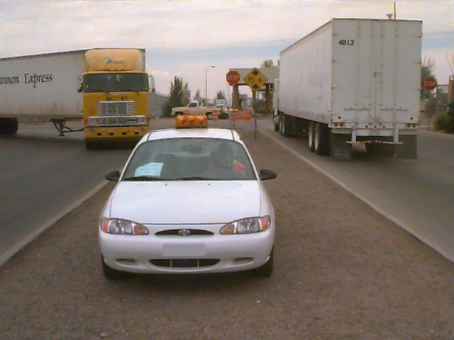

Figure 2. Outbound 1 data collection point just prior to tollbooths on U.S. side.
On reaching the other side of the bridge, they turn sharply left and get into single file to go through an unmanned booth (on one side of the structure that houses the toll collectors for the other direction of travel). Then they fan out upon arrival at the Mexican primary inspection checkpoint at 0.6 mile. Mexican primary has a total of five booths (see figure 3), but generally only two or three were open. One booth on the extreme right (left in the picture) was originally intended for “favored” carriers under a NAFTA provision but that arrangement was never enacted. Empty trucks use that “NAFTA” lane, however.

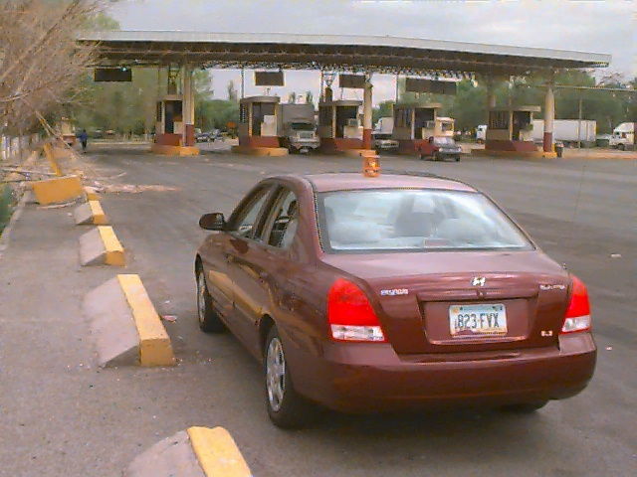

Figure 3. Outbound 2 data collection point at Primary on the Mexican side.

At primary, some trucks are directed to the secondary inspection dock just pass primary on the left, but most proceed straight to a backup checkpoint at 0.9 mile. The two-booth backup checkpoint (“Segundo Reconocimiento”) is technically not a secondary inspection but rather a double-check on primary that is conducted by a contractor for the Mexican government. Trucks that are selected at this backup checkpoint to undergo an inspection, back up to a small adjacent dock where they are unloaded. The final checkpoint for all outbound trucks is at 0.9 mile; it has two lanes for outbound trucks but generally operates with one closed off (see figure 4). On one occasion when trucks were backed up all the way from this final checkpoint through the double-check booths and to primary, personnel opened the gate for a second lane that cleared out the backup.

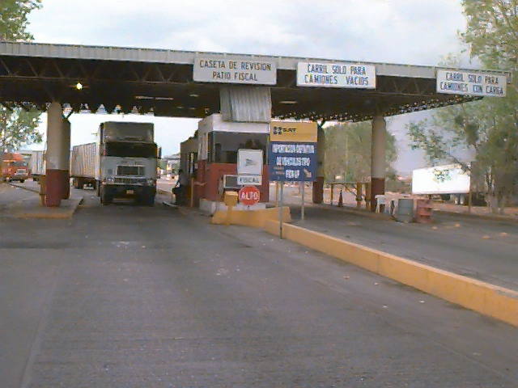

Figure 4. Final outbound/ initial inbound Customs
station on Mexican side (looking north).

Trucks exit the Customs area from this final checkpoint onto a roadway known as “Prol. M.J. Clouhtier,” which intersects with the Juarez street system after a short distance (see figure 5). At the direction of Mexican Customs officials, a few trucks were observed pulling over to the side of the road immediately past this final checkpoint – apparently to get them out of the traffic flow while clearing up some details of their paperwork. Along this road that leads away from Customs, some truck drivers pull over to the right side of the road to buy snacks from entrepreneurs who set up carts for that purpose.

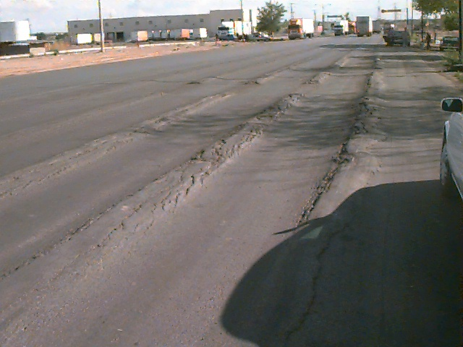

Figure 5. Juarez road looking south after departing final outbound checkpoint
(note Maquiladora facility in background); also site of one of the
Inbound 1 data collection points for queue on Mexican side.

Just past the vicinity of Mexican Customs are facilities of a number of maquiladoras, the “twin plant” assembly operations that hug Mexico’s border with the U.S. The maquiladoras have become the industrial backbone of Mexico’s northern border, with more than 3,500 plants employing 1.2 million people. Because of the presence of the maquiladoras, many trucks were observed to cross the Zaragoza Bridge multiple times and short periods apart during the days we collected data. In addition to the trucks that come from the maquiladoras and other Juarez-area origins, other trucks come from the city of Chihuahua approximately 230 miles to the south on Mexico Highway 10.

U.S.-bound Traffic. Trucks make their way through the western outskirts of Juarez onto Prol. M.J. Clouhtier and enter the customs area at an initial checkpoint (which is the same structure as the final checkpoint for Mexico-bound trucks – see figures 4 and 6). At the initial checkpoint, empty trucks go into a booth on the left for processing and trucks with cargo go into a booth on the right (see figure 7). From the initial checkpoint to a two-booth export checkpoint (“Segunda Seleccion Automatizada”) is 0.1 mile, and just past on the left are export inspection docks. Most trucks proceed directly to the two-lane tollbooth at 0.4 mile, cross the bridge and reach the six-booth U.S. primary inspection at 0.9 mile (see figure 8).

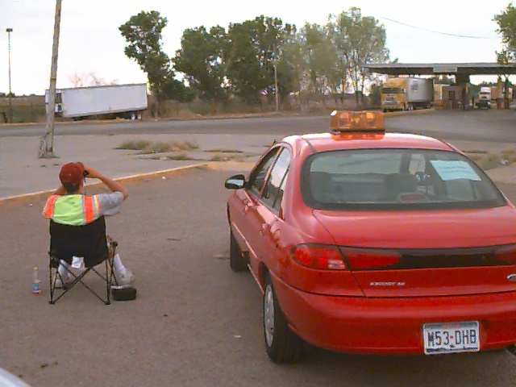

Figure 6. Inbound 1 data collection point at initial gate on Mexican side.

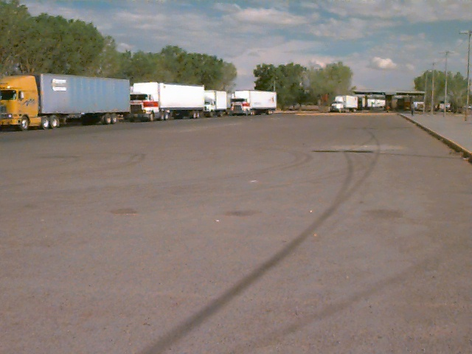

Figure 7. Inbound traffic on Mexican side between initial and export checkpoints.

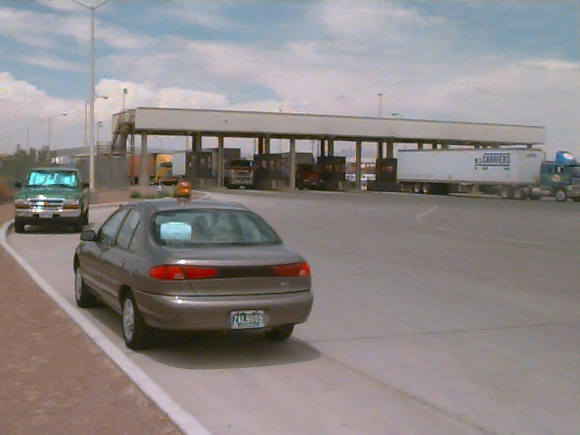

Figure 8. Inbound 2 data collection point at Primary on the U.S. side.

Immediately past primary is a two-booth truck safety inspection area that is manned by the Federal Office of Motor Carrier Safety Administration and the Texas Department of Public Safety (see figure 9). Selected trucks go through the safety inspection. Some other trucks must go through agricultural, X-ray, or other secondary Customs inspections. All cleared trucks exit at a one-booth final checkpoint at 1.1 mile (on the far side of the sprawling Customs building from primary). This exit point is just out of sight to the left in figure 2; the truck with the yellow cab has just passed through the final gate next to a data collection point. Exiting trucks then make a sharp right turn to access the 375 Loop. A large number of those trucks have a destination that is within a short distance of the Zaragoza Bridge.

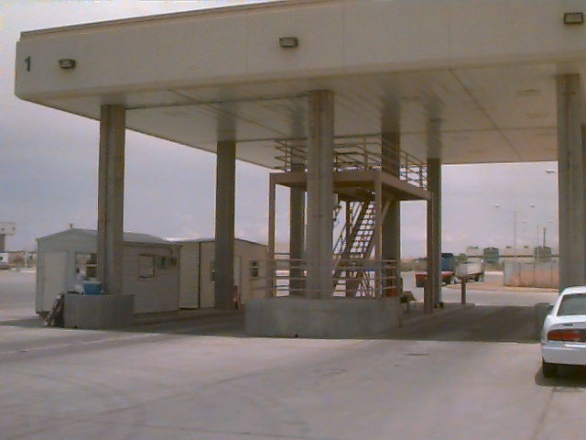

Figure 9. Inbound safety inspection checkpoint beside primary on the U.S. side.

Data Collection Process

For this study, two data collection locations were used in each direction. For consistency among all border crossings visited as part of the overall project, the data collection positions were distinguished by the direction of travel that they were measuring (Inbound or Outbound). Thus, movement from the U.S. side to Mexico is Outbound, and from the Mexican side to the U.S. is Inbound. The Inbound 1 (IB-1) position, therefore, was where U.S.-bound trucks cleared the initial checkpoint entering the Mexican Customs. The Outbound 1 (OB-1) position was immediately before the tollbooth on the El Paso side for Mexico-bound trucks. The “number 2” locations (e.g., IB-2 and OB-2) were immediately after the primary inspection booths on both sides.

Each data collector used a handheld computer to record partial license plate information of all commercial vehicles that passed their location. The computer would also store the time that each license plate was entered. The data from the two locations in each direction would be combined, allowing the determination of the travel time for each vehicle that was recorded at both locations.

During the data collection, the on-site team included four data collectors and one supervisor. The supervisor provided additional support to take over data collection when a collector was given a break or lunch, or sometimes collected supplemental data during a non-typical event.

As previously mentioned, the hours during which data were collected were structured to ensure the greatest possible coverage of traffic from when the bridge opened until data collection was no longer possible due to daylight being lost. Table 1 shows the data collection hours for each day during the site visits. Each data collector actually worked about 12-1/2 hours, with the supervisor collecting data to give them a meal break or rest breaks during the day.

Table 1. Hours of Data Collection

Date | Start | End
6/26/01 | 8:00 am | 8:40 pm
6/27/01 | 8:00 am | 8:40 pm
6/28/01 | 8:00 am | 8:40 pm

Obtaining permission for the data collection was a relatively smooth process. The initial meeting was held on May 14, 2001 with the U.S. Customs El Paso Assistant Port Director – Trade Operations and the Zaragoza Bridge Chief Inspector. They gave the Battelle representative an extensive tour of the facilities and shared a great deal of information about the bridge and border operations. They also arranged for a meeting the same day with El Paso-West Texas Customs Management Center (CMC) officials, specifically the Acting Director and an Operations Specialist. While very helpful and informative, the CMC officials had not yet received communications from their superiors in Washington authorizing support for the data collection effort and thus were limited in their ability to facilitate any further meetings or liaison with other organizations.

A follow-on meeting of eleven people at the CMC headquarters on June 13 was very productive. Aside from U.S. and Mexican Customs, many local U.S. and Mexican officials including the Mexican Consulate attended the meeting. The result was strong support for the data collection and assurance that all necessary approvals would be secured. In advance of these preparatory meetings, Battelle had distributed several key documents (e.g., the project’s explanation, methodology and goals) to help all host organizations understand our purpose. These documents helped to inform all concerned and maximized the time available for discussion and coordination at the meetings.

The data collectors were all experienced, having performed data collection at the Blue Water Bridge two weeks earlier. All permissions and preparations were in place and there was no delay in data collection. No badges were required by either U.S. or Mexican Customs to be on their premises. All three personnel (two data collectors and the supervisor) who operated on the Mexican side retained a copy of the letter of permission from Mexican Immigration and the supervisor provided a copy of that letter to Mexican Customs. Key FHWA Texas Division and Texas DOT representatives were informed about the nature and times of the border crossing study.

Table 2 contains a list of the individuals who were contacted and their telephone and e-mail information. With this, future data collection for this project should be able to be organized and authorized with much less effort. However, any new project would require additional time to explain the data collection objectives to the involved parties and gain their approval.

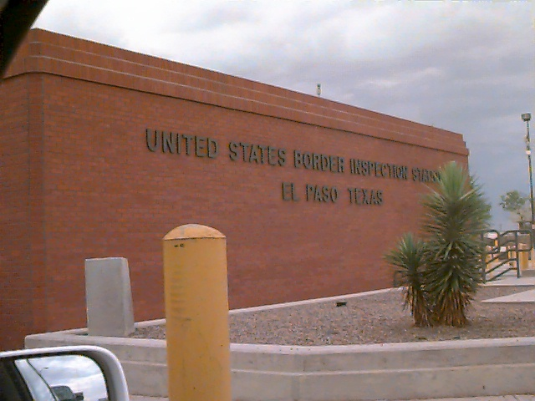

Figure 10. U. S. Customs building at the Zaragoza Bridge.

Table 2. Agency Contacts

Contact | Agency | Phone/Fax | E-mail
Jack Calloway  Assistant Director | U.S. Customs  El Paso/West Texas Customs Management Center (CMC) | 915-633-7300 ext. 141  915-633-7390 (fax)
Roger Snider  Operations Specialist | U.S. Customs  El Paso/West Texas Customs Management Center (CMC) | 915-633-7300 ext. 165  915-633-7390 (fax) | Roger.D. Snider@  customs.treas.gov
Frederick Keyser  Assistant Port Director – Trade Operations | U.S. Customs | 915-872-5731  915-872-5895 (fax) | fredrick.w.keyser@  customs.treas.gov
Jose De Jesus (J.J.) Lopez  Chief Inspector | U.S. Customs  Zaragoza Bridge | 915-872-3432  915-872-3403/33 (fax) | jose.lopez@  customs.treas.gov
Jose Contreras Corral  International Business Consultant and Manufacturer’s Representative | FAMCO International Group | 915-727-6536 or  011-611-1707/08  011-611-0404 (fax) | famco@  jz.cablemas.com
Jorge Pasaret  Administrador | Aduana Mexicana  (Mexican Customs)
Jorge Stevenson  Port Director | Aduana Mexicana  (Mexican Customs) | 915-726-1772  011-5216-297329 (fax)
Allejandro Miranda  Chief Inspector,  Zaragoza Bridge | Aduana Mexicana  (Mexican Customs) | 915-727-0546
Martha Winberg  Director, Communications & Marketing | The Greater El Paso Chamber of Commerce | 915-534-0505  915-534-0554 (fax) | mwinberg@elpaso.org
Mike Regan | U.S. Consulate, Juarez | 011-5216-11-0720
Larry Warner | GSA Dallas/Ft. Worth | 817-313-0569  817-978-4016 (fax)
Mark Olson | FHWA Texas Division | 512-536-5972
Lisa Dye | FHWA Texas Division | 512-536-5926
Manny Aguilara | Texas DOT  El Paso | 915-790-4205/4259

Data Collection Details

The City of El Paso Street Department, Zaragoza Bridge provided hourly outbound border crossing statistical data for the three days of collection and the U.S. Customs Management Center (CMC) provided daily inbound data for the 3 days. The City of El Paso also provided daily Zaragoza truck crossing data for the period August 2000 through July 2001 and the CMC provided monthly data for that period. These data were evaluated for an assessment of the variability in travel conditions at the Zaragosa Bridge. The goal of this analysis process is to obtain statistically useful data with as few data collection days as possible. In order to customize the data collection activities at the Zaragosa Bridge, the following steps were conducted:

- Define significant “seasonal” variations,
- Define significantly different days of the week,
- Identify traffic streams that experience significantly different conditions, and
- Estimate the number of days needed for the data collection survey.

As shown in Table 3, there is some variation in the commercial traffic by month. Due to project constraints, data collection needed to occur between late May and early September 2001. From Table 3, the two months with the greatest average volumes during this data collection window were June and August.

Table 3. Monthly Traffic Distribution of Outbound Commercial Vehicles

Month | 1998 | 1999 | 2000 | 1998-2000 Average
January | 28,622 | 24,077 | 30,457 | 27,719
February | 31,928 | 24,958 | 31,742 | 29,543
March | 34,434 | 29,682 | 34,606 | 32,907
April | 31,296 | 26,982 | 27,816 | 28,698
May | 31,849 | 26,624 | 34,120 | 30,864
June | 29,351 | 32,169 | 35,072 | 32,197
July | 27,804 | 26,987 | 32,600 | 29,130
August | 27,107 | 29,700 | 38,989 | 31,932
September | 26,754 | 30,885 | 32,084 | 29,908
October | 29,889 | 29,979 | 32,144 | 30,671
November | 25,483 | 30,742 | 32,905 | 29,710
December | 23,709 | 28,860 | 29,535 | 27,368
Total | 350,224 | 343,644 | 394,070 | 362,646
Source: Data collected from U.S. Customs and compiled by the Texas Center for Border Economic and Enterprise Development

Tables 4 and 5 show that there is a significant difference in commercial traffic between weekdays and weekends and, further, there is a significant difference between Monday and Friday and the three mid-week days. Weekend traffic is 8 percent of typical weekday traffic and Monday/Friday traffic is 76 percent of typical Tuesday/Wednesday/Thursday traffic. It was determined that collecting three days of data, from Tuesday through Thursday, would provide an adequate number of data samples to represent “typical” conditions.

Table 4. Sample Month – Daily Traffic Distribution of Commercial
Outbound Vehicles for June 2001

Day | Day of Week | Outbound
1 | Friday | 1,369
2 | Saturday | 514
3 | Sunday | 0
4 | Monday | 1,203
5 | Tuesday | 1,304
6 | Wednesday | 1,349
7 | Thursday | 1,418
8 | Friday | 1,480
9 | Saturday | 490
10 | Sunday | 0
11 | Monday | 1,281
12 | Tuesday | 1,360
13 | Wednesday | 1,282
14 | Thursday | 1,326
15 | Friday | 1,349
16 | Saturday | 392
17 | Sunday | 0
18 | Monday | 1,229
19 | Tuesday | 1,349
20 | Wednesday | 1,266
21 | Thursday | 1,192
22 | Friday | 1,294
23 | Saturday | 423
24 | Sunday | 0
25 | Monday | 1,190
26 | Tuesday | 1,243
27 | Wednesday | 1,179
28 | Thursday | 1,150
29 | Friday | 1,274
30 | Saturday | 368
Total |  | 29,274
Source: City of El Paso Street Department, Zaragoza Bridge

Table 5. Averages for Sample Month – Daily Traffic
Distribution of Outbound Commercial Vehicles for June 2001

Day of Week | Week 1 | Week 2 | Week 3 | Week 4 | Week 5 | Average
Sunday |  | 0 | 0 | 0 | 0 | 0
Monday |  | 1,203 | 1,281 | 1,229 | 1,190 | 1,225.75
Tuesday |  | 1,304 | 1,360 | 1,349 | 1,243 | 1,314.00
Wednesday |  | 1,349 | 1,282 | 1,266 | 1,179 | 1,269.00
Thursday |  | 1,418 | 1,326 | 1,192 | 1,150 | 1,271.50
Friday | 1,369 | 1,480 | 1,349 | 1,294 | 1,274 | 1,352.20
Saturday | 514 | 490 | 392 | 423 | 368 | 437.40
Source: City of El Paso Street Department, Zaragoza Bridge

From discussions with U.S. Customs, we learned that backups at the Zaragoza Bridge typically did not occur on the U.S. side and, when they did, they did not grow very long. However, on the Mexican side, backups occurred more frequently, which reflected the more stringent U.S. Customs inspection methodology.

Data Collection Procedures

The data collection stations selected for the crossing were chosen because of the particular actions that occur at each site. Segments defined by the data collection stations were used to determine the commercial vehicle travel times and freight delay. As illustrated in Figures 2, 3, 6 and 8, the data collection sites could be located at:

- An advance station located upstream of the commercial vehicle queue – IB-1 and OB-1.
- The import station (primary inspection booths before detailed, or secondary, inspection) – IB-2 and OB-2.

Data collection was conducted by recording commercial vehicle license plates as vehicles crossed fixed points within the data collection sites. Survey individuals or teams, were placed at each of the four data collection sites to record commercial vehicle license plate data. The various photographs in this report display the facilities on both sides of the border, including station locations and major and secondary points of inspection.

Collectors at these locations would record the last five characters of the front, lower-left license plate of as many trucks as possible that passed their location. When trucking firms register many vehicles at once, they often get assigned sequential license plate numbers. Using the last five characters helps to ensure that as different trucks operated by the same firm travel across the bridge that they are uniquely identified. License plate information was entered into Handspring Visor PDAs (handheld computers) with a special application designed for this project. Each entry was time-stamped with the current date and time. Prior to each day’s collection, all PDAs were synchronized to the same time. Prior experience indicated that recording the entire license plate was too time-consuming and that entering only the last four characters did not provide adequate distinction between different vehicles, so the project team chose to record the last five characters.

The team frequently had difficulty reading two common types of license plates at this crossing. One was from the city of Chihuahua and the other was from the state of Chihuahua. One was difficult to read because of its bright yellow color, the other because of an image on the plate that overlays one of the readable digits and partially obscures it.

On the U.S. side, the queue of Outbound trucks crossing the border did not extend beyond the vicinity of the tollbooths during our collection. However, on the Mexican side, the Inbound queue would extend out to the feeder road where trucks enter from the Juarez street system. When this occurred, the data collector at the starting location would have to move further from the initial checkpoint to a point beyond the end of the queue. In this way, they could continue to record trucks before they began their wait at the end of the line. When this or any other event of interest occurred, the collectors would use an “EVENT” feature of the PDA software to record it.

For the IB-1 starting location, the supervisor would record the distance from any data collection point other than the original position (which would be in the Customs area near the original checkpoint). During post-processing, the data from all locations nearer to the bridge than the farthest location would be adjusted to include the additional travel time from the farthest location to the original location. The travel time would be computed at free-flow speeds, since there would have been no queue at the times that the data were collected at these closer locations. In this way, the data all would appear to be collected from the same location, the one most distant from the bridge.

Data Collection Sample Size

Sample sizes are typically not a concern with videotape or handheld data entry devices, because the data collection includes a large number of vehicles. However, minimum sample sizes should be verified with variability values from field data. Early research found that sample sizes from 25 to 100 license matches were necessary for a given roadway segment and time period (Turner, et. al.). In general, there were sufficient records each day to meet this requirement.

Data Collection Equipment

As outlined in the “Data Collection Procedures” section above, Handspring Visor PDAs were used as the data entry device and proved adequate to the task. Low-end models with 2 Mb of storage capacity were selected as the application and data size were projected to be well below this limit. The Handspring Visors use the Palm OS (operating system) and have faster processing speeds (at least in side-by-side comparison with this application) and larger screen sizes than comparable models from Palm Computing.

A custom application was developed for the Palm OS that allowed the data collectors to identify their locations (e.g., IB-1, OB-2), the number of open booths (primarily used for the customs inspection booths), special events or other comments, and license plate information. A screen shot of the application interface is shown in Figure 11.

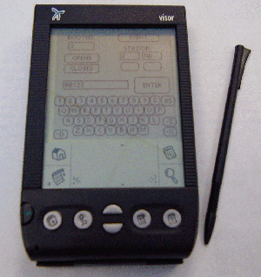

Figure 11. Data Collection Device and Software Application

The data were downloaded via a serial cable directly from the application into a text file on the field laptop computer, which was a Dell Latitude CPx H running with a 500 MHz Pentium III processor.

Data Collection Summary

Table 6 shows the number of commercial vehicle license plates recorded for each of the stations on each of the data collection days. Table 7 shows the average daily traffic volume as recorded by the El Paso Street Department International Bridges tollbooth operations (Outbound direction) and U.S. Customs (Inbound direction). (Mexican Customs combines hourly traffic for all three bridges: Zaragoza, Cordova, and Santa Theresa, so a particular bridge’s hourly volumes from that source were not distinguishable). Hourly volumes are used in the calculation of delay; those are shown with the delay calculations in Tables 8 through 19.

Table 6. Number of Commercial Vehicle License Plates Collected

Station | 6/26/01 | 6/27/01 | 6/28/01
IB-1 | 870 | 981 | 988
IB-2 | 999 | 1,044 | 1,037
OB-1 | 837 | 821 | 826
OB-2 | 965 | 959 | 955
Total | 3,671 | 3,805 | 3,806

Table 7. Average Daily Traffic at the Zaragoza Bridge

Direction | 6/26/01 | 6/27/01 | 6/28/01
Inbound | 1,171 | 1,066 | 1,015
Outbound | 1,243 | 1,179 | 1,150
Total | 2,414 | 2,245 | 2,165

Data Quality Steps

At the end of each day of data collection, the supervisor would collect the PDAs and download the data into the field laptop computer where it was stored on the hard drive. The data would be examined for any anomalies and transferred across the Internet to a secondary location for backup purposes. The IB-1 and IB-2 data would be merged together and license plates from the two locations would be “matched” using a spreadsheet developed in Microsoft Excel. As it is easy to mistake certain characters, particularly letters that looked like numbers, the license plate data was pre-processed. All ‘I’s were replaced with ‘1’s; all ‘O’s, ‘D’s, and ‘Q’s were replaced with ‘0’s; all ‘S’s were replaced with ‘5’s; and all ‘Z’s were replaced with ‘2’s. In addition, the data collectors were instructed to always use ‘1’s for ‘I’s and ‘0’s for ‘O’s (i.e., to use the digit, rather than the letter).

Occasionally, collectors would be unsure about a license plate and would append “QQQ” to their entry. This would typically occur when several trucks passed the collector in rapid succession or if one truck blocked the license plate of another and he or she could only manage a quick glimpse. This would allow the supervisor to search the downloaded data for a potential match by using the travel times of other trucks that were recorded in the same general time frame. During this process, the supervisor could identify the few records in which the data collector forgot to press “ENTER” after recording a license plate before recording the next one. These ten-character entries could be split into two and the time for the first interpolated from the adjacent entries if they were less than a minute or so apart.

Freight Delay Analysis

The measure for the freight transportation system at international roadway border crossings is travel delay per truck trip through the first inspection point in the import country. Delay is measured relative to the travel time at low volume conditions, which will allow the processing time of the inspection to be accommodated outside of the measure. Estimating the average delay per truck for each hour where congestion is present and then applying the average hourly truck volume produces an estimate of total delay.

The average delay per truck for each hour is the difference between the travel time at low volume conditions and the travel time each hour. The number of open inspection booths also affects travel time and this information was recorded on all days as it changed. To determine the average travel time for each road segment, the matched license plate data in the database is used. The number of matches is noted for statistical analysis and the travel time is noted for each hour. The travel time for each truck was assigned to the hour when they passed through the primary customs inspection location as this was the only location that remained consistent throughout the data collection. It should be noted, however, that the hourly volumes are obtained from the bridge operators and are measured at the tollbooths.

The data are presented in Tables 8 through 13. The columns illustrate the key elements for estimating delay:
- No Delay Travel Time – The time through the system at low volume conditions. For this report, the value used was that of the lowest hourly travel time in that direction for each three-day data collection period.
- Number of Matched Vehicles – The number of vehicle observation used to estimate the travel time for each hour.
- Average Travel Time – The amount of travel time from entry to exit for trucks entering the system each hour (use the time the vehicle passes the advance point as the determinant of the time period label).
- Delay per Trip – The difference between the average travel time and the “no delay” time.
- Average Traffic Volume – The average hourly truck volume for the “season” or time of year being analyzed.
- Total Delay – The product of the hourly truck volume and delay per trip.

Note: since hourly inbound data from which to derive average traffic volume for the time of year were not available, the daily inbound to outbound traffic figures from Table 7 were compared to derive a ratio that was applied to the outbound hourly figures per each day in Tables 8-10 below.
Table 8. Total Delay – 6/26/2001 – Inbound

Table 9. Total Delay – 6/27/2001 – Inbound

Table 10. Total Delay – 6/28/2001 – Inbound

Table 11. Total Delay – 6/26/2001 – Outbound

Table 12. Total Delay – 6/27/2001 – Outbound

Table 13. Total Delay – 6/28/2001 – Outbound

As previously mentioned, the number of open primary Customs inspection booths was also recorded.

Statistics

Table 14 shows the baseline or “no delay” travel time, the average travel time, and three other measures that indicate the reliability of the travel time estimates. The baseline time (in minutes) is the time needed to travel the study distance (between the starting point in the exporting country and the initial inspection point in the importing country) in free-flow traffic conditions. The average time is computed from all vehicles measured during the data collection period over the study distance. The 95th percentile time is the time (in minutes) within which 95 percent of all trucks can cross the border. The buffer time is the additional time above the average crossing time (in minutes) that it takes for 95 percent of all trucks to cross. The buffer index expresses the buffer time in terms of the average time and is the percentage of extra time that must be budgeted to cross the border within the 95th percentile time. For example, if the average time was 10 minutes and the buffer time was 5 minutes, the buffer index would be 50 percent.

Table 14. Crossing Times

 | Baseline  Time | Average Crossing Time | 95th Percentile Time | Buffer Time | Buffer Index
Outbound | 9.0 | 9.3 | 34.0 | 24.7 | 187.1
Inbound | 7.6 | 37.2 | 77.4 | 40.2 | 108.1

From the table, it is apparent that the average travel time is more favorable for outbound traffic than for inbound traffic. The buffer time for inbound traffic is much higher than for outbound traffic but the reliability in travel time for inbound traffic is much more favorable.

Figure 12 illustrates the average travel time experienced for different truck volumes per lane per hour in each direction.
Figure 12. Average Travel Time for Different Hourly Volumes

Figures 13 and 14 show typical average hourly traffic volumes per booth for the study period as well as the measured average hourly travel times. In addition, the average number of open primary Customs booths in each direction is shown.

Figure 13. Typical Inbound Traffic

Figure 14. Typical Outbound Traffic

Conclusions

Lessons learned during data collection activities in this project at this site and at others along the Canadian and Mexican borders with the U.S. have identified several issues that should be taken into consideration to assist future data collection efforts. Some apply to advance planning and the initial site visit and others apply more specifically to the data collection activities themselves.

Planning and Site Visits

- Prior to conducting any data collection project, all jurisdictional and cooperating agencies should be made explicitly aware of the purpose and objectives of the study as well as all the details associated with the data collection project (e.g. dates, times, procedures to be followed during the data collection period, etc.). Failure to do so may result in confusion and possible delay of the study. This has been very time-consuming at some ports and should be adequately accounted for in the schedule. For some agencies, including U.S. Customs, it is important to contact both the federal and local levels. Some entities that should be contacted might not be readily apparent and can include construction companies working on public rights-of-way, state police, city officials, and Thruway Authorities. Some agencies provide verbal approval for the data collection and may even provide supporting documentation to their field staff, yet are reluctant to provide documentation for the data collectors to carry. Every effort should be made to obtain written authorization that can be carried by the data collectors, particularly from bridge authorities and immigration officials. Several times at some sites, the officer at the primary auto inspection booths asked data collectors to go to secondary inspection and speak with immigration officials. Although allowed to continue, this caused some unnecessary delay in the data collection.

- Prior to data collection activities, a general idea of traffic peak periods and conditions should be understood to optimize collection of appropriate traffic data and coverage of the appropriate times. This information should be obtained from discussions with knowledgeable officials and by examining historical traffic data.

- Any additional data needs should be discussed explicitly with the appropriate officials. At some crossings, for example, average hourly truck volumes are not normally recorded and maintained, but can be if special arrangements are made in advance. Alternatively, it may be appropriate to use other means to measure truck volumes, such as roadway counters or having the data collectors indicate the vehicles that pass without their license plates being recorded (assuming continuous data collection during each day). These additional traffic volumes could be used to corroborate data provided by the local authorities or used if their planned data collection did not occur or there was some other problem in providing the data.

- It is also important to be aware of special federal or local holidays on both sides of the border when scheduling data collections as these could affect traffic flows. Some minor holidays that occur on Mondays and Fridays, might not significantly affect traffic for a Tuesday through Thursday data collection period, but may increase the likelihood that key local officials will be on vacation and unavailable should any problems arise.

- When scheduling the data collection times, consider the availability of sunlight or high-powered lighting. It becomes increasingly difficult to read license plates at night as trucks approach with their headlights on (also a problem during rain) and entering the data into the PDAs also becomes more difficult when it is dark.

- Photographs of the border facilities and data collection locations should be taken during the site visits to assist in documenting the collection effort and to better inform the data collectors prior to their arrival on-site.

- Processing, data quality, and analysis of all traffic data require the largest portion of the study time.

Data Collection Activities

- Prior to data collection activities, an explanation and understanding of the procedures to be followed and logistics should be made clear to all members of the study team (e.g., number and location of license plate characters to be recorded, all commercial vehicles should be recorded, when and how to contact the on-site supervisor, etc.).

- Proper identification for all survey members and written documentation of authorization from all jurisdictional agencies should be carried at all times by all members of the study team, especially when conducting business in a foreign country.

- The supervisor should assess all conditions upon arrival for data collection to note any changes from the site visit or prior collection activities. Sometimes unplanned construction or other events may alter the preferred data collector locations or the truck flow patterns.

- While only one supervisor was originally planned for each data collection visit, it was determined that installing one supervisor on each side of the border was highly desired. One supervisor would be designated the overall site supervisor. This presented several benefits, the most important being added safety and security for the data collectors, particularly for a collector who needed to move to a remote location upstream from the border when the queue extended beyond their original location. Other benefits were increased awareness of current conditions and the origin of backups, the increased ability to relieve data collectors for breaks and lunch while maintaining continuous data collection, and assisting with data collection during exceptionally high-volume times or in difficult locations (such as remote spots along a highway when the vehicles were passing at free-flow speeds). Without the extra supervisor, a single supervisor would make repeated trips across the border to check on the collectors, relieve them, and provide them with food and drink if they were not conveniently located nearby. Border delays would often make this an extremely time-consuming process.

- For Mexican data collection, it is recommended that Mexican nationals be used, both as supervisors and as data collectors. This helps to enhance coordination with national, state, and local officials and to minimize the likelihood of immigration or other problems with federal, state, or local agencies.

- As mentioned above, the supervisors should be used to maintain nearly constant data collection during breaks. This improves data quality by ensuring the supervisors repeatedly observe each collector and can identify and correct any problems they might be having. Further, this improves the number of trucks matched at both the #1 and #2 locations, improving the sample size for analysis.

- Communication between the data collectors and their supervisors is crucial to an efficient and successful effort, particularly when one of the data collectors must move upstream past the end of a growing queue. Communication with the supervisor is also important when a data collector is having a problem with an official questioning their authority to do their work or when some other unexpected event occurs. For example, occasionally, there may be an anomaly with the data collection equipment and the collector can receive immediate instructions on how to proceed rather than having to wait until the supervisor next visits their location. Two-way radios (FRS-type with up to a two-mile range) and cell phones work adequately in most situations, but interference and range can limit their effectiveness. Cell phone service can be spotty near border areas. Additional longer-range communication options that do not require FCC approval should be considered for future collections. Obviously, when using cell phones, ensure that long-distance charges and roaming fees will not be significant costs.

- It is important to ensure that the data collectors are safe and comfortable during their long periods of collection. If their data collection locations cannot provide adequate cover from severe rains or heat, additional vehicles should be considered. Comfortable sport chairs with attachable beach umbrellas served to protect the collectors well during light rain and moderate sun. Ensure that the collectors have an adequate supply of water and that facilities are conveniently accessible. This becomes more difficult for the remote locations upstream from the border crossing.

- At the Zaragoza Bridge, data collectors did not have to relocate due to an increasing queue length in the Outbound direction, but did have to move in the Inbound location. The IB-1 collector moved to a total of two additional data collection points that were utilized during the data collection period. The first was at 0.3 mile upstream from the initial IB-1 checkpoint and the second was at 0.6 mile, both along the roadway “Prol. M.J. Clouhtier.” Trucks along this stretch were traveling fast enough that their license plates were more difficult to read when traffic was heavy. The queue was rarely in place for long, however.

- The Zaragoza Bridge area had a brief dust storm during the afternoon of the third day of collection. A strong wind picked up dust and sand, causing visibility to drop. The dust storm did not significantly interfere with data collection due to its briefness, although anyone who is outside of a car during such a storm will not be able to perform his/her duties.

- The data collection personnel on the Mexico side initially drove back to the U.S. by proceeding Outbound on the truck route and driving across part of Juarez to cross the auto bridge. However, we discovered that both U.S. and Mexican toll collection and Customs personnel were amenable to the team’s data collectors crossing in our autos, provided it was only occasional. The Mexican toll collectors charged the team, but the convenience was well worth the cost of the auto toll.

- The team utilized cell phones. They generally worked quite well on both sides. It is doubtful that handheld radios (walkie-talkies) that do not require a license would work for data collection at Zaragoza Bridge, because of distances involved and the lack of line-of-sight geometry.

REFERENCES

Turner, S.M., W.L. Eisele, R.J. Benz, and D.J. Holdener. Travel Time Data Collection Handbook.Report. No. FHWA-PL-98-035. Federal Highway Administration, Texas Transportation Institute, March 1998

