Planned Special Events:
Checklists for Practitioners

Federal Highway Administration
Office of Transportation Operations, HOTO-1
400 Seventh St., SW
Washington, DC 20590

October 2006

FHWA-HOP-06-113
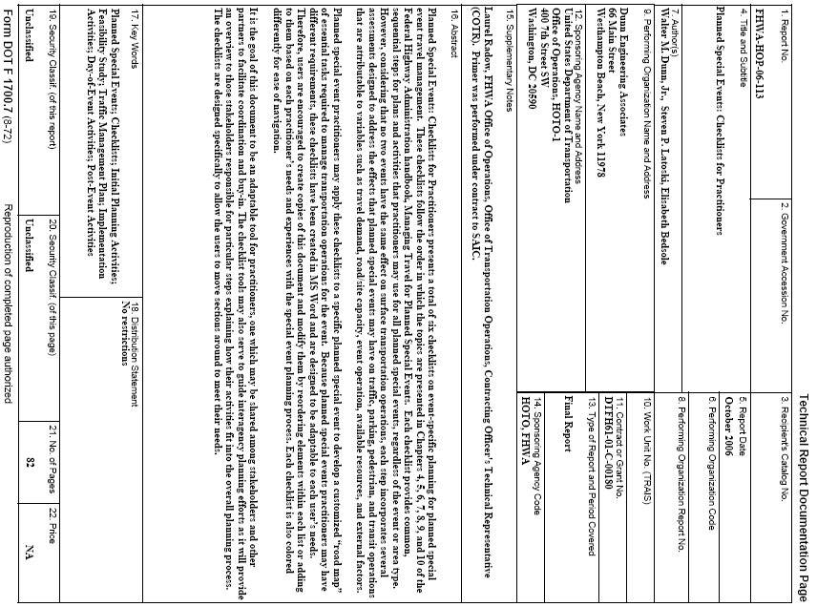
Planned Special Events: Checklists for Practitioners

Introduction

Planned Special Events: Checklists for Practitioners presents a total of six checklists on event-specific planning for planned special event travel management. These checklists follow the order in which the topics are presented in Chapters 4, 5, 6, 7, 8, 9, and 10 of the Federal Highway Administration handbook, Managing Travel for Planned Special Events. Each checklist provides common, sequential steps for plans and activities that practitioners may use for most significant planned special events, regardless of the event or area type. However, considering that no two events have the same effect on surface transportation operations, each step incorporates several assessments designed to address the effects that planned special events may have on traffic, parking, pedestrian, and transit operations that are attributable to variables such as travel demand, road/site capacity, event operation, available resources, and external factors.

Initial Planning Activities
Feasibility Study
Traffic Management Plan
Implementation Activities
Day-of-Event Activities
Post-Event Activities

Planned special event practitioners
may apply these checklists to a specific planned special event to develop a customized “road map” of essential tasks required to manage transportation operations for the event. Because planned special events practitioners may have different requirements, these checklists have been created in MS Word and are designed to be adaptable to each user’s needs. Therefore, users are encouraged to create copies of this document and modify them by reordering elements within each list or adding to them based on each practitioner’s needs and experiences with the special event planning process. Each checklist is also colored differently for ease of navigation.

It is the goal of this document to be an adaptable tool for practitioners, one which may be shared among stakeholders and other partners to facilitate coordination and buy-in. The checklist tools may also serve to guide interagency planning efforts as it will provide an overview to those stakeholders responsible for particular steps explaining how their activities fit into the overall planning process. The checklists are designed specifically to allow the users to move sections around to meet their needs. The checklists should not be considered mandates or standards but viewed as guidelines that indicate when in the process the item should be considered and addressed.

At the end of this document are three blank forms: a Contact List, a Resources List, and a Map List. These may be used to improve the coordination and comprehensiveness of the special events planning process.

Additional FHWA documents are available to help practitioners plan for special events, including:

- Managing Travel for Planned Special Events Handbook; Publication No. FHWA-OP-04-010, EDL Doc. #13883.
- Outreach Material
  - Brochure; Publication No. FHWA-OP-04-033, EDL Doc. #13903
  - Fact sheet; Publication No. FHWA-OP-04-034, EDL Doc. #13904
  - Technical presentation – available on the TMC Pooled-Fund Study website

These resources can be found at http://ops.fhwa.dot.gov/program_areas/sp-evnts-mgmt.htm.

Instructions

The checklists are provided in an MS Word format, so users may save copies of each file under a new name, thereby keeping a the original checklists in an unaltered state while using the renamed copies as working documents that can then be adapted to reflect each users’ particular needs.

To use a checklist, review each assessment under a particular step and insert a check next to the assessments that apply to the known planned special event scenario. The checklists provide the following guidance to users in determining whether a certain assessment applies to the subject event:

- “If Checked” column – defines potential action items to be addressed in the operations planning phase if the assessment applies to the planned special event.
- “Tips / Examples” column – clarifies the concept of the assessment and cites specific events and/or circumstances under which the assessment may more likely apply.

Practitioners have space available for recording notes on their review of each assessment. User notes may include documenting:
(1) What resources are needed – planning (the Resources List is available as a comprehensive compilation of needed resources.)
(2) When and how to act – operation
(3) Who is in charge – command
(4) Who will pay – finance.

These checklists have been designed to fit easily in a 3-ring binder, and are in an expandable format, allowing users to create more space by adding rows where needed, delete those that are not necessary to a particular event, or to reorder the assessments in any step to more effectively meet the needs of a specific event, locality, or user.

To add a row:
1. Place your cursor in the row above which you wish to add a row.
2. Select Table from the menu bar.
3. Select Insert.
4. Select Row Above.

If you wish to add a row at the end of a step section, place your cursor in the last cell of the section (e.g., at the end of step 2 but before step 3) and hit the Tab key. Another cell will automatically be added.

To move a row.
1. Place the cursor in the first cell of the row you wish to move.
2. Select Table from the menu bar.
3. Select Select.
4. Select Row.
5. Press Ctrl-x.
6. Place the cursor in the row below the place you wish the selected row to appear.
7. Press Ctrl-v.

Remember, by saving the original document under a new name, the original checklist is able to be copied again and again for use in planning future events. Or, once copied and adapted, use the modified version as the starting point for the planning phase of your next planned event if it more closely resembles your process than the base document.

If you would like to provide feedback or comments on this product, please provide them to OperationsFeedback@dot.gov.

Notice
This document is disseminated under the sponsorship of the Department of Transportation in the interest of information exchange. The United States Government assumes no liability for its contents or use thereof. This report does not constitute a standard, specification, or regulation.

The United States Government does not endorse products or manufacturers. Trade and manufacturers’ names appear in this report only because they are considered essential to the object of the document.

