Deployment of Maintenance Decision Support Systems (MDSS)
for Winter Operations

By

Paul A. Pisano
Federal Highway Administration
Road Weather Management Program
400 7th Street, S.W.
HOTO-1 Room 3408
Washington, D.C. 20590 USA
Voice: 202-366-1301
Fax: 202-366-3225
Paul.Pisano@fhwa.dot.gov

David L. Huft
State of South Dakota
Department of Transportation
Becker/Hanson Building
700 East Broadway Avenue
Pierre, SD, 57501 USA
Voice: 605-773-3358
Fax: 605-773-4713
Dave.Huft@state.sd.us

Andrew D. Stern
Mitretek Systems, Inc.
Oceanic, Atmospheric and Space Systems
3150 Fairview Park Drive South
Falls Church, Virginia 22042 USA
Voice: 703-610-1754
Fax: 703-610-1563
astern@mitretek.org

Corresponding Author: Paul A. Pisano
Submission Date: 15 December 2005
Word Count (text body): 3,525 + (6x250) = 5025

ABSTRACT

The art and science of road maintenance during adverse winter conditions has long been hampered by a lack of true integration of weather information into operations. Beginning in 1999, the Federal Highway Administration (FHWA) began to study this deficiency with its Surface Transportation Weather Decision Support Requirements (STWDSR) effort. The results clearly showed that road maintenance personnel desire better, more specific weather forecast information, which could improve the productivity and efficiency of winter maintenance practices and ultimately lead to improved mobility and a safer driving environment.
Beginning in 2000, the FHWA convened a team of national laboratories and created a stakeholder group of interested personnel from State Departments of Transportation (DOTs), private sector weather service providers and academia. With guidance from the stakeholder community, the laboratories combined state-of-the-art weather forecasting capabilities with computerized winter maintenance rules of practice. This was the genesis of the winter Maintenance Decision Support System (MDSS) prototype. This prototype underwent several development cycles and three seasons of field demonstrations and evaluations—two in Iowa and one in Colorado. By 2004, MDSS technologies were mature enough for interested private sector companies to begin to incorporate MDSS features into their product lines and begin to provide services to State DOTs. At this point, the FHWA MDSS effort transitioned from prototype enhancement to a focus on technology transfer to both the private sector and the states.
Based on the national MDSS effort, as well as related activities, a group of eight states (led by the South Dakota DOT) initiated a pooled-fund study in 2002 to develop and implement an operational version of MDSS for their agencies. The study has focused upon refinement, validation, and wide-scale deployment of sustainable MDSS technology, as demonstrated in a successful operational testing period over the 2004-2005 winter. Based on these complementary efforts, it is clear that the MDSS presents a valid and viable operational strategy, but not without its development and deployment challenges. This paper will detail strategies for the continued evolution of MDSS technologies into the marketplace as well as advancement of the state of the practice of winter maintenance. Details of the pooled-fund MDSS project will be presented as one success story of deployment.

INTRODUCTION

Managing winter maintenance activities is a complex endeavor. Ensuring that the plow blades are ready when the first flakes fall is only a small part of the task. Maintenance managers also must know the regulations about chemical applications and environmental impacts, and be able to analyze and make sense of multiple and often contradictory weather forecasts. Many maintenance managers also face tight budgets. When these factors come together, they test a public agency’s skill at meeting the traveling public’s high expectations for roads to be kept free of snow and ice. Thus, today’s maintenance managers require the ability to efficiently handle multiple tasks and process high volumes of information, or risk getting left behind in the onslaught of winter weather (1).

The Federal Highway Administration (FHWA) long recognized the challenges faced by maintenance managers (2). With the creation of the Road Weather Management Program in the late 1990s, the FHWA began to work on improving the kinds of information that were available for winter maintenance. At that time, weather forecasts were plentiful, and a few companies issued route-specific forecasts; however, there was no link between the available weather information and the decisions made by maintenance managers about winter road treatments (e.g., the best time to treat roads, and whether salting, plowing or a combination of approaches is most appropriate). It was this missing link that led to the genesis of the winter Maintenance Decision Support System (MDSS) project (3). The MDSS project was a collaboration between a diverse stakeholder group consisting of State Departments of Transportation (DOT) maintenance practitioners, five national laboratories, and the academic and private sector communities. The MDSS prototype project was funded and directed by the FHWA Road Weather Management Program with significant support from the Intelligent Transportation Systems Joint Program Office.

MDSS OVERVIEW

Figure 1 shows the data flow and major components of the FHWA MDSS prototype. Ten different numerical weather prediction models (top left, Figure 1) provide weather forecast prediction information into a data fusion module called the Road Weather Forecast System (RWFS). The RWFS (top right, Figure 1) also receives surface meteorological observations (METARS) from National Weather Service (NWS) and Federal Aviation Administration (FAA) airport sites. The system ingests both atmospheric and pavement data from State DOT Environmental Sensor Stations (ESS) that are deployed along many roads. Algorithms within the RWFS component then process the information and provide one set of forecast outputs that can be used in the Road Condition and Treatment Module (RCTM).
The RCTM (lower right, Figure 1) contains algorithms that focus on the state of the road surface. These include models for road temperature prediction, snow accumulation, road and bridge frost probability, blowing snow probability, and chemical concentration and dilution. These routines then provide input into the rules of practice algorithm for anti-icing and deicing. The resultant output consists of route-specific forecasts of weather, road conditions and treatment recommendations. Most of these can be seen in the MDSS graphical user interface (GUI) (lower left, Figure 1).
The layout of the main GUI of the FHWA MDSS prototype (Figure 2) was approved by a committee of State DOT maintenance practitioners. It was developed so that maintenance personnel would be able to quickly peruse the screen and determine if there were any weather hazards forecast in their area.
The top left portion of the GUI (in Figure 2) contains the alert status window. This window uses easily distinguished color-coded bars to alert users if there are forecast hazards due to weather, deteriorating road conditions, blowing snow or road frost. The middle left window allows the operator to select different observations or forecasts. These values can be displayed on the main GUI window. The bottom of the GUI provides a time scale controller to allow for animating forecast data in the main GUI screen. There are also color coded bars that show which hours specific routes could be affected by road frost or blowing snow. The main display screen provides high resolution topographical backgrounds along with displayed observed and forecast information.
One innovative module that was developed for the MDSS prototype was called the “what-if” generator (Figure 3). This capability allows an operator to modify the timing, chemical type or application rate on any of the routes to see how the changes might affect the treatments or forecast road condition. In the example shown in Figure 3, the total number of plowing and chemical application passes was decreased (from 4 to 3). In addition the amount of applied chemical was reduced (from 200 to 100 pounds per lane mile). The resulting alternative set of inputs (as shown with a dark blue trace on the graph) shows that snow will begin to accumulate on the route. The green trace shows the snowfall accumulation rate if no treatments were made.
The MDSS is a complex amalgam of computer hardware and algorithms. As such, it is unlikely that many (if any) State DOTs have the expertise or desire to own or operate an entire MDSS. It is more likely that states interested in MDSS capabilities will contract with a private sector weather service provider so that only display software would need to reside in DOT maintenance facilities. For this reason, numerous private sector weather service providers have been encouraged to participate and have been engaged in the stakeholder group to develop the MDSS prototype. The intent is to get as many companies involved as possible, and provide to them the prototype software, thereby making deployment as fair and seamless as possible.
The MDSS prototype was demonstrated and evaluated over three winter seasons in Iowa and Colorado (4). While there are still scientific challenges to be overcome in both weather forecasting and understanding the complexities of winter road conditions, the MDSS project has been quite successful in bringing the winter maintenance and weather communities closer together and to help seed the weather service industry with new advancements.

FOCUS ON DEPLOYMENT

The FHWA has invested several years in funding and guiding the development of the MDSS prototype. However, the success of the program was not accomplished in a vacuum. A stakeholder group gathered at least annually during the multi-year requirements gathering and system development process. This group was used as a sounding board at each step and played a significant role in the GUI design and the selection of the type of forecast elements that were to be available to the end users. This stakeholder process also provided buy-in and involvement from the private sector. The ultimate deployment of MDSS will depend on the private sector recognizing that there is a market for these capabilities and that integrating (some or all) modules into their product lines is worth their investment.
By the end of 2005, FHWA had sponsored seven MDSS stakeholder meetings with interest and attendance continuing to climb with each. Figure 4 shows that from 2000 through 2005, 37 U.S. States (73%) participated in one or more MDSS stakeholder meetings. Oregon is shaded in brown because they have shown an interest in MDSS technologies but could not attend the meetings.
The MDSS deployment strategy, however, goes beyond just annual meetings. FHWA has a multi-faceted program to educate and promote deployment of MDSS technologies. The following sections highlight these strategies.

Technology Transfer

FHWA has established a multi-tiered technology transfer program for the deployment of MDSS technologies. Technical guidance is geared towards the two key stakeholder groups of State DOTs and private sector weather service providers. For the State DOTs, the focus is on procurement of MDSS, and for the weather service providers, the focus is on technical implementation of the software. All MDSS prototype software has been made available at no cost. This includes all of the source code for the treatment algorithms, the numerical weather models and the Java-based GUI. The RWFS data fusion module is licensed to the National Center for Atmospheric Research (NCAR). However, they are making the object code available for free use for a year to allow interested parties to test and evaluate the entire package. Registration to receive the latest MDSS prototype software can be obtained at:
www.rap.ucar.edu/projects/rdwx_mdss/release3/.
During the summer of 2004, FHWA sponsored a full day technology transfer workshop that allowed all interested parties to obtain copies of the latest software. Engineers and scientists that developed the system gave seminars and were available to answer questions. FHWA also funded NCAR to provide telephone support to any party that had procurement, installation or operating questions about the MDSS prototype software.

Outreach and Education

Staff from FHWA’s Road Weather Management program and scientists from NCAR have provided dozens of presentations and published numerous papers and articles on the development, evaluation and deployment of MDSS technologies. Some of the more well known organizations where MDSS presentations have been made include:

- Transportation Research Board (TRB)
- American Meteorological Society (AMS)
- Intelligent Transportation Society of America
- Institute of Transportation Engineers (ITE)
- Standing International Road Weather Commission (SIRWEC)
- World Road Association (PIARC)
- American Public Works Association (APWA)
- Canadian Meteorological and Oceanographic Society (CMOS)

During the spring of 2004, FHWA co-sponsored the filming of a 30-minute television program with The Weather Channel. The segment, called Road Risk, visually depicted the dangers of driving in wet, snowy and icy conditions. Digital Video Disks (DVDs) of the program can be obtained from the FHWA Road Weather Management web site at www.fhwa.dot.gov/weather/.
NCAR continues to maintain a website which serves as the main repository for MDSS prototype presentations and documentation. The site contains technical descriptions of the software, summaries from the stakeholder meetings and tutorials on how to use the MDSS prototype GUI. The address for this site is www.rap.ucar.edu/projects/rdwx_mdss/.
Finally, FHWA has created a one-page flyer that provides background information, shows highlights of the MDSS prototype GUI and provides a list of potential benefits of using MDSS technologies. The MDSS flyer can be downloaded from the FHWA Road Weather Management web site.

Supporting Documentation

Several State DOTs have already begun to include requirements for MDSS functionality into their weather support contracts. To assist states in understanding what new technologies may be on the horizon and to help them understand how to incorporate the requirements for new technologies into their request for proposals (RFPs), FHWA’s Road Weather Management program can provide technical assistance. NCAR has also created a document that provides a template for creating a MDSS-centric RFP. This document is available from
www.rap.ucar.edu/projects/rdwx_mdss/documents/MDSS_Procurement_Template27Nov04.pdf.
In an effort to capture the state-of-the-art in weather forecasting and future trends, NCAR has also created the document “Road Weather Forecasting and Observations: Assessment of Current Capabilities and Future Trends.” This document is available from
www.rap.ucar.edu/projects/rdwx_mdss/documents/Weather_Observation_Prediction_Capability_Assessment_10Dec04.pdf.

DEPLOYMENT EXAMPLE – THE SOUTH DAKOTA POOLED FUND PROJECT

It took only until 2002 for several states to realize that technologies such as the MDSS may be a good investment. As the expectations for road mobility continued to rise by the traveling public and commercial carriers, State DOTs continued to be constrained by both funding and staffing. A core group of five states pooled funds to begin development of an operational MDSS.
The pioneering group of states in the Pooled-Fund (PF) effort included South Dakota (as the lead state), Indiana, Iowa, Minnesota, and North Dakota. During 2005, three additional states – Colorado, Kansas and Wyoming - joined the pool. The states along with their contractor, Meridian Environmental Technology, had as their goal to build and evaluate an operational and sustainable MDSS to improve the ability to forecast road conditions in response to changing weather and applied maintenance treatments.
The essential elements of the PF MDSS include (5):

- Reporting actual road surface conditions
- Reporting actual maintenance treatments
- Assessing past and present weather conditions
- Assessing the present state of the roadway
- Predicting storm-event weather
- Recognizing resource constraints
- Identifying feasible maintenance treatments
- Predicting road surface behavior
- Communicating recommendations to supervisors and workers

To realize these essential elements, the PF team not only had to build upon the foundational work completed in the FHWA MDSS prototype, but expands upon it by adding new innovations. This included equipping snowplows with Geographic Positioning Systems (GPS) Automated Vehicle Location (AVL) devices that are capable of reporting weather conditions and equipment status (e.g., plow blade position). The goal was to be able to obtain in near real-time, the location of each truck, the plow blade position, the chemical application rate and the types of materials used. There were also other challenges such as communicating the state of the road surface (e.g., snow depth) into an automated system.
Like the FHWA MDSS prototype, the PF MDSS used a series of weather models and a pavement model that provided forecast guidance on elements such as pavement temperature, pavement chemical concentration, pavement moisture types and depths. However, unlike the FHWA MDSS prototype, the PF MDSS predicts road conditions and recommends maintenance treatments on the basis of physical modeling, rather than rules of practice. The PF MDSS added radar data, near term (tactical, under 6 hour) forecast support, and the provision for meteorologist intervention in the weather forecast process. Also different in the PF MDSS is the capability for the operator to select either an ‘optimal’ treatment recommendation (e.g., safety first, cost considerations second), or a ‘standard’ treatment based solely on local maintenance practices. Finally, similar to the prototype, the PF MDSS has a ‘what-if’ capability to allow the user to try any number of alternative maintenance actions and see the resulting forecast effects on the road surface (6).
Figure 5 shows an example of the PF MDSS main display with radar data overlaid on a highway map. The different colors represent precipitation phase (liquid, freezing, and frozen). The box in the center of the screen shows an observation from a snowplow with GPS/AVL equipment reporting location, weather and road conditions.
Figure 6 provides an example of the PF MDSS forecast and treatment recommendation screen. Through the use of graphical visualization, the series of tables shows probabilities of precipitation, snow accumulations, precipitation types, forecast road conditions, treatment recommendations and forecast road temperatures.

NEXT STEPS FOR MDSS

The FHWA MDSS prototype continued its limited deployment in Colorado during the winter of 2005-2006 where there is continued evaluation of how the system operates in complex terrain. This was sponsored by the E-470 Public Highway Authority and the City and County of Denver, Colorado. The PF MDSS was also undergoing field trials during the winter of 2005-2006 in the eight pooled fund states. Once an evaluation is completed, full deployment is expected in 2006 and 2007.
During the 2005-2006 and 2006-2007 winter seasons, the participants in the PF MDSS project plan to expand field trials to include more locations in the eight participating states and more extensive use of vehicles equipped with on-board instrumentation and AVL. The project will include validation of forecasts of weather, road conditions, and treatment effectiveness, as well as refinement of physical models and software. Finally, the project will address issues relating to statewide deployment, including operational environments, business models, and linkages to other state information systems. The ultimate goal of the project is to provide a sustainable, fully functional, and easily scalable MDSS to support the needs of transportation agencies.
FHWA will continue to actively promote the deployment of MDSS throughout 2006 and beyond, including further efforts pertaining to all the technology transfer items described above, as well as possible field evaluations. In addition, FHWA is planning on sponsoring a MDSS stakeholder meeting in late summer/early fall 2006. Updates on both programs as well as new deployment initiatives will be discussed. It’s clear that deployment of such a complex system takes time. State DOTs must be confident that the services provided by the private sector work as they should and reap benefits. Private sector providers must have the technical wherewithal to provide the services, and know that their investments will be profitable. While there’s every reason to think that both sets of needs can be met, it will still take time to get there.

CONCLUSION

In an effort to create a link between the winter road maintenance and meteorological communities, the FHWA has directed and funded a multi-faceted campaign to both develop a MDSS and to provide technology transfer support and outreach so that the greater community understands and embraces these technologies. The FHWA will be able to claim success in this endeavor if State DOT agencies create a market for these advanced technologies and the private sector moves to integrate these capabilities into their product lines.
A significant step has already been taken by a group of eight State DOTs as they have pooled their resources to develop a customized MDSS for their agencies. FHWA continues to provide technology transfer support and educational outreach activities to assist all parties in understanding and nurturing this concept into reality. The benefits to everyone in the success of this project are safer roads, more efficient use of resources and more targeted (reduced) use of chemicals.

REFERENCES

1. Pisano, P.A., A.D. Stern, and W.P. Mahoney. The U.S. Federal Highway Administration Winter Road Maintenance Decision Support System (MDSS) Project: Overview and Results. American Meteorological Society Preprint, the 21st International Conference on Interactive Information Processing Systems (IIPS), San Diego, CA, 2005, Paper 6.5.

2. Mahoney, W.P., B. Bernstein, J. Wolff, S. Linden, W. Myers, R. Hallowell, J. Cowie, A. Stern, G. Koenig, G. Phetteplace, P. Schultz, P. Pisano, and D. Burkheimer. The Federal Highway Administration’s Maintenance Decision Support System Project: Summary Results and Recommendations, Transportation Research Record, Journal of the Transportation Research Board, National Research Council, Washington, D.C., publication Spring 2005.

3. Mahoney, W.P. and W. Myers. Predicting Weather and Road Conditions: Integrated Decision Support Tool for Winter Maintenance Operations. Transportation Research Record, Journal of the Transportation Research Board, No. 1824, TRB, National Research Council, Washington, D.C., 2003, pp. 98−105.

4. The Maintenance Decision Support System (MDSS) Project Technical Performance Assessment Report, Colorado Field Demonstration Winter 2004-2005, version 1.0, National Center for Atmospheric Research, Boulder, CO, September 2005.

5. David L. Huft, Maintenance Decision Support System Pooled Fund Study TPF-5(054), presentation made to the MDSS Stakeholder Meeting on 10/20/05 in Boulder, CO,
www.rap.ucar.edu/projects/rdwx_mdss/plans_reviews/Sess3-MDSS_for_Stakeholders_Huft2_talk3.pps

6. Mewes, J, R Hart, L. Osborne and B. Podoll, The Pooled Fund Study Maintenance Decision Support System: A Functional Overview. American Meteorological Society Preprint, the 21st International Conference on Interactive Information Processing Systems (IIPS), San Diego, CA, 2005, Paper 6.6

LIST OF FIGURES

FIGURE 1. MDSS functional structure (data and process flow). Ten different weather models and sources of observations feed into the Road Weather Forecast System (RWFS). The RWFS integrates and processes each set of data and provides optimized forecast elements to the Road Condition and Treatment Module (RCTM). The RCTM contains algorithms for road temperature prediction, chemical concentration and the rules of practice for anti and de-icing. The resulting forecast information and treatment recommendations flow to the user displays.

FIGURE 2. MDSS prototype Graphical User Interface (GUI). The GUI consists of several distinct sections that are optimized for the maintenance manager. The alert screen (top left) shows color coded bars representing forecasts of weather and road condition. There are also indicators for blowing snow and bridge frost potential. The weather selection box (center left) provides the ability to display many observed and forecast fields. The animation control box (bottom) allows the user to change forecast times and to create an animation of forecast parameters. The main display (top right) provides high resolution topographic backgrounds and graphics depicting observed data and forecasts.

FIGURE 3. The MDSS ‘what-if’ Scenario treatment selector. This ‘what-if’ selector is provided with the MDSS prototype system. It provides a way for the operators to provide alternative treatment strategies including using different chemicals, application rates and times. The result is provided as a time series (top) that shows the consequences of deviating from the recommended parameters. This capability can be used to work around scheduling conflicts or to test and see if changing the application strategy would still produce acceptable mobility on roads.

FIGURE 4. Total MDSS stakeholder participation 2000-2005. Thirty seven states participated in at least one MDSS activity during the system development years of 2000-2005.

FIGURE 5. The Pooled Fund (PF) MDSS main display. The PF version of the MDSS GUI not only provides high resolution backgrounds and observations but also provides data from mobile observations and color-coded weather radar.

Figure 6. The PF MDSS forecast treatment recommendation screen. Like the prototype MDSS display, the PF version provides advanced visualization graphics on precipitation type and accumulation, road temperature forecasts and treatment recommendations specifically tailored for winter maintenance personnel.

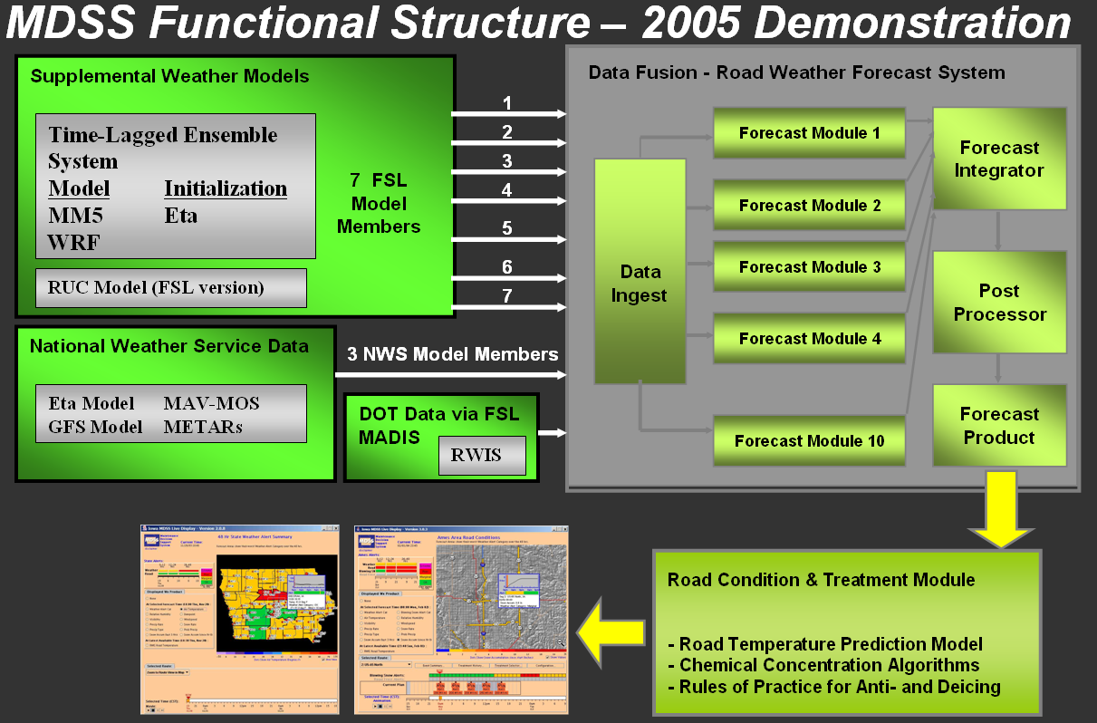
Figure 1 – MDSS functional structure (data and process flow). Ten different weather models and sources of observations feed into the Road Weather Forecast System (RWFS). The RWFS integrates and processes each set of data and provides optimized forecast elements to the Road Condition and Treatment Module (RCTM). The RCTM contains algorithms for road temperature prediction, chemical concentration and the rules of practice for anti and de-icing. The resulting forecast information and treatment recommendations flow to the user displays.

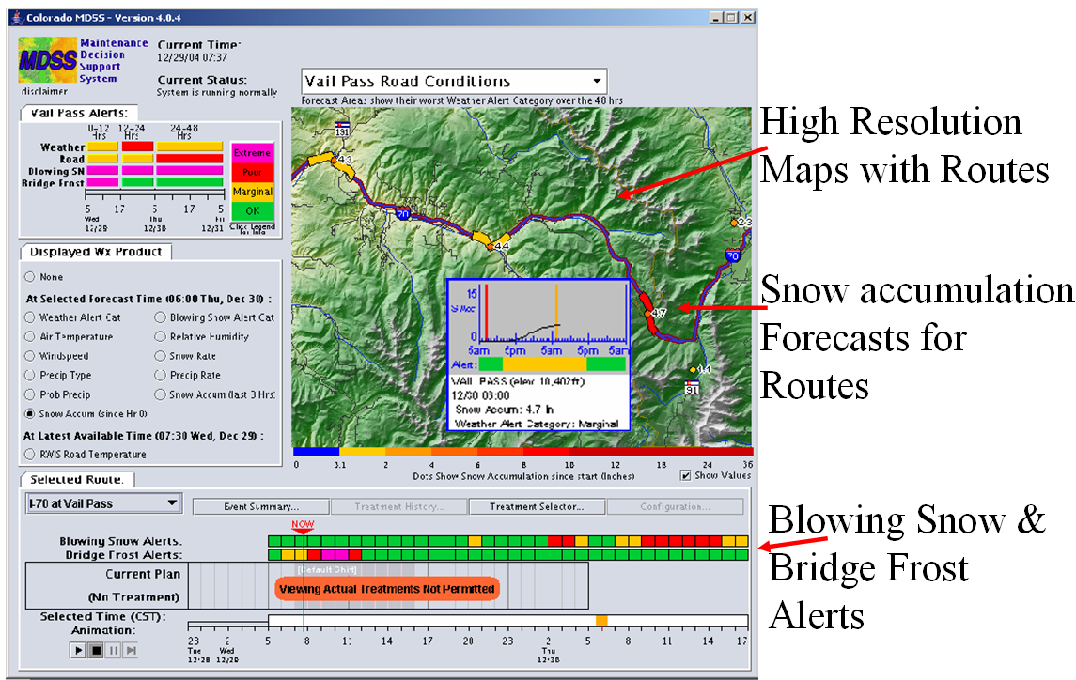
Figure 2 – MDSS prototype Graphical User Interface (GUI). The GUI consists of several distinct sections that are optimized for the maintenance manager. The alert screen (top left) shows color coded bars representing forecasts of weather and road condition. There are also indicators for blowing snow and bridge frost potential. The weather selection box (center left) provides the ability to display many observed and forecast fields. The animation control box (bottom) allows the user to change forecast times and to create an animation of forecast parameters. The main display (top right) provides high resolution topographic backgrounds and graphics depicting observed data and forecasts.

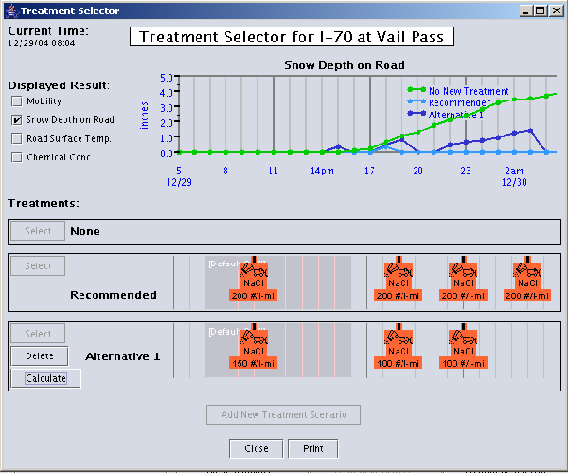
Figure 3 – The MDSS ‘what-if’ Scenario treatment selector. This ‘what-if’ selector is provided with the MDSS prototype system. It provides a way for the operators to provide alternative treatment strategies including using different chemicals, application rates and times. The result is provided as a time series (top) that shows the consequences of deviating from the recommended parameters. This capability can be used to work around scheduling conflicts or to test and see if changing the application strategy would still produce acceptable mobility on roads.

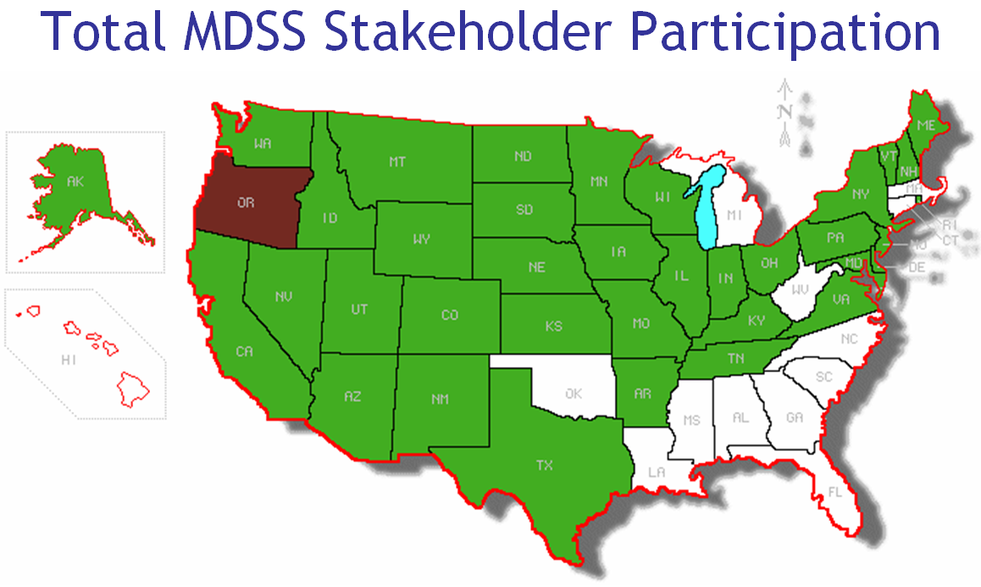
Figure 4 – Thirty seven states participated in at least one MDSS activity during the system development years of 2000-2005.

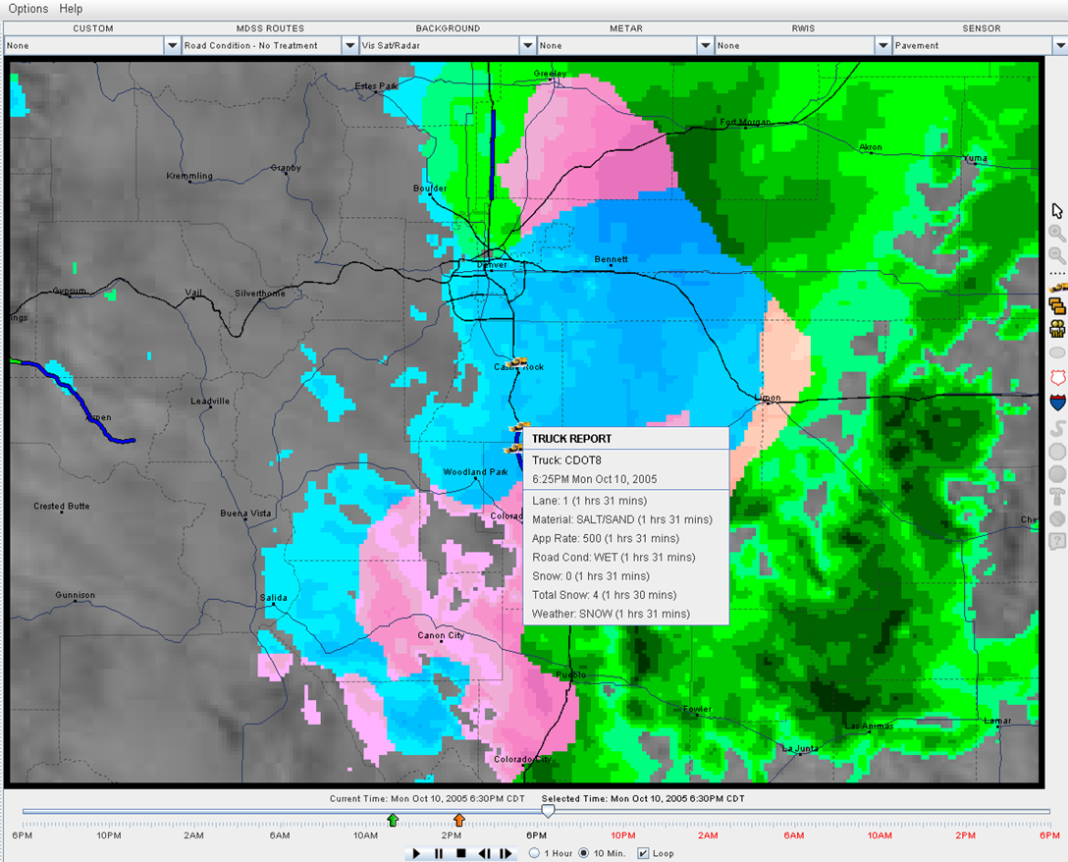
Figure 5 – The Pooled Fund (PF) MDSS main display. The PF version of the MDSS GUI not only provides high resolution backgrounds and observations but also provides data from mobile observations and color-coded weather radar.

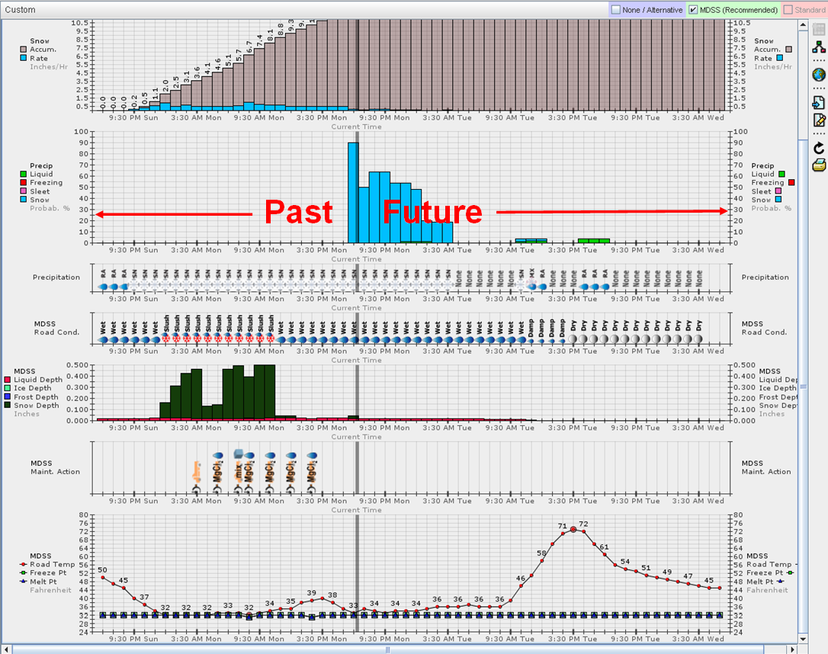
Figure 6 – The PF MDSS forecast treatment recommendation screen. Like the prototype MDSS display, the PF version provides advanced visualization graphics on precipitation type and accumulation, road temperature forecasts and treatment recommendations specifically tailored for winter maintenance personnel.

