The U.S. Federal Highway Administration
Winter Road Maintenance Decision Support System (MDSS) Project: Overview and Results

W. Mahoney III & W. Myers
National Center for Atmospheric Research
Boulder, Colorado USA
E-mail: Mahoney@ucar.edu
E-mail: myers@ucar.edu

P. Pisano
Federal Highway Administration
Washington, D.C. USA
E-mail: paul.pisano@fhwa.dot.gov

R. Hallowell
MIT Lincoln Laboratory
Lexington, Massachusetts USA
E-mail: bobh@ll.mit.edu

A. Stern
Mitretek Systems
Falls Church, Virginia USA
astern@mitretek.org

The Maintenance Decision Support System (MDSS) project was initiated in 1999 by the U.S. Federal Highway Administration (FHWA) Office of Transportation Operations Road Weather Management (RWM) Program. The MDSS capabilities were designed based on feedback received by the FHWA in 2001 from maintenance managers at a number of State Departments of Transportation (DOTs) as part of an initiative to capture surface transportation weather decision support requirements.

The MDSS project goal is to seed the implementation of advanced decision support services provided by the private sector for state DOTs. This has been achieved by developing core software capabilities that serve as a basis for these tailored products.

After the 2001 user needs assessment was completed, the MDSS program was extended with the objective of developing and demonstrating a functional prototype MDSS. Field demonstrations of the prototype MDSS were conducted in Iowa between February and April 2003, and during the winter of 2004. Additional field tests were conducted during the winter of 2004-2005 in Colorado.

The performance of the prototype MDSS improved during each of the successive field demonstrations. The weather and road condition predictions and treatment recommendations generated by the system were increasingly more accurate as the development effort moved forward. Iowa garage supervisors actively considered the treatment guidance and on occasion they successfully used the recommended treatments without modification.

This paper describes the status of the MDSS project, results and lessons learned from the Iowa field demonstrations, and future development efforts.

KEY WORDS: WINTER MAINTENANCE, DECISION SUPPORT, SNOW, ICE

1. Introduction

With tight budgets and the high expectation of the public for keeping roads clear of snow and ice, today’s maintenance snow and ice manager must be able to handle multiple tasks or risk falling behind the onslaught of winter weather. While good information leads to effective practices, all of the regulations concerning chemical applications, environmental impacts and multiple, often contradictory, weather forecasts can lead to information overload.

The FHWA recognized this potential problem in the late 1990’s as part of its RWM program. Weather forecasts were plentiful and a few companies issued road-specific forecasts, but there was a lack of linkage between the information available and the decisions made by winter maintenance managers. It was this gap between meteorology and surface transportation that became the genesis for the winter MDSS (1).

Since 1999, the MDSS has evolved into a functional prototype system. During the winter of 2002−2003, the prototype was deployed at several maintenance garages in central Iowa for an initial field demonstration. A second, more comprehensive field demonstration was conducted during the winter of 2003−2004. The prototype was moved to Colorado in 2005 to assess its capabilities in complex terrain.

2. PROJECT Organization

The MDSS is a research project that is funded and administered by the FHWA RWM program. A consortium of five national laboratories in coordination with state DOTs, academia, and the private sector have participated in the development and implementation of the project. These laboratories include:

- Cold Regions Research and Engineering Laboratory (CRREL)
- National Center for Atmospheric Research (NCAR)
- Massachusetts Institute of Technology/Lincoln Laboratory (MIT/LL)
- National Oceanic and Atmospheric Administration (NOAA) Forecast Systems Laboratory (FSL)
- NOAA National Severe Storms Laboratory (NSSL)

The MDSS project integrates state-of-the-art weather forecasting, data fusion, and optimization techniques with computerized winter road maintenance Rules of Practice (RoP) logic. The result is guidance aimed at maintenance managers that provides a specific forecast of surface conditions and treatment recommendations customized for individual plow routes. The MDSS project has several goals:

- Demonstrate to the state DOTs that new technologies are available to assist maintenance managers with maintaining safety and mobility on roadways and provide for more efficient use of chemicals, equipment and staff.
- Show the private sector road weather providers that there is a market for these new technologies. To aid this process, the FHWA is providing the core MDSS modules to any company or organization using an aggressive technology transfer process with the expectation that the MDSS technologies will become commercialized.

Success, as defined by the FHWA, will be reached when private sector companies integrate MDSS components or similar functions into their products and state DOTs purchase these new services. Both of these activities have already begun. In the end, the project will serve to raise the bar on standards for services provided by the private road weather forecasting industry. This cycle has the potential to make state DOT operations more efficient and road conditions safer.

3. Prototype System Overview

Each national laboratory brings unique capabilities and expertise to the project. CRREL has experience in creating models for predicting road surface temperature. MIT/LL concentrates on translating the road maintenance RoP into computer algorithms. FSL provides high resolution weather models. NSSL contributed algorithms for determining precipitation type (e.g., rain, ice, snow) in weather models. NCAR is the lead laboratory providing the core data processing capability, the graphical user display, and the engineering to integrate all of the disparate parts into a complete, working prototype.

Figure 1 shows a high-level flow diagram for the MDSS functional prototype that was used in the winter 2003−2004 demonstration. The top box in the left column represents data received from the U.S. National Weather Service (NWS) National Centers for Environmental Prediction (NCEP). These data include surface observations, statistical guidance products, daily weather summaries, and numerical weather prediction model output from national scale numerical weather prediction models called Eta and Global Forecast System (GFS).

Figure 1 - High-level flow diagram of the prototype Maintenance Decision Support System (MDSS) as configured for the winter 2003−2004 Iowa field demonstration.
RWIS Data

NOAA/FSL (Boulder, CO)

Supplemental Numerical Weather Prediction Models
RWIS Data
MADIS

NCAR (Boulder, CO)

NOAA/NWS

Numerical Weather Prediction Models
Surface Observations
Model Statistics

Iowa DOT Data

RWIS
Road characteristics
Route characteristics

Iowa DOT Ames Garage

PC Java Application
Iowa DOT Des Moines West Garage

PC Java Application
Iowa DOT Des Moines North Garage

PC Java Application
Road Weather Forecast System

Road Condition and Treatment Module

Data Server

The NWS models were supplemented by high-resolution models run by NOAA FSL. These models were the NCAR/Penn State Mesoscale Model 5 (MM5) and the Weather and Research Forecasting (WRF) model. The fine-scale models had a grid spacing of 12 km. In order to provide diversity into the data fusion module, FSL used the NWS Eta model to provide lateral boundary conditions to initialize each model. For the 2004 field demonstration, the FSL models were run hourly generating 15 hour forecasts.

Differing from the NWS models, the FSL models used a new initialization routine to add realistic distributions of moisture and clouds to the model atmosphere. This method, called “hot-start,” allows the models to begin with a much better representation of clouds and precipitation (2). The anticipated benefit of the hot start process is a more accurate prediction, particularly in the first six hours of the forecast cycle.

Forecast output from the models, plus surface observations from state DOT road weather information systems (RWIS) were forwarded to NCAR’s data fusion engine called the Road Weather Forecast System (RWFS). The RWIS data were obtained from the Iowa DOT server and ingested into the NOAA/FSL Meteorological Assimilation Data Ingest System (MADIS) where they were quality controlled and disseminated. The RWFS module uses a fuzzy-logic ensembling scheme that has the ability to generate more accurate forecasts than any one individual model input by optimizing the blend of predictors based on recent skill (3,4).

Specialized components such as the road temperature forecast module and the road condition and treatment module (RCTM) use the weather model outputs to generate temperature forecasts for the state and condition of the road surface as well as guidance for chemical concentration and dilution rates.

The final module in the system contains the RoP algorithms. The RoP are customized rules and techniques that are used at DOT maintenance garages for maintaining mobility during winter conditions. These rules tend to be different for each state and in many cases are different for each garage. Hence, this module has the ability to customize many of its inputs so that it can be portable between garages. Treatment recommendations include the following information:

- Recommended treatment plan such as plow only, chemical use, and abrasives
- Recommended chemical amount (e.g., pounds per lane mile)
- Timing of initial and subsequent treatments
- Indication of the need to pre-treat or post-treat the roads

Figure 2 is an example from the MDSS prototype route view page. The top left panel shows an alert summary table with color-coded bars displaying forecasted weather and road condition alerts for the next 48 hours. The panel at the left center provides access for displaying predicted weather parameters and measured road temperatures. The bottom section controls forecast time selection and animation. Forecasts are generated for locations that routinely provide observations (e.g., airports, NWS reporting sites, and road weather observations stations) and along each plow route using interpolation techniques. Moving a cursor over any point brings up a time series graph of the selected forecast parameter plus additional site specific details. Actual treatments selected by the user are shown in the bottom center along with blowing snow alerts.

The MDSS contains a “what-if” scenario treatment selector. This means that the operator is able to modify the recommended treatment times, chemical types or application rates, and see how the road condition predictions change.

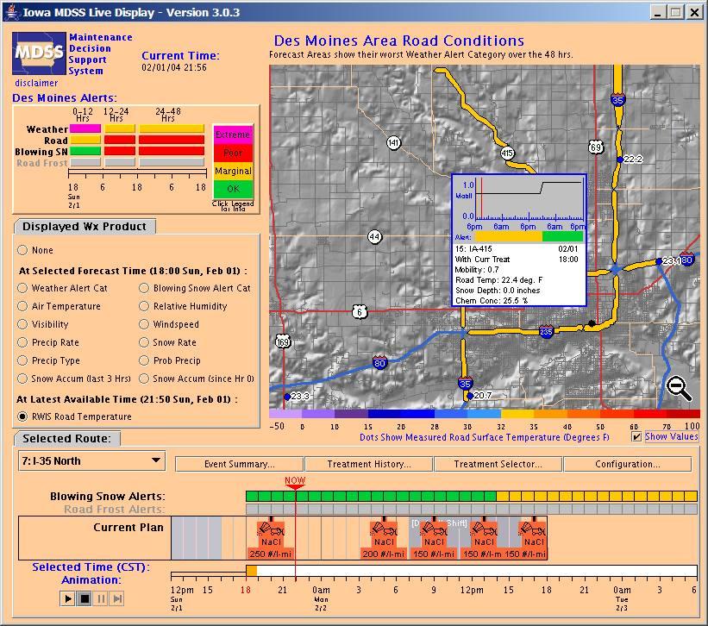

Figure 2 - Des Moines area MDSS plow routes and forecast points. Users can view the weather and road condition alerts and information for each route as well as the current treatment plan. In addition, users can select to view the recommended treatments and treatment history.

An example of the MDSS treatment selector for US 30 in Iowa on 2 February 2004 is shown in Figure 3. This provides the user with an indication of the mobility, snow depth on the road, road surface temperature and chemical concentration for various treatment scenarios. The lower part of the screen shows the recommended treatment plan and the current plan chosen by the Ames, Iowa garage supervisor. In this example, the recommended and current plan includes a plowing treatment followed by applications of salt (NaCl).

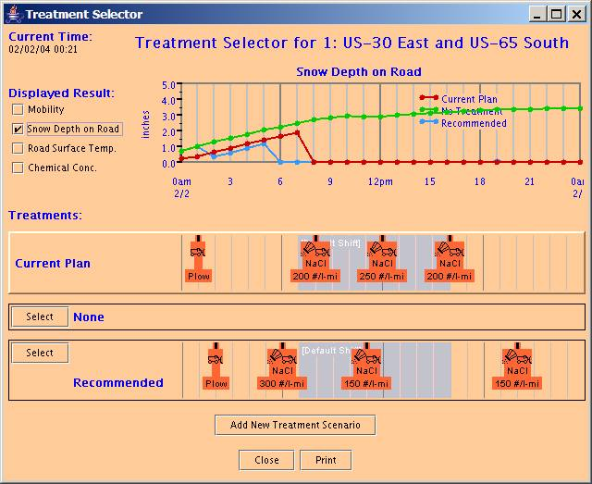

Figure 3 - Sample image of the MDSS treatment selector screen. The traces (top window) show the predicted snow depth on the road for various treatment scenarios (e.g., no treatment, recommended treatment, and current treatment plan). The lower part of the screen shows the recommended treatment plan and the current plan chosen by the Ames, Iowa garage supervisor.

4. Field Demonstration RESULTS

During the summer of 2002, six states competed to win the opportunity to host the MDSS project. While there were several very good candidates, Iowa DOT was selected. Determining factors included the climatological frequency of snow and ice events, their progressive maintenance programs, the availability of high-speed communications and computers at maintenance garages, and a willingness of DOT personnel to participate in training and verification activities. Iowa was also surrounded by a dense network of surface observations and did not have complex terrain. In all, 15 plow routes and 3 maintenance garages around Des Moines and Ames, Iowa were selected to participate in the demonstration.

The first MDSS demonstration was quite valuable as it gave the development team first hand observations of winter maintenance operations. While the demonstration was a success because the prototype was deployed and utilized by several state DOT maintenance personnel, a long list of lessons learned was compiled (5). Some of the more important lessons included:

- The MDSS requires highly specific forecasts of precipitation type, amount, start time, and duration. However, there were numerous occurrences of light precipitation that were not captured by the numerical models. It was found that numerous, short-lived, light precipitation events could produce significant problems on roads because drivers and maintenance crews alike were often caught off guard. It was determined that such accurate predictions of small-scale precipitation events push current limits of predictability.
- The RoP module needed additional development to handle a wider variety of weather and road condition scenarios and treatment responses.
- The availability and quality of observed real-time precipitation rate and accumulation data are very poor for snow and ice. State DOT RWIS sites do not have heated precipitation gauges making them useless for measuring freezing and frozen precipitation amounts. The lack of accurate precipitation ground truth data prevents the use of the dynamic weighting schemes and forward correcting algorithms in the RWFS.

The second field demonstration that took place in central Iowa from December 29, 2003 through March 24, 2004 (6). Improvements made prior to the second field demonstration are described below.

4.1 Road Condition and Treatment Module (RCTM) Enhancements

The RCTM is the module that receives weather forecast and observations as input and generates road condition forecasts and treatment guidance. The RCTM encompasses several algorithms such as the RoP module and the road temperature forecast model.

The RoP module was significantly enhanced to recognize the overall storm situation. This new logic allowed the algorithm to handle changing weather situations predicted several hours into the future as the storm evolved.

In the absence of a more sophisticated solution, a blowing snow potential alert was created for the maintenance managers. This alert was designed to indicate when snow was likely to blow across roads (from the surface to approximately 1 meter above the surface) and it was based on precipitation type, snowfall history, snowfall rate, air temperature and wind speed. Also taken into account was the occurrence of any other precipitation types (such as rain) that may have fallen since the last snowfall.

4.2 Road Weather Forecast System (RWFS) Enhancements

The RWFS is the weather data fusion component of the prototype MDSS. It ingests several types of weather data including observations, model output and statistical data and uses ensemble and data optimization techniques to generate forecast parameters for the RCTM modules.

The RWFS was configured to utilize and integrate ten different forecast modules for the winter 2003-2004 demonstration. Models that were ingested into the RWFS included the Eta, GFS, MM5, Rapid Update Cycle (RUC), and WRF. MM5 and WRF were initialized using the NWS Eta model for boundary conditions and was run hourly. MM5 and WRF forecasts from the current run and previous two runs (valid at the same time) were utilized. Aviation model Model Output Statistics (MAVMOS) were also used as input, and Dynamic Model Output Statistics (DMOS) were calculated within the RWFS for each of the model inputs. Other improvements to RWFS included adding probabilistic forecast information for selected fields, such as the conditional probability of precipitation type as shown in Figure 4, and forward error correction to adjust predictions to better match observations when the forecast time is the current time.

4.3 Mesoscale Model Enhancements

An evaluation was conducted to compare the forecast accuracy of the mesoscale models used in the first demonstration. The results indicated that two of the three models (MM5 and WRF) had more skillful precipitation results. These models were also used in the second demonstration. However, because the method used to create a diversity of forecast output was not optimal, the ensemble technique was altered. For the second demonstration, rather than running six different combinations of models every three hours, a time-lagged ensemble technique was used. This method had the mesoscale models running with new data every hour. Then, every three hours the RWFS would accept forecast data from the current hour, the previous hour, and the hour before that as input from the mesoscale model ensemble. This method was also selected to reduce forecast inconsistencies that would sometimes occur as the models would alternate from one solution to another.

4.4 MDSS Graphical User Interface (GUI) Enhancements

An event summary page (see Figure 4) was developed to provide a “quick-look” summary of weather and road variables for each forecast period and for each plow route. The summary page included maximum and minimum predicted air and road temperatures, total new snow accumulation on the roadway, and an indication of the conditional probability of precipitation type, which is the probability of a certain precipitation type (e.g., rain, snow or ice) should any precipitation occur.

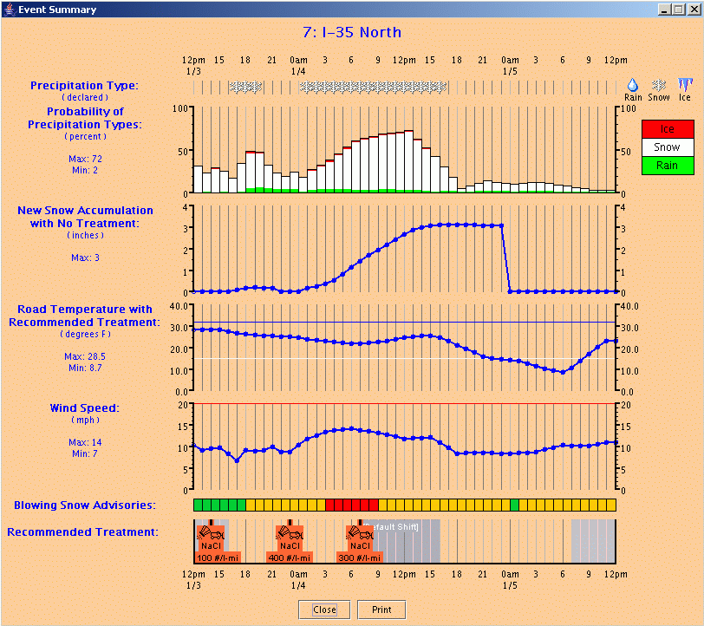

Figure 4 - Sample image of the MDSS event summary page. Graphical probabilistic forecasts were introduced (top set of graphics) for precipitation type. Each bar in the time line contains the model derived probability of rain (green), ice (red) or snow (white).

4.5 Results and Recommendations

The second field demonstration began on December 29, 2003. By the conclusion of the 88-day demonstration, there were 15 weather event days ranging from mixed rain and snow events to freezing rain and record heavy snows.

Enhancements made to all aspects of the prototype based on the results of the 2003 demonstration made a significant difference in the quality of the forecasts and treatment guidance, and the subsequent confidence shown by the users. The primary results and recommendations are described below.

4.5.1 Road Weather Forecast System

The data fusion methods and statistical techniques used in the RWFS improved the overall weather prediction skill for parameters that are measured and available in real time. The use of multiple inputs also made the system more robust as it was not prone to down time with the loss of individual forecast modules.

The RWFS forecasts had significantly better skill in the first six hours because of their forward error correcting capability. The performance of the RWFS was analyzed via comparison of the forecast skill of individual inputs to the consensus (final) forecast. Seasonal assessments of RMSE and bias (forecast-observation) were performed for the ten input forecast modules and the final consensus forecast for the meteorological state variables (temperature, dewpoint, wind speed, cloud cover, and wind direction). Results were based on weighted average RMSE and bias values at every lead time for all forecasts initiated at 18 UTC over the entire winter season for all sites across the state of Iowa. Note that the FSL models only covered a 15 hour forecast period, whereas the NCEP model products covered a 48-hour period.

For all variables except cloud cover, the RWFS forecast has a lower RMSE than its components for a majority of the lead times (0-48 hours). For the air temperature forecasts, it is interesting to note that the individual inputs are clustered between 2.0 and 2.5 C. The MM5 based air temperature forecasts were slightly more accurate than WRF, and AVN MOS is slightly better than both. For dew point predictions, the AVN MOS had the best skill of the individual components, while the mesoscale models had less skill. The increased skill of the RWFS air and dew point temperatures is good news as these fields are important for predictions of road temperature and frost. The RMSE of the RWFS wind speed predictions was 1.5 meters per second (~3 mph).

The high resolution models did not add value above the standard NWS products for wind, temperature and humidity forecasts, but they did have more skill at predicting precipitation type, rate and timing. The reduction is skill is partially due to the fact that the fine-scale models did not include a coupled land surface model, which is very important for predicting air temperature and humidity in the lowest few meters.

4.5.2 Winter Precipitation Measurements

The poor quality of winter precipitation measurements did not provide the same automatic forward correcting benefit for the prediction of precipitation amount. If a data fusion system that adjusts itself based on observations similar to the RWFS is utilized, care must be taken to ensure that the weights given to individual prediction modules are appropriate. If only low quality verification data are available, the weights should be fixed based on experience and/or expert opinion.

4.5.3 Short Wave Solar Radiation

The ability of models to predict insolation varies greatly between models, particularly in partly cloudy conditions. Care must be taken to ensure the model values compare well with measured values. Changes to both research and operational models may impact insolation calculations so routine comparisons should be made. Because insolation measurements are critical for road temperature prediction, it is recommended that insolation measurements be added to surface observing stations and be provided in real time to weather service providers. Real time access to insolation data would provide an opportunity for systems like the RWFS to utilize the data and optimize predictions.

4.5.4 Probabilistic Products

Winter maintenance supervisors are in the business of risk management. Because weather and road conditions will never be perfectly predicted on the scale of plow routes, probabilistic prediction products should be considered. The MDSS conditional probability of precipitation type product was well received by the end users.

4.5.5 Road Temperature Prediction

The MDSS provides three sets of road temperature forecasts for each segment of road: untreated, recommended treatment, and actual treatment. The “untreated” forecast is the expected road temperature given that the weather occurs (snow fall on the road, etc.) and no treatments are made (the road is left “as is”). “Recommended treatment” is the expected road temperature, given that the treatment suggested by the MDSS is applied. “Actual treatment” is the expected road temperature, given the actual performed, but this was not always known. The most appropriate field to verify is the “recommended treatment” field, since it represents a treatment scenario for each event. Only results for that field are discussed here.

It must be noted that there is uncertainty in establishing ground truth for road surface temperature. The MDSS is configured to model the road temperature from the surface to 3 mm deep. The RWIS pavement sensors are embedded in the pavement and the sensor materials and their thermal coupling (or lack thereof) to the pavement below and around them contributes to some of the measurement differences.

For all months there were considerably higher measurement differences during the heat of the day. In January, daytime Mean Absolute Error (MAE) values were up to 3.5˚C, while they were nearly 4˚C during March. During the night, the MAE values were between 1 and 2˚C during all months. A positive road temperature bias was found during the morning hours, followed by a weaker negative (cold) bias in the afternoon. This daytime swing in bias may be attributable to differences in the depth over which road temperature is forecast (~ 3 mm) and the depth of pavement that surrounds the measuring device (several centimeters). Response time differences may have caused a phase shift in the diurnal heating/cooling cycle. Cold biases up to 1.5˚C were present during the night, and were typically strongest during the hours between midnight and sunrise.

The road temperature predictions were the most accurate during snowy periods, particularly at night. During nighttime snow events, the MAE ranged from 0.25 to 1.0 C. The next best skill occurred during cloudy days and the least skill occurred during clear or partly cloudy days. It is no surprise that these results strongly suggest that the prediction of insolation is critical and that the weather models have difficulty predicting insolation on partly cloudy days. Additional research focusing on insolation prediction is required.

4.5.6 Rules of Practice

One of the biggest improvements to the MDSS in 2004 was the revision of the RoP code based on lessons learned and experience gained from the first MDSS field demonstration. The primary improvement in the RoP was in considering the entire storm life-cycle for characterizing the overall storm conditions and for recommending treatment strategies. The storm life-cycle includes not only the in-storm conditions when precipitation is falling but also the pre- and post-storm road conditions. Pre-storm conditions control the application of pre-treatment chemicals (such as liquid brine) that are used to prevent icing at precipitation onset. Post-storm conditions (including road temperature and residual water on the pavement) are utilized to protect against re-freezing of the roads after the precipitation has stopped.

Interviews with Ames and Des Moines garage supervisors indicated that there was a general comfort level with the treatment recommendations. On several occasions, the DOT used the recommended treatment strategy with little modification. Results in most cases were satisfactory unless storm conditions varied greatly from the forecast. Unfortunately, quantifying the verification of treatment strategies is a formidable task as it is nearly impossible to ascertain whether seemingly different treatment applications might yield the same ice-free road conditions. It is onerous, but manageable, to determine if the selected Iowa DOT strategy did or did not keep the roads at the desired level of service. But it is almost impossible to take an unimplemented recommended treatment strategy and determine the exact road conditions.

The 2004 analysis of treatment recommendations highlighted strengths and weaknesses in the current version of the RCTM. The lack of logic for explicitly dealing with blowing snow conditions was a noticeable weakness causing the recommended treatments to be below what might be needed during blowing snow conditions. Modifications made to the RCTM and improvements in the RWFS have yielded recommended treatment strategies that are fairly consistent from run to run. Enhancements made to suppress pre-treatments under warm road and cold road/ blowing snow conditions are effective. Finally, the added ability to protect the wet road surface after the storm precipitation ends was also effective.

4.5.7 User Benefits

There was general agreement that the system showed significant promise and had proven itself to be a valuable tool both for operations and training. Iowa DOT estimated that an operational MDSS has the potential of saving the DOT between 10% and 15% of their annual maintenance costs (materials and manpower), which equates to approximately $3.5M per year.

5. Technology Transfer

One of the main goals of the MDSS project was to use federal funds and national laboratory resources to create a base capability for the private sector to embrace and nurture into new products and services for the state DOTs. Throughout the life of the MDSS project, all briefing materials, technical reports, evaluations, and software have been made available to any interested parties via NCAR’s MDSS Web site at: http://www.rap.ucar.edu/projects/rdwx_mdss/index.html.

6. Summary

The FHWA has been funding and directing a team of national laboratories to create and refine a decision support system for the winter road maintenance community. Demonstrations of the MDSS prototype were conducted in central Iowa during the winters of 2003 and 2004. The system showed consistent improvement as the demonstration progressed and a list of lessons learned has been described. Comments from Iowa DOT personnel found the system to be of growing value and showed increasing confidence in its use. They also stated that an operational system could save millions of dollars per year in winter maintenance costs.

7. ACKNOwledgements

The FHWA’s Office of Transportation Operations, Road Weather Management program sponsors this project. The MDSS development team is grateful for the support and leadership provided by Regina McElroy, James Pol, and Ray Murphy. More than twenty state DOTs have been active participants and their feedback has been critical.

8. References

- Mahoney, W.P. and W. Myers. (2003) Predicting Weather and Road Conditions: Integrated Decision Support Tool for Winter Maintenance Operations. In Transportation Research Record, Journal of the Transportation Research Board, No. 1824, TRB, National Research Council, Washington, D.C., pp. 98−105.
- McGinley, J., S. Albers, D. (2000) Birkenheuer, B. Shaw and P. Shultz. The LAPS Water in All Phases Analysis: the Approach and Impacts on Numerical Prediction. Preprints, 5th International Symposium on Tropospheric Profiling, Adelaide, Australia.
- Myers, W., M. Petty and J, Cowie. (2001) An Automated Road Weather Prediction System for Road Maintenance Decision Support. Preprints, 18th International Conference on Interactive Information and Processing Systems, Orlando, Florida, American Meteorological Society, Boston.
- Pisano, P., A. Stern and W. Mahoney. (2004) The Winter Maintenance Decision Support System: Demonstration Results and Future Plans. Preprints, 20th Conference on Interactive Information and Processing Systems, Seattle, Wash., American Meteorological Society, Boston.
- The Maintenance Decision Support System (MDSS) Project, Preliminary Technical Performance Report, Second Iowa Field Demonstration Winter 2003-2004. Version 1.0, National Center for Atmospheric Research, Boulder, Colo., April 29, 2004.
- The Maintenance Decision Support System (MDSS) Project, Technical Performance Report, Iowa Field Demonstration Winter 2003. Version 1.1, National Center for Atmospheric Research, Boulder, Colo., September 12, 2003.

