

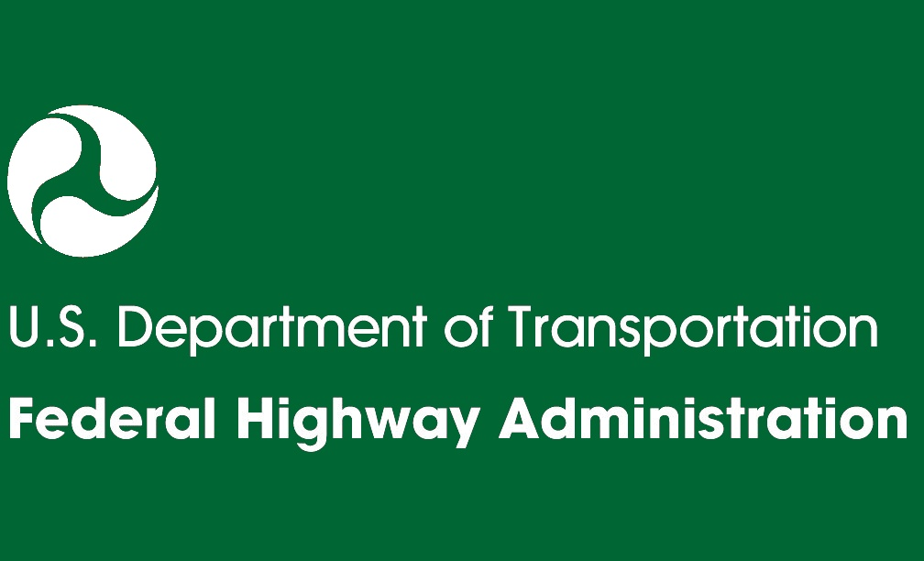
C. MINOR-TO-MODERATE IMPACTS PROJECT TEMPLATE
A. How to Use
the Guide

D. TMP Template 2
Moderate-to-Major Impacts

E. Sample TMP 1 Minor-to-Moderate Impacts

C. TMP Template 1
Minor-to-Moderate Impacts

F. Sample TMP 2 Moderate-to-Major Impacts
TRANSPORTATION MANAGEMENT PLAN (TMP) TEMPLATE 1
August 2010

B. TMP
Tips and Tools

August 2010
Table of Contents
1.0 Project Description C-1
2.0 TMP Team—Roles and Responsibilities C-1
3.0 Preliminary Work Zone Impact Assessment C-2
4.0 Work Zone Impact Management Strategies C-4
5.0 Notes C-9
6.0 TMP Implementation/Monitoring C-9
7.0 TMP Review/Approvals C-9
8.0 Appendices C-9

Project Description
This section provides an overview of the project, which generally includes:
- Work zone limits (if possible, include a map showing the limits of the work)
- Project background information
- Overview of roadways directly affected by project work zones
- Specific traffic restrictions expected on major roadways during the work
(e.g., shoulder closures, lane closures, lane shifts)
- Regional projects that may impact each other
- Project Schedule.

TMP Team—Roles and Responsibilities
This section includes contact information and roles and responsibilities of major personnel involved in the project such as:
- TMP Development Managers—Agency/Contractor personnel who have primary responsibility for developing the TMP.
- TMP Implementation/Monitoring Managers—Agency/Contractor personnel who have primary responsibility for implementing and monitoring the TMP.
- TMP Implementation Task Leaders—Responsible for managing, completing, overseeing, or assisting in specific transportation management tasks during the work.
- Emergency Contacts—Public and semi-public agencies, such as hospitals, schools, health clinics, etc., who must be kept informed about the work zone activities, especially in case of a road closure.

The following tables can be used to list the contact information and roles and responsibilities for major personnel involved in the project. Tables can be modified depending on agency needs.
TMP Development Managers
Department Of Transportation (DOT) | Consultant
Name/Title:  Unit:  Phone:  Email: | Name/Title:  Unit:  Phone:  Email:
Roles and Responsibilities:

TMP Implementation/Monitoring Managers
DOT | Consultant
Name/Title:  Unit:  Phone:  Email: | Name/Title:  Unit:  Phone:  Email:
Roles and Responsibilities:
TMP Implementation Task Leaders
DOT | Consultant
Name/Title:  Unit:  Phone:  Email: | Name/Title:  Unit:  Phone:  Email:
Roles and Responsibilities:

Emergency Service Contacts
Fire and Emergency Medical Services (FEMS) | Police Department (PD)
Name/Title:  Unit:  Phone:  Email: | Name/Title:  Unit:  Phone:  Email:
Roles and Responsibilities:

Preliminary Work Zone Impact Assessment
As challenges vary greatly from one project to another, a preliminary assessment of work zone impacts developed in the early planning stages of the project will help identify issues or uncover problem areas that should be considered during project development. Agency guidelines apply on determining the impact levels and how extensive the preliminary assessment should be. Some agencies use decision-support tools, while others have developed checklists/flowcharts to assist in the decision-making process.
Some of the potential questions that could help in the preliminary assessment of work zone impacts include:
Does the project includes a long-term closure and/or extended weekend closure?
If Yes, what is/are the applicable type of facility(ies)?
- Freeway
- Principal Arterial
- Minor Arterial
- Collector
- Local
Can traffic be detoured?
- Is the local alternate detour route in good condition?
- Will the detour route have a detrimental impact on emergency vehicles, school buses, or other sensitive traffic?
- Are there load limit restrictions on the detour?
- Are there bridge/culvert height or width restrictions on the detour?
Is the existing shoulder sufficient to support traffic during construction?
Is additional width required on culverts or bridges to maintain traffic?
Is there a pedestrian/bicycle facility that must be maintained?
Would a temporary structure(s) be required?
Would a median crossover be needed?
Would there be a need to maintain railroad traffic?
Could maintenance of traffic have an impact on existing or proposed utilities?
Does it appear that maintenance of traffic will require additional right-of-way?
Can the contractor restrict the roadway during the time periods listed?
- a.m. peak hours, one direction
- p.m. peak hours, one direction
- a.m. peak hours, both directions
- p.m. peak hours, both directions
- Overnight
- Local celebrations
- Holidays or weekends
- Sporting events/other special events
Will project timing (for example, start or end date) be affected by special events:
- School closings or openings?
- Holidays?
- Sporting events?
Are there any projects to be considered along the corridor or in the region?
- Roadwork in the immediate area that may affect traffic or the contractor’s operations?
- Roadwork on other roads that may affect the use of alternate routes?
Are there other maintenance of traffic issues? If so, specify.

Some projects (e.g., on low volume rural roads) may need only a simple screening tool such as a checklist, while others (e.g., in congested urban areas) may need quantitative analysis (level of service analysis, signal timing, etc) to determine the impact levels. Quantitative analysis may indicate the need for some additional analysis and/or strategies to assess and manage the impacts, or it may indicate that impacts are relatively low and few strategies are required beyond the temporary traffic control (TTC) plan.

NOTE: If the project is expected to create moderate-to-major impacts, use Template 2. For lower impacts projects, continue with this template.

Work Zone Impact Management Strategies
This section provides an overview of various strategies employed to improve the safety and mobility of work zones and reduce the work zone impacts on communities and businesses. The strategies are grouped according to the following categories:
- Temporary Traffic Control (TTC)
- Transportation Operations (TO)
- Public Information and Outreach (PI&O).

Additional Considerations
TMP Details—Many agencies have the details of proposed work zone strategies in TTC plans (e.g., PCMS message content) and strategies listed in the TMP document. In such cases, it will be useful to include the detailed plans (e.g., TTC Plan) as attachments to the TMP.

TMP Costs—Agency guidelines apply regarding whether cost should be shown in the TMP document. If the TMP is to be a contract document, it typically does not show cost items. However, estimating the work zone management strategy implementation costs and including these within the overall project budget is crucial, as it may be difficult to obtain additional funding at a later time. This potentially avoids under-allocation of funds. Where feasible, it is helpful to itemize the cost estimates for the various management strategies and document them in the TMP, and specify cost responsibilities, opportunities for sharing or coordinating with other projects, and funding sources. TMP components can be funded as part of the construction contract and/or in separate agreements.

The sample tables below provide a summary of various work zone management strategies. They can be modified by agencies to suit their needs.
Temporary Traffic Control | √ | Cost
Control Strategies
- Construction phasing/staging
- Full roadway closures
- Lane shifts or closures
- One-lane, two-way controlled operation
- Two-way, one-lane traffic/reversible lanes
- Ramp closures/relocation
- Freeway-to-freeway interchange closures
- Night work
- Weekend work
- Work hour restrictions for peak travel
- Pedestrian/bicycle access improvements
- Business access improvements
Temporary Traffic Control | √ | Cost
- Off-site detours/use of alternate routes
Traffic Control Devices
- Temporary signs
- Arrow boards
- Channelizing devices
- Temporary pavement markings
- Flaggers and uniformed traffic control officers
- Temporary traffic signals
- Lighting devices
Project Coordination Strategies
- Other area projects
- Utilities
- Right-of-Way
- Other transportation infrastructure
Innovative Contracting Strategies
- Design-Build
- A+B Bidding
- Incentive/Disincentive clauses
- Lane rental
- Performance specifications
Innovative or Accelerated Construction Techniques
- Prefabricated/precast elements
- Rapid cure materials

Transportation Operations | √ | Cost
Demand Management Strategies
- Transit service improvements
- Transit incentives
- Shuttle services
- Parking supply management
- Variable work hours
- Telecommuting
- Ridesharing/carpooling incentives
- Park-and-Ride promotion

Transportation Operations | √ | Cost
Corridor/Network Management Strategies
- Signal timing/coordination improvements
- Temporary traffic signals
- Street/intersection improvements
- Bus turnouts
- Turn restrictions
- Parking restrictions
- Truck/heavy vehicle restrictions
- Reversible lanes
- Dynamic lane closure system
- Ramp closures
- Railroad crossing controls
- Coordination with adjacent construction site(s)
Work Zone ITS Strategies
- Late lane merge
- PCMS with speed display
- Travel time estimation system
- Advanced speed information system
- Advanced congestion warning system
- Conflict warning system (e.g., construction vehicles entering roadway)
- Travel time monitor system
- Freeway queue monitor system
- CCTV monitoring
- Real-time detour
Work Zone Safety Management Strategies
- Speed limit reduction/variable speed limits
- Temporary traffic signals
- Temporary traffic barrier
- Movable traffic barrier systems
- Crash cushions
- Temporary rumble strips
- Intrusion alarms
- Warning lights
- Automated flagger assistance devices (AFADs)

Transportation Operations | √ | Cost
- Project task force/committee
- Construction safety supervisors/inspectors
- Road safety audits
- TMP monitor/inspection team
Incident Management and Enforcement Strategies
- ITS for traffic monitoring/management
- TMC
- Surveillance (e.g., CCTV)
- Helicopter for aerial surveillance
- Traffic Screens
- Call boxes
- Mile-post markers
- Tow/freeway service patrol
- Total station units
- Photogrammetry
- Media coordination
- Local detour routes
- Contract support for Incident Management
- Incident/Emergency management coordination
- Incident/Emergency response plan
- Dedicated (paid) police enforcement
- Cooperative police enforcement
- Automated enforcement
- Increased penalties for work zone violations
- Emergency pull-offs

Public Information and Outreach | √ | Cost
Public Awareness Strategies
- Branding
- Press kits
- Brochures and mailers
- Press releases/media alerts
- Mass media (earned and/or paid)
- Paid advertisements
- Project Information Center
Public Information and Outreach | √ | Cost
- Telephone hotline
- Planned lane closure website
- Project website
- Public meetings/hearings, workshops
- Community task forces
- Coordination with media/schools/business/emergency services
- Work zone education and safety campaigns
- Work zone safety highway signs
- Rideshare promotions
- Visual information
Motorist Information Strategies
- Radio traffic news
- Changeable message signs
- Temporary motorist information signs
- Dynamic speed message sign
- Highway Advisory Radio (HAR)
- Extinguishable Signs
- Highway information network (web-based)
- Traveler information systems(wireless, handheld)
- Transportation Management Center (TMC)
- Live traffic camera(s) on a website
- Project information hotline
- Email alerts

Notes
Any additional notes on selected strategies, the TMP in general, or any item requiring special attention for the project can be provided in this section.

TMP Implementation/Monitoring
Monitoring performance of the TMP during the construction phase is important in establishing whether the predicted impacts closely resemble the actual conditions in the field, and whether the TMP strategies are effective in managing the impacts. According to 23 CFR 630 Subpart J -§630.1012(e), the State/Agency and the contractor shall each designate a trained person at the project level who has the primary responsibility and sufficient authority for implementing the TMP and other safety and mobility aspects of the project.
Agency requirements for TMP implementation and monitoring can be included here. The responsible personnel for TMP implementation and monitoring can be identified in Section 2.0—Roles and Responsibilities.

TMP Review/Approvals
TMPs, and changes to TMPs, must be approved by the DOT before they are implemented. A sample TMP Approval Template is given below which can be modified by agencies according to their practice/needs.
Chief Engineer |  |  | Project Engineer
All approvals must be obtained prior to start of work
Signature:  Name:  Date: |  |  | Signature:  Name:  Date:
Revision# | Initials | Date | Revision# | Initials | Date
1 |  |  | 1
2 |  |  | 2

Appendices
- Traffic Analysis Reports (if applicable)
- Temporary Traffic Control Plans
- Public Information and Outreach Plan (if applicable)
- Post Project Evaluation Report

