Innovative Traffic Control Devices for Improving Safety at Rural Short-Term Maintenance Work Zones

Michael D. Fontaine

Texas Transportation Institute
Texas A&M University System
3135 TAMU

College Station, TX 77843-3135
Phone: (979) 845-9929
E-mail: m-fontaine@tamu.edu

The Texas Department of Transportation (TxDOT) maintains almost 80,000 miles of roadway, and rural roads with an average daily traffic (ADT) of less than 2000 vehicles per day represent more than half of all lane-miles. As the state’s highway system continues to age, drivers are encountering maintenance activities on these low-volume rural facilities with increasing frequency. The Texas Manual on Uniform Traffic Control Devices establishes standard practices for installing work zone traffic control when maintenance work is performed (1). Although the MUTCD provides basic guidance for installing work zone traffic control, there is the potential to improve safety by utilizing innovative countermeasures.

Much of the maintenance work performed on low-volume rural roads is completed in a single day. The short duration of these work zones can create a number of safety challenges. First, it is often difficult to coordinate work zone speed enforcement for these sites with local law enforcement agencies. Many rural enforcement agencies have limited resources, and it can be difficult to schedule enforcement activities when the location of work zones change daily. In Texas, most rural roads have a posted regulatory speed limit of 70 mph, but regulatory speeds are usually not reduced for short-term work zone activities. Traffic control is often limited to devices that can be easily installed and removed by a work crew due to the short duration of maintenance activities.

PROJECT OBJECTIVES
TxDOT and the Federal Highway Administration (FHWA) sponsored a Texas Transportation Institute (TTI) research project to determine if innovative traffic control devices could improve safety at short-term rural maintenance work zones. This project examined several innovative countermeasures to determine if they would produce a positive safety benefit at short-term rural work zones. The following objectives were established to evaluate the devices:

- identify devices not currently used by TxDOT that could potentially improve safety at temporary traffic control zones by either reducing speeds, improving worker visibility, or increasing awareness of the upcoming work zone;
- determine the impact of the devices by conducting field evaluations; and
- assess the feasibility of using these devices at short-term maintenance sites.

With these goals in mind, five different traffic control devices were selected for further evaluation:

- speed display trailers,
- radar drones,
- portable rumble strips,
- alternative worker vests, and
- fluorescent orange roll-up signs.

This paper describes the results of the evaluation of these devices. Recommendations for the application of these devices to short-term work zones are also made.

DESCRIPTION OF COUNTERMEASURES

Speed Display Trailer
Speed display trailers detect the speed of approaching vehicles using a radar unit. These speeds are then displayed to oncoming drivers using large numerals on the face of the display. Figure 1 shows the speed display trailer used in this study. The display tested in this evaluation used Ka band radar and displayed speeds in 24-inch high light emitting diode (LED) numerals. The display also had a speed-activated strobe light that flashed when vehicles were detected traveling over a preset speed threshold. Throughout this study, the strobe light was activated when a vehicle was detected traveling more than 5 mph over the speed limit.
Figure 1. Speed Display Trailer.

Radar Drone
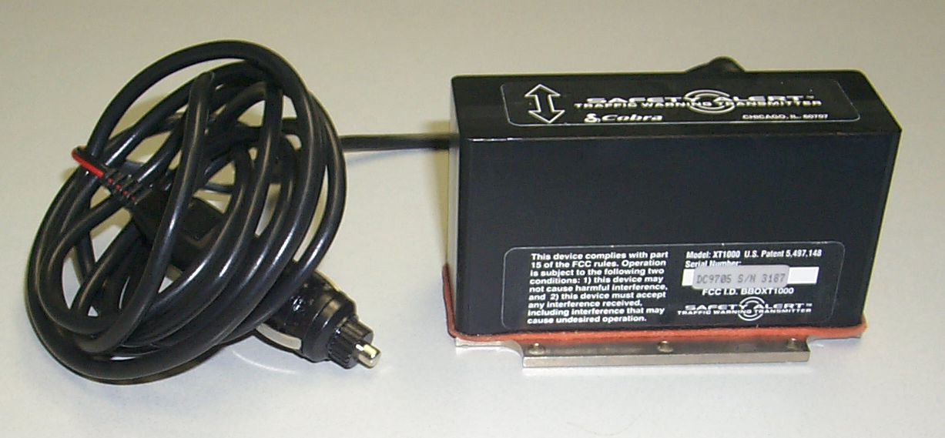
Radar drones simulate the presence of law enforcement by continuously emitting radar signals. Vehicles with radar detectors may decelerate when they detect the radar transmission, thinking that an officer is performing speed enforcement ahead. Figure 2 shows the radar drone evaluated in this study. The radar drone used in this evaluation emitted a K band radar signal that could be detected up to a mile away.
Figure 2. Radar Drone.
Portable Rumble Strips
Rumble strips can be used to provide an auditory and vibratory cue to drivers that they are about to enter a work zone. The portable rumble strips used in this study were 12 feet long, 4 inches wide, and 0.25 inches thick. The rumbles strips were installed by removing the protective backing, placing the rumble strip on the road surface, and using a weighted roller to firmly adhere the strip to the pavement. Each rumble strip installation consisted of a series of six rumble strips placed parallel to one another at 18-inch spacings. Figure 3 shows a typical portable rumble strip installation.

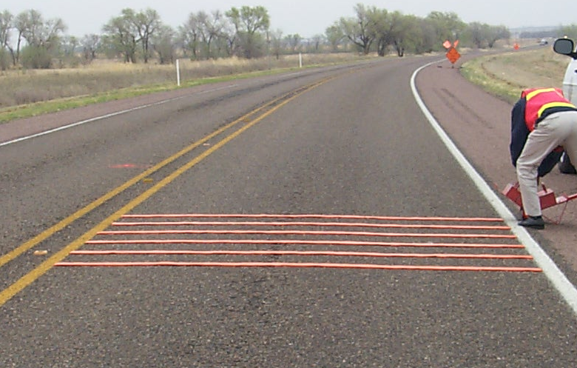
Figure 3. Portable Rumble Strip Installation.
Alternative Worker Vests
At the time of this study, TxDOT workers wore fluorescent orange mesh vests. There was some concern that the color of these vests may cause workers to be camouflaged by work zone traffic control devices. Fluorescent yellow-green worker vests offered the potential to better distinguish workers from surrounding traffic control than the standard TxDOT orange vest. This evaluation examined five different worker garments in order to determine if worker conspicuity could be improved. These garments are shown in Figure 4. The garments were evaluated based on both their visual performance and the wearer’s comfort level. The vests in Figure 4, from left to right, are:

- TxDOT orange mesh vest,
- Proposed TxDOT yellow-green mesh vest,
- Mesh yellow-green vest,
- Solid fabric yellow-green vest, and
- Yellow-green jacket with sleeves.

It should be noted that American National Standards Institute (ANSI) standard ANSI/ISEA 107-1999 was released after this evaluation was performed (2). The proposed TxDOT yellow-green vest did not meet the requirements for background material for small and medium vests.
Figure 4. Alternative Worker Vests.
Fluorescent Orange Roll-Up Signs
Fluorescent orange roll up signs were also evaluated during this study. It was hypothesized that these signs would improve driver awareness of the approaching work zone by increasing the conspicuity of the signs. These signs could be implemented at a site without placing any additional burden on the maintenance workers at the site. The size of the signs evaluated was 48 inches by 48 inches.
Figure 5. Fluorescent Orange Roll-Up Signs.

METHODOLOGY
Most traffic control devices were examined primarily through field tests. The effect of a countermeasure was examined by comparing several measures of effectiveness with and without the device present. Some limited closed-course testing was also performed to evaluate the alternative worker vests.

Field Data Collection
Field testing occurred in north Texas near Oklahoma. All test sites had 70 mph posted regulatory speed limits and level grades. A mix of four lane and two lane sites were evaluated, and the length of the activity area at these sites was typically between ¼ and ½ mile. In all cases, the work sites were only in place during daylight hours for a single day. Table 1 summarizes the sites used to evaluate each device.

Table 1. Data Collection Site Summary.
Device Evaluated | Number of Sites | ADT (vpd)
Speed display trailer | 4 | 1000-8900
Radar drone | 3 | 6900-8900
Portable rumble strips | 3 | 1250-1850
Alternative worker vests | 6 | 410-8900
Fluorescent orange roll-up signs | 7 | 410-8900

Since each site was only in place for a single day, all testing at a location had to be completed in one day. Data were collected in two phases at each site. First, data were collected with only the work zone traffic control required by the MUTCD present. Approximately halfway through the day, the test treatment was installed in addition to the MUTCD-required traffic control. Table 2 summarizes the measures of effectiveness (MOEs) that were established for each device.

Table 2. Measures of Effectiveness for Each Device.
Device | Traffic Speed | Conflicts | Worker Comments | Driver Comments
Speed display trailer | ✓ | ✓ | ✓
Radar drone | ✓ | ✓ | ✓
Portable rumble strips | ✓ | ✓ | ✓
Alternative worker vests |  |  | ✓ | ✓
Fluorescent orange roll-up signs |  |  | ✓ | ✓

Traffic speed was measured using lidar guns and traffic counters. This MOE was used to determine if the countermeasure reduced speeds on the approaches to the temporary traffic control area and within the work zone activity area. Since the work zone was only in place for a short time, conflicts were used as a surrogate measure for safety. The approach to the work zone activity area was videotaped in order to examine conflicts between vehicles, such as late merges, sudden braking maneuvers, or other actions that caused surrounding vehicles to brake or perform evasive action. The workers at the job site were also interviewed in order to assess the potential usability of the devices for short-term operations. Finally, drivers were interviewed at some low-volume sites to determine their opinions on the measures being evaluated.

Closed Course Evaluation
Closed course evaluations were also conducted to assess the luminance and contrast ratio of the alternative worker vests. All measurements were made under ambient daylight illumination between 11:00 AM and 4:00 PM on a clear day in August. Since this project focused on daytime operations, the retroreflectivity of the vests was not evaluated.

Luminance can be thought of as the brightness of the vest, while contrast ratio measures how much a vest stands out from a background. This was done in order to obtain objective performance data for the various vests. The luminance of the vests was determined by measuring a worker wearing a vest in front of a simulated work zone. The worker wore the vest over a dark t-shirt, and was stationed in the same position as a flagger at the beginning of the work zone. The luminance of the vest was then measured from approximately 500 feet away using a telephotometer. This was repeated for each of the five worker garments evaluated.

A second series of measurements were collected in order to determine the luminance contrast ratio of the vests against a variety of backgrounds. The contrast ratio is defined as the ratio of the vest luminance to the luminance of the background. The larger the ratio, the more the vest “stands out” from the background. The measurements of the vest were made against the following backgrounds:

- open concrete road,
- open asphalt road,
- mix of fluorescent and standard work zone traffic control,
- white pickup truck (typical of TxDOT vehicles),
- foliage typical of a Texas summer, and
- a yellow construction front end loader.

EVALUATION RESULTS
This section summarizes the results of the evaluations of each of the five devices. A brief description of each countermeasure is provided, followed by a summary of the results of the evaluation.

Speed Display Trailers

The speed display trailer was field tested at four sites. Two of these sites were at lane closures on a four-lane divided highway, while the remaining two occurred on two-lane roads where traffic was being diverted onto the shoulder. Traffic speed, conflicts, and worker comments were used to assess this device.

Table 3 summarizes the average speed results obtained when the speed trailer at the four test sites. In general, the speed trailer was effective in reducing vehicle speeds at all sites. Mean speeds were reduced by an average of 5.2 mph within the advance warning area for both cars and large trucks. Speed reductions were slightly less within the activity area of the work zone.

Table 3. Average Speed Results for Speed Display Trailer.
Vehicle Type | Change in Mean Speeds |  | Change in % Exceeding Speed Limit
Vehicle Type | Before Taper | Activity Area | Before Taper | Activity Area
Cars | -5.2 | -3.9 | -6.9% | -4.4%
Trucks | -5.2 | -2.4 | -15.7% | -11.6%

The video data were examined in order to determine if the speed display influenced conflicts or aggressive behavior approaching the taper. The video data showed a slight decrease in conflict rate at one site, but no discernable impact was observed at the remaining sites.

Worker comments on the speed display trailer were almost uniformly positive. Workers felt that it was quick and easy to set up. Researchers noted that the trailer could be installed and removed within 10 minutes. The maintenance crews felt that the trailer increased awareness of the work zone and significantly lowered speeds in the activity area.

Radar Drones

The radar drone was tested at three sites. The radar drone was placed in a vehicle stationed at the start of the advance warning area at all sites. Speed data were collected approximately 1000 feet before the start of the taper and approximately halfway through the work zone activity area.

Table 4 summarizes the speed results for the radar drone. The radar drone did not significantly impact the speeds of vehicles traveling through the work zone. The average speed reductions observed were no greater than 1.6 mph, and only small changes in the number of vehicles exceeding the speed limit were observed.

Table 4. Average Speed Results for Radar Drone.
Vehicle Type | Change in Mean Speeds |  | Change in % Exceeding Speed Limit
Vehicle Type | Before Taper | Activity Area | Before Taper | Activity Area
Cars | +0.5 | -0.3 | +10.0% | -2.3%
Trucks | -1.6 | -0.5 | -7.1% | -2.1%

Since only a subset of the traffic stream possesses radar detectors, there were no observable widespread trends in driver behavior. Worker reaction to the radar drone was mixed. While they felt that the drone was quick and easy to set up, they were unsure if it would remain effective if used for extended periods.

Portable Rumble Strips

The portable rumble strips were tested at three sites. Two separate rumble strip installations were installed at the sites. Each installation consisted of six individual rumble strips placed perpendicular to the direction of traffic across the road. The installations were placed approximately 500 feet and 1000 feet from the start of the taper.

Table 5 shows the speed results that were collected with the rumble strips. Passenger cars generally experienced smaller changes in speed than large trucks did. It is possible that the larger viewing angle of truck drivers made the rumble strips more visible, and therefore they responded by decelerating more than cars did.

Table 5. Average Speed Results for Portable Rumble Strips.
Vehicle Type | Change in Mean Speeds |  | Change in % Exceeding Speed Limit
Vehicle Type | Before Taper | Activity Area | Before Taper | Activity Area
Cars | -1.6 | +0.7 | -2.8 | -2.5
Trucks | -4.0 | -3.5 | -1.6 | +0.2

Very few erratic maneuvers were observed when the portable rumble strips were used. Two cars were observed to cross into the opposing lane in order to go around the rumble strips. All of these maneuvers occurred in a passing zone when there was no oncoming traffic.

The maintenance crews were very concerned with the installation time required for the portable rumble strips. It took 40 minutes for a crew of three people to install all of the rumble strips on a low volume road. The removal of rumble strips was accomplished in less than 10 minutes. The maintenance crews commented that the installation time for the rumble strips would take away from the time available to perform actual work activities. There was also concern that it would be difficult to install the rumble strips on four-lane roads or under high traffic volumes without completely stopping oncoming traffic. Although the workers felt that installation time was too lengthy, they did feel that the portable rumble strips might produce some benefit in safety. They felt that the rumble strips would improve driver awareness of the upcoming work zone and also create speed reductions.

Alternative Worker Vests

Field Evaluation

The worker vests were evaluated at 6 field sites. The solid fabric worker vests were used during this testing since they provided the maximum amount of fluorescent fabric and retroreflective material. Workers were asked to wear the vest for an afternoon, and then comment on their perceptions of its comfort and visibility. Worker comments on the vests were positive. They felt that the vests were more visible than the orange vests. They also felt that the garments were comfortable, and that the solid fabric vest was not noticeably warmer than the standard TxDOT mesh vest.

A downstream driver survey was also conducted at two sites in order to determine if drivers noticed the new worker vest more than the normal TxDOT worker vest. Approximately 4 percent of drivers noticed that the workers were wearing yellow vests rather than orange vests.

Photometric Testing
The field luminance of the five worker garments was measured to assess how bright each garment appears to the eye. The field luminance factor should be between 0 and 100, with low numbers representing dark colors and high numbers representing very bright colors. Table 6 summarizes the field luminance factors determined for the five garments. The fluorescent yellow green solid vest had the largest field luminance of all garments tested.

Table 6. Results of Luminance Testing for Vests.
Garment | Field Luminance (cd/m²) | Field Luminance Factor (%)
TxDOT Fluorescent Orange Mesh Vest | 3570 | 35.5
TxDOT Fluorescent Yellow-Green Mesh Vest | 5926 | 58.9
Alternative Fluorescent Yellow-Green Mesh Vest | 3431 | 34.1
Fluorescent Yellow-Green Solid Vest | 7998 | 78.4
Fluorescent Yellow-Green Solid Jacket | 7197 | 71.5

The luminance contrast ratio was also determined for each worker garment. The larger the contrast ratio, the more the vest “stood out” from the surrounding background. Thus, larger ratios tend to indicate that the vest is more conspicuous. Table 7 shows the luminance contrast values determined for the various vests. The fluorescent yellow-green solid vest produced the highest contrast ratios for 6 of the 8 backgrounds evaluated. The fluorescent yellow-green solid jacket performed the best for the remaining two alternatives, but the jacket is probably not a feasible alternative for workers to wear during the Texas summer. If a mesh vest is needed to accommodate workers during summer heat, the proposed TxDOT fluorescent yellow-green mesh vest appears to be the best alternative

Table 7. Worker Vest Luminance Contrast Ratios.
Garment | Background
Garment | Lane Closure | Sky | Asphalt | Concrete | Foliage | Work Zone | White Truck | Yellow Loader
TxDOT Fl. Orange Mesh Vest | 2.00 | 0.88 | 1.54 | 0.90 | 1.99 | 1.14 | 0.67 | 2.24
Proposed TxDOT Fl. Yellow-Green Mesh Vest | 3.21 | 1.42 | 2.33 | 1.68 | 3.56 | 1.61 | 0.28 | 3.64
Alternative Fl. Yellow-Green Mesh Vest | 1.89 | 0.83 | 1.32 | 0.84 | 2.16 | 1.19 | 0.71 | 1.94
Fl. Yellow-Green Solid Vest | 4.30 | 1.90 | 3.06 | 2.46 | 4.76 | 2.19 | 1.51 | 4.75
Fl. Yellow-Green Solid Jacket | 4.61 | 2.04 | 2.64 | 1.97 | 4.07 | 1.97 | 1.41 | 4.70

Fluorescent Orange Roll-Up Signs

The primary MOEs for the fluorescent orange roll-up signs were worker comments and driver comments. Traffic data were collected in order to examine the speeds of the traffic stream, but the signs did not produce any significant impact on measurable traffic variables.

Maintenance crew comments on the fluorescent orange signs were positive. They felt that the signs were more visible than conventional roll-up signs. The workers were also pleased that the set up and removal of this treatment would not take any more time than they already spend installing signs.

The fluorescent orange signs were perceived positively by motorists. Approximately 15 percent of drivers surveyed noted that the signs appeared brighter than normal when asked if they noticed anything different about the work zone. The drivers that noticed the signs stated that they felt that the signs made them more aware of work zone conditions.

SUMMARY OF RESULTS
This section provides a brief assessment of each countermeasure’s applicability to short-term rural maintenance work zones.

Speed Display Trailer
- The speed display trailer produced the largest speed reductions of all the devices tested. Average speed reductions of approximately 5 mph were achieved.
- Workers felt that the speed display trailer was appropriate for use at short-term rural work zones. They felt that the trailer produced significant speed reductions and the installation and removal of the trailer was reasonable for a short-term work zone.

Radar Drone
- The radar drone produced smaller speed reductions than the speed display trailer, averaging less than 1 mph. The effectiveness of this device is dependent on the number of vehicles with radar detectors in the traffic stream.
- Workers felt that the drone was very easy to set up and remove, but questioned its effectiveness when applied for long periods.

Portable Rumble Strips
- Speed reductions for the rumble strips were between 1.5 and 4 mph.
- Installation of the rumble strips took a three-person crew 40 minutes under light traffic. Maintenance crews were concerned that the amount of time required to install the portable rumble strips would be excessive for many short-term work zones. The rumble strips may be better suited to longer-term applications.

Worker Vests
- Fluorescent yellow-green worker vests tended to possess a higher luminance and contrast ratio than traditional orange worker vests. The fluorescent yellow-green solid vest generally performed the best out of the alternatives examined. The proposed TxDOT yellow-green worker vest performed the best of all mesh vests tested.
- Workers believed that the yellow-green vests were more visible than the orange vests, and felt that the solid weave vests were not significantly warmer than the mesh vests.

Fluorescent Orange Signs
- The fluorescent orange signs did not have any measurable impact on the speed of traffic in the work zone.
- Workers felt that the signs offered improved visibility over conventional roll-up signs, and also did not think that the signs would increase the amount of time required to install or remove traffic control at the site.
- Driver comments about the signs were positive, and many drivers commented that the signs appeared brighter than usual.

REFERENCES
- Texas Manual on Uniform Traffic Control Devices for Streets and Highways, Part VI: Standards and Guides for Street and Highway Construction, Maintenance, Utility, and Incident Operations. Texas Department of Transportation, Austin, TX, 1995.
- American National Standard for High-Visibility Apparel. American National Standards Institute, Arlington, Virginia, 1999.

