Effective Noise Control During Nighttime Construction

Introduction
In recent years there have been fundamental changes in the types of projects that Departments of Transportation (DOT) are constructing. Today a significant number of projects are urban widening/rehabilitation work where daylight construction closures of the routes cause unacceptable congestion problems. Therefore, because of the high traffic volumes during the normal workday on these major urban transportation corridors, it is usually only possible to perform construction operations during the nighttime.
Departments of Transportation are writing into the specifications for these projects severe restrictions on when a contractor can execute the work. Typically the work must be performed at night. In turn, these nighttime work requirements precipitated disturbances to adjacent property owners’. When residents complain the path of their complaints is often through their local government. Additionally, the resulting complaints are coming during a climate of national concern about the adverse effects of environmental noise.
In the conduct of their construction and rehabilitation programs agencies struggle with three interested and impacted parties that must be satisfied.
- The driving public both commercial and private
- The community through which the transportation corridor traverses
- The construction contractors
This is a compilation of methods and techniques for mitigating nighttime construction nuisances. Mitigation is a critical requirement for serving the traveling public, for conducting DOT business in a responsible manner, and for preparing valid contract documents.

PROBLEMS
The major nuisances associated with the nighttime construction are noise, vibration, and illumination. Noise problems are normally caused by the operation of heavy equipment and specifically by vehicle and machine backup-alarms, Table 1. Vibration problems are primarily a result of pile driving, blasting operations, or the use of vibratory rollers. While good illumination is necessary for the work to proceed at night and for the safety of the traveling public, proper work zone illumination can be very intrusive to project neighbors. There is also concern by Departments about exposure to possible contractor claims if noise objectives are not properly presented in the contract documents.
A telephone survey of state DOTs found that many require adherence to certain noise (decibel) limits during nighttime construction. In many cases these limits are the consequence of specific local ordinances. Some Departments indicated that they could receive local ordinance waivers rather easily. Other Departments stated that they had jurisdiction over the local municipalities in these matters, but they tried to abide by the local ordinances.

TABLE 1. Critical Nighttime Construction Noise Generators
Noise Generator | Percent of DOTs identifying as Cause of Problems*
Back-up Alarms | 41%
Slamming Tailgates | 27%
Hoe Rams | 24%
Milling/Grinding Machines | 16%
Earthmoving Equipment | 14%
Crushers | 6%
*As rated by the 50 State DOTs

SOUND
The human ear does not judge sound in absolute terms, but instead senses the intensity of how many times greater one sound is to another. A decibel is the basic unit of sound level; it denotes a ratio of intensity to a reference sound. Most sounds that humans are capable of hearing have a decibel (dB) range of 0 to 140. A whisper is about 30 dB, conversational speech 60 dB, and 130 dB is the threshold of physical pain, Fig. 1.
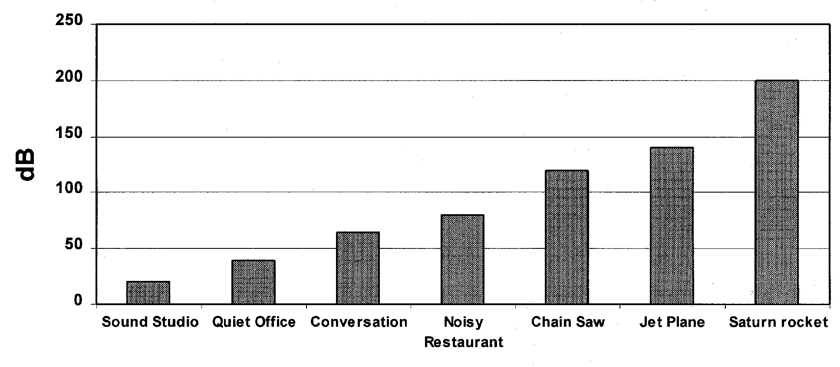

Figure 1. Representative Noise Levels
Noise levels tested (in increasing decibel level) include: sound studio (20 dB), quiet office (40 dB), conversation (60 dB), noisy restaurant (75 dB), chain saw (120 dB), jet plane (148 dB), and saturn rocket (200 dB).

Sound and noise are not the same thing, but sound becomes noise when:
- It is too loud
- It is unexpected
- It is uncontrollable
- It occurs unexpectedly
- It has pure tone components
Noise is any sound that has the potential to annoy or disturb humans, or cause an adverse psychological or physiological effect on humans. In the case of the general population a 5 dBA change is required before most people realize there is a perceptible sound difference.
The noise levels generated during the construction process vary depending on the type of equipment and the nature of the work being performed. It should be recognized that noise impacts can be severe, especially during nighttime activities, and that in many cases simple noise mitigation strategies will not suffice.
Noise generation on most construction projects is the result of equipment operation with diesel engines being the primary generators. Equipment components that generate noise include: the engine, cooling fan, air intake, exhaust, transmission, and tires. In assessing noise generation, construction equipment can be grouped into two categories, stationary and mobile. Equipment noise can also be categorized as being either continuous or impulse in nature. Stationary equipment is considered to operate in one location for one or more days at a time; pumps, generators, compressors, screens, are typical examples of stationary equipment. In addition, pile drivers and pavement breakers are sometimes categorized as stationary equipment. Mobile equipment includes machinery that performs cyclic processes such as: bulldozers, scrapers, loaders, and haul trucks.

EQUIPMENT NOISE
Construction equipment is a major noise generator on nearly all nighttime construction projects. The equipment type, specific model, equipment condition and the operation performed influence equipment noise. Equipment manufacturers began attacking machine noise problems in the late ‘60s and today because of design improvements and technological advances new machines have been quieted to an acceptable level for almost every situation. Newer equipment is noticeably quieter than older models due primarily to better engine mufflers, refinements in fan design and improved hydraulic systems. Noise levels as generated by typical equipment are shown in Table 2.
How equipment noise will be perceived is also a function of use duration. On a monitored project in New Jersey the highest noise levels resulted from pile driving; but, because the driving was completed in a short period of time, the activity did not draw any complaints.
One of the conclusions from the U.S. Department of Transportation’s 1979 construction equipment noise study was that 88 dBA is a reasonable noise level to expect for used equipment with an engine horsepower of 400 or less. It should be noted that the USDOT tests were made in the field under actual operating conditions at road construction sites, mines and quarries.
In 1994 and 1995 Harris Miller Miller & Hanson Inc. performed noise studies for the Central Artery/Tunnel project in Boston. The first study sought to quantify an average noise level while the second defined a typical noise level. It would seem that a typical value is better to use in developing specifications or project restrictions. That data delineates the most commonly occurring level.

Table 2. Construction Equipment Noise Emission Levels
Equipment | Typical Noise Level (dBA)  50 ft., U. S. Dept. of Trans. study 1979 | Average Noise Level (dBA)  50 ft., CA/T Project study 1994 | Typical Noise Level (dBA)  50 ft., U. S. Dept. of Trans. study 1995 | Lmax Noise (dBA)  50 ft., CA/T Project Spec. 721.560
Air Compressor |  | 85 | 81 | 80
Backhoe | 84 | 83 | 80 | 80
Chain Saw |  |  |  | 85
Compactor | 82 |  | 82 | 80
Compressor | 90 | 85 |  | 80
Concrete Truck |  | 81 |  | 85
Concrete Mixer |  |  | 85 | 85
Concrete Pump |  |  | 82 | 82
Concrete Vibrator |  |  | 76 | 80
Crane, Derrick | 86 | 87 | 88 | 85
Crane, Mobile |  | 87 | 83 | 85
Dozer | 88 | 84 | 85 | 85
Drill Rig |  | 88 |  | 85
Dump Truck |  | 84 |  | 84
Excavator |  |  |  | 85
Generator | 84 | 78 | 81 | 82
Gradall |  | 86 |  | 85
Grader | 83 |  | 85 | 85
Hoe Ram |  | 85 |  | 90
Impact Wrench |  |  | 85 | 85
Jackhammer* |  | 89 | 88 | 85
Loader | 87 | 86 | 85 | 80
Paver | 80 |  | 89 | 85
Pile Driver, Impact |  | 101 | 101 | 95
Pile Driver, Sonic |  |  | 96 | 95
Pump | 80 |  | 85 | 77
Rock Drill |  |  | 98 | 85
Roller |  |  | 74 | 80
Scraper | 89 |  | 89 | 85
Slurry Machine |  | 91 |  | 82
Slurry Plant |  |  |  | 78
Truck | 89 | 85 | 88 | 84
Vacuum Excavator |  |  |  | 85
* There are 82 dBA @ 7 meter rated jackhammers (90 lb. class) available. This would be equivalent to 74 dBA @ 50 ft. These are silenced with molded intricate muffler tools.

Equipment Noise Control Options
Listed in Table 3 are the major sources of equipment noise that cause complaints. The Table also lists specific methods for controlling the identified noise problem.

Table 3. Construction Equipment Noise Control Options
Noise Source | Control
Backup alarms | Use manually-adjustable alarms  Use self adjusting alarms  Use an observer  Configure traffic pattern to minimize backing movement
Slamming tailgates | Establish truck cleanout staging areas  Use rubber gaskets  Decrease speed of closure  Use bottom dump trucks
Pavement breakers (jackhammers) | Fit with manufacturer approved exhaust muffler  Prohibit within 200 ft. of a noise sensitive location during nighttime hours  Enclose with a noise tent
Prolonged idling of equipment | Reduce idling  Locate equipment away from noise sensitive areas
Ambient-sensitive self-adjusting backup alarms increase or decrease their volume based on background noise levels. These alarms work best on smaller equipment such as backhoes and trucks. The alarm self-adjusts to produce a tone that is readily noticeable over ambient noise levels (a minimum increment of 5 decibels is typically considered readily noticeable), but not so loud as to be a constant annoyance to neighbors. The typical alarm adjustment is 82 or 107 dBA. Close attention must be give to the alarm’s mounting location on the machine in order to minimize engine noise interference, which can be sensed by the alarm as the ambient noise level. These alarms should be mounted as far to the rear of the machine as possible. An alarm mounted directly behind a machine’s radiator will sense the cooling fan’s noise and adjust accordingly, Figure 2. Such a mounting will negate the purpose of the device.
Manually-adjustable alarms are effective in reducing backup alarm noise nuisance but their use requires that each alarm be set at the beginning of each day and night shift. The manual setting feature eliminates the machine mounting location problem of the ambient-sensitive self-adjusting backup alarms. The manually adjustable alarms typically have an 87 and 107 dBA setting range, with the 87 dBA setting used for nighttime operations.

NOISE MITIGATION
Of interest in terms of community noise impact is the overall noise resulting from a construction site. The noise of each individual piece of equipment and sometimes the highest noise source is not always the number one priority. Noise control is directed toward modification of a perceived sound field. It strives to change the impact at the receiver so that the sounds conform to a desired level. Mitigation of undesired sounds should consider source control, path control, and receptor control Figure 3.
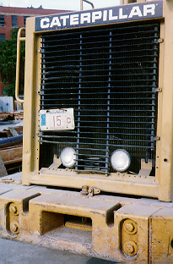
Alarm mounted behind radiator exhaust

Figure 2. A Self-Adjusting Backup Alarm Mounted in the Wrong Position

Figure 3. Noise Transfer Situation
The Noise Transfer Situation shows the relation between sources, such as a pile driver, loader and truck, and their paths, groundborne vibration and direct sound (which includes a reverberant field) to the receiver. The relation is detailed below.
The Pile Driver creates a groundborne vibration path to the receiver. The loader and truck create a direct sound (reverberant field) path to the receiver.

Source Controls
Source control is the most effective method of eliminating noise problems. It is a cardinal rule that, where possible, noises control should occur at the source. Source controls, which limit noise emissions, are the easiest to oversee on a construction project. Source mitigation reduces the noise problem everywhere not just along a single path or for one receiver. Consequently, a project’s noise mitigation strategy should emphasize noise control at the source.

Require Construction Operations Planning
Restrict the movement of equipment into and through the construction site. Long-term impacts are generated along haul routes when there are large quantities of materials to be moved. Reroute truck traffic away from residential streets. Impose seasonal limitations on construction noise, the spring or fall are critical times in residential areas because windows are usually open at night.

Example Specifications
Where practical and feasible, construction sites shall be configured to minimize back-up alarm noise. For example, construction site access should be designed such that delivery trucks move through the site in a circular manner without the need to back up.

Require Modern Equipment
Unions recognize construction noise as a hazard to workers and the first of five things suggested to workers to address the problem is that they “Ask contractors to buy quieter equipment when they buy new equipment.” DOT specification of equipment noise emission limits forces the use of modern equipment having better engine insulation and mufflers. The emission levels specified should reflect levels that can reasonably be achieved with well-maintained equipment, see Table 3.

Equipment Restrictions
Restrict the type of equipment used.

Example Specifications
The use of impact pile drivers shall be prohibited during evening and nighttime hours.
All jackhammers and pavement breakers used on the construction site shall be fitted with manufacturer’s approved exhaust mufflers.
The use of pneumatic impact equipment (i.e. pavement breakers, jackhammers) shall be prohibited within 200 feet of a noise-sensitive location during nighttime hours.
The local power grid shall be used wherever feasible to limit generator noise. No generators larger than 25 KVA shall be used and, where a generator is necessary, it shall have a maximum noise muffling capacity.
Call the contractor’s attention to the back-up alarm noise problem and require measures to address the issue.
By specification direct the use of only power grid connected or solar powered traffic control devices, Figure 4.

Example Specifications
All variable message/sign boards shall be solar powered or connected to the local power grid.
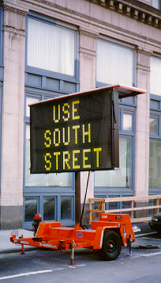

Figure 4. Solar Powered Traffic Control Devices

Operate at Minimum Power
Noise emission levels tend to increase with equipment operating power. This is a critical issue with older street sweepers, demolition work using a hoe-ram, and equipment such as vac-trucks, Figure 5. Require that such equipment operate at the lowest possible power levels.
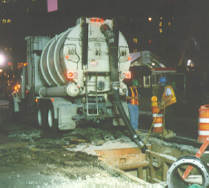

Figure 5. vac-truck working at night

Use Quieter Alternate Equipment
Electric or hydraulic powered equipment is usually quieter than a diesel-powered machine. Encourage contractors to use alternate equipment. Use electric tower cranes, Fig. 6, instead of diesel power mobile cranes
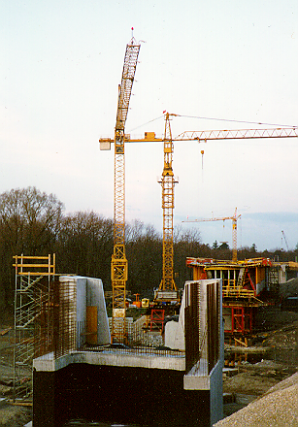

Figure 6. Electric Tower Cranes for Bridge Construction

Path Controls
Alone, source noise controls are frequently inadequate at adequately minimizing noise impacts on abutting sensitive receptors because of the close proximity to residences and businesses in urban areas and because of the very nature of the construction work. Thus, having exhausted all possible mitigation methods of controlling noise at the source, the second line of attack is controlling noise radiation along its transmission path. Noise path barriers should provide a substantial reduction in noise levels, should be cost effective, and should be implementable in a practical manner without limiting accessibility. Barriers can increase a project’s visual impact. This visual change can have either a positive or negative impact. Therefore, aesthetic effects must be considered when designing barrier systems.

Path Mitigation Techniques
Once established, only reflection, diffraction insulation or dissipation can modify an airborne sound field. In other words, it is necessary to increase the distance from the source or to use some form of solid object to either destroy part of the sound energy by absorption, or to redirect part of the energy by wave deflection. The three techniques for path mitigation are therefore:
- Distance
- Reflection
- Absorption

Enclose especially Noisy Activities or Stationary Equipment
Enclosures can provide a 10 to 20 dBA sound reduction. Additionally the visual impact of roadwork activities has an affect on how construction sounds are perceived. An important noise mitigation issue, therefore, is the audio-visual sensing factor. Enclosures address both the absolute audio and the visual perception issue, Figure 7.

Example Specifications
All jackhammers and pavement breakers used at the construction site shall be enclosed with shields, acoustical barrier enclosures, or noise barriers.
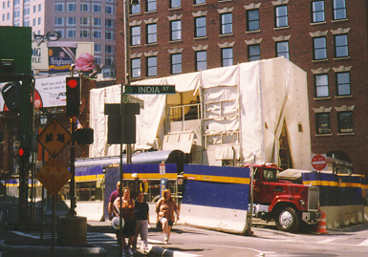

Figure 7. Slurry Plant Enclosure for Audio-Visual and Dust Control

CONCLUSIONS
A significant number of future construction projects will involve urban work. Therefore, it is important that before contracts are advertised and bid that there be an objective assessment as to the magnitude of noise nuisances. Noise problems are normally caused by the operation of heavy equipment. The identification of methods and techniques for mitigating such nuisances is a critical planning requirement for both owners and contractors.
Source control is the most effective method of controlling construction noise. Source controls, which limit noise, are the easiest to oversee on a construction project. Mitigation at the source reduces the problem everywhere not just along one single path or for one receiver. The specification of equipment noise emission limits forces the use of modern equipment having better engine insulation and mufflers.
Path Controls are the second line of attack in controlling noise. Barriers can provide a substantial reduction in the nuisance effect in some cases. The use of barriers should be examined against other possible measures to prove that they are cost effective. Further, aesthetic effects must be considered when designing barrier systems. Path control measures include:
- Move equipment farther away from the receiver
- Enclose especially noisy activities or stationary equipment
- Erect noise barriers or curtains
- Use landscaping as a shield and dissipater

