CREATING ENFORCEMENT-FRIENDLY
WORK ZONES

by

Gerald L. Ullman, PhD, PE
Program Manager
Texas Transportation Institute

Michael D. Fontaine
Research Scientist
Virginia Transportation Research Council
530 Edgemont Road
Charlottesville, VA 22903

Steven D. Schrock
Graduate Assistant Researcher
Texas Transportation Institute

TEXAS TRANSPORTATION INSTITUTE
The Texas A&M University System
3135 TAMU
College Station, Texas 77843-3135
Phone: (979) 845-1728
Fax: (979) 845-6006

Prepared for
Making Work Zones Work Better Workshops

INTRODUCTION

Law enforcement presence in work zones has long been recognized as one of the most effective speed reduction methods available to transportation officials (footnotes 1,2,3). Unfortunately, high labor costs, manpower shortages, and the many other demands placed on law enforcement makes universal enforcement presence at all work zones impossible. In addition, most states have enacted higher fines for violations in work zones. While designed to improve motorist compliance, some of these higher fine structures include certain stipulations that create unintended difficulties for enforcement personnel (footnote 4). Further complicating the problem is the fact that the actual design of, and activities within, many work zones makes effective enforcement extremely difficult (footnote 4). Long work zones that have no emergency shoulders on either side of the roadway offer no place for enforcement personnel to position their vehicles to monitor traffic or to pull over violators to issue a citation. Consequently, officers attempting to stop a violator are forced to either follow the violator completely through the work zone before activating their emergency lights and pulling the violator over, or activating their lights within the work zone and risk the chance that the motorist will then stop in the moving lane of traffic.

Recently, the Texas Department of Transportation (TxDOT) has funded research to identify and evaluate ways that work zones could be made more “enforcement friendly.” This paper summarizes some of the key findings from that research. Three categories of possible improvements to the enforceability of work zones have been identified:

- Improvements in coordination between transportation and enforcement agencies throughout the work zone planning, design, and construction process;
- Technologies to improve work zone enforceability;
- Designs to improve work zone enforceability.

IMPROVEMENTS IN COORDINATION

Surveys of both law enforcement and transportation agency personnel suggest that coordination between transportation and enforcement agencies regarding work zone enforcement could be improved nationwide. Figure 1 illustrates the responses of law enforcement agencies from 20 states as to when enforcement agencies first become involved in the work zone planning process (footnote 5). Note that over one-third of those surveyed said there is little coordination with, or involvement from, enforcement agencies prior to work zones being installed on a highway in their jurisdiction.

Figure 1. Start of Coordination Between Law Enforcement and Transportation Agencies for Highway Work Zone Planning (footnote 5).

The state of New Jersey has taken a proactive approach to facilitating the coordination of enforcement personnel in and around highway construction projects. Specifically, the state maintains a unit of 35 state police officers who are dedicated to work zone enforcement. These officers work approximately nine months of the year enforcing work zones and supervising other officers that are manning work zones on an overtime basis. This unit coordinates the placement of all officers at work zones statewide. In addition, these officers are certified Occupational Safety Health Administration (OSHA) safety inspectors and are considered the main state safety inspector for highway work zones.
During the winter months, this unit conducts training of other officers to prepare them for work zone enforcement duty. Department of Transportation (DOT) engineers also receive training from this unit, to gain a better understanding of work zone enforcement duties. This unit also reviews traffic control plans, attends work zone planning meetings, and works with contractors to ensure that the proper traffic control devices are present at work zones.

TECHNOLOGIES FOR IMPROVING WORK ZONE ENFORCEABILITY

Flashing Lights to Indicate Worker Presence in Work Zones

In recent years, the vast majority of states have enacted legislation that increases the fine of traffic violations that occur within a highway work zone (footnote 6). Approximately one-half of these states require that workers be present at the worksite in order for the higher penalties to apply. This stipulation is intended to emphasize safety for highway workers. Unfortunately, anecdotal information obtained from several law enforcement officers (footnote 4) suggests that this requirement can make enforcement of the law more difficult by requiring officers to continuously check the worksite for workers prior to issuing a citation. In some instances, the inability of an officer to testify that he or she was absolutely sure that workers were present then the citation was issued has led to the dismissal of the citation in court.

To combat the enforcement difficulties associated with the worker presence requirement of these laws, Illinois and Tennessee have adopted technological improvements to their work zones that indicate when workers are present. Figure 2 illustrates the type of display utilized in Tennessee. Not only do these types of signs assist enforcement personnel in their efforts, they also provide approaching motorists additional information to notify or reaffirm that workers are present and that additional caution should be exercised through the work zone.

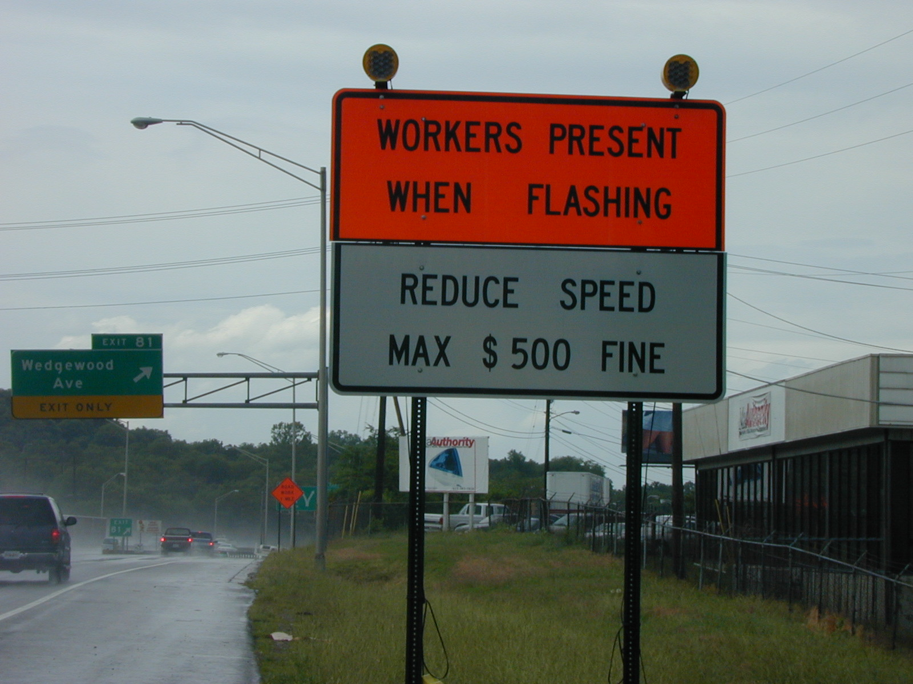

Figure 2. “Workers Present” Sign in Tennessee.

Use of Automated Speed Enforcement Technology in Work Zones

Automated speed enforcement (ASE) technology is considered by some to offer significant potential to improve the enforceability of highway work zones nationwide. ASE has been used as a speed control and enforcement tool by over 40 countries around the world, with some systems having been in place for up to 30 years (footnote 7). However, ASE systems are not used widely in the United States, primarily due to legal and political barriers. Specifically, ASE systems require the speeding violation to be issued as a civil, rather than a criminal, infraction, which requires a change to most state traffic laws. Politically, many citizens also believe that automated enforcement systems are purely revenue generators, with limited benefit to safety. Given these concerns, widespread utilization of traditional ASE systems in work zones is not likely nationwide in the foreseeable future.

Although traditional ASE systems are not likely to see deployment in U.S. work zones anytime soon, the potential does exist to utilize the technology in such a way as to improve the safety and effectiveness of law enforcement personnel who are assigned to work zone enforcement. Researchers at the Texas Transportation Institute (TTI) have successfully demonstrated the feasibility of a prototype system that combines speed detection, video image capture, and wireless communication technologies in a real-time remote enforcement process. The prototype equipment is set up at one location, and an officer is positioned at a downstream location (presumably outside the limits of the work zone). When a speeding violation is detected by the system, it sends the captured violation image (see Figure 3) and data over a wireless link to a laptop located in the vehicle of the downstream officer, who then identifies the offender in the traffic stream and pulls them over to issue a citation.

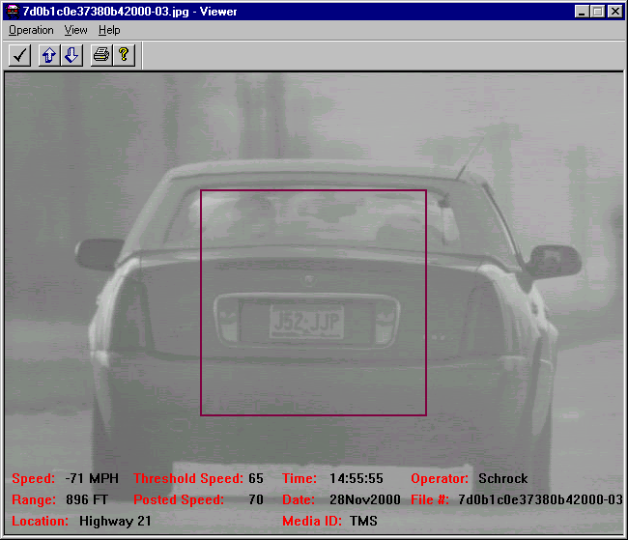

Figure 3. Example of a Violation Image Sent to a Downstream Officer.

In order for such a concept to work, the officer located downstream of the work zone must be able to identify a violating vehicle from a captured image. Tests conducted in Texas suggest that 85 to 90 percent of violating vehicles could be identified at a location as much as 1.5 miles downstream of the prototype, using black-and-white images sent to the downstream vehicle (footnote 7). Higher levels of accuracy might be achievable with color images. However, color images would require either a longer transmission time or higher bandwidth than was tested in these evaluations. Some law enforcement officers who watched the prototype operate felt that the system could be used in the existing legal structure and would provide a safety benefit to enforcement personnel. However, others felt that there may be some initial legal challenges to the use of this system and that some modifications, especially the inclusion of real-time video, might be necessary.

DESIGNS FOR IMPROVING WORK ZONE ENFORCEABILITY

Shoulders are often eliminated within work zones because is that roadway space is often severely limited, and planners are forced to decide how to best allocate this space between the traffic that desires to use that roadway and the personnel and equipment required to do the roadway work. Intuitively, construction efficiency is at its highest if the maximum amount of space is allocated to the work activity and maintained throughout the work zone over the duration of the project.

From the perspective of enforcement, it would be advantageous to always maintain full emergency shoulders on at least one side of a roadway so that officers could stop violators and issue citations. Given the demands of work activity, this is not always a feasible option. In an attempt to balance the competing space needs of both construction and enforcement activities, some transportation agencies have considered the incorporation of periodic enforcement pullout areas into work zone designs (footnote 8). However, questions arise as to how to best incorporate periodic enforcement areas into a work zone so as to effectively support enforcement activities while at the same time not unduly penalizing the efficiency of roadwork activities. If placed too closely, the roadway contractor must devote extra resources to constructing and maintaining the pullouts, increasing project costs and complicating construction sequencing and methods. On the other hand, if the pullouts are spaced too widely, they are likely to become less useful to law enforcement personnel, to the point where all of the benefits of the pullouts are lost. To examine these hypotheses in a more objective manner, separate “expert” panels of contractors and law enforcement personnel in Texas were created to provide opinions and expectations regarding the difficulties and usefulness of pullout areas within work zones. A survey instrument was developed to explore the level of usefulness (for enforcement personnel) or difficulty (for contractor personnel) of having enforcement pullout areas placed at various spacings throughout a long work zone (footnote 9).

Overall, construction contractors were generally against placing pullout areas closer than 2 miles apart in long work zones, indicating that more pullouts would dramatically lengthen project time and increase cost. By contrast, law enforcement officers indicated that at spacings greater than 3 miles, the pullout area would not be useful for traffic enforcement purposes. By comparing the results of the two surveys, a distance of between 2 and 3 miles emerges as the spacing between pullout areas that would be acceptable to both contractors and traffic law enforcement officers. This comparison is illustrated in Figure 4.

Figure 4. Comparison of Contractor and Enforcement Personnel Opinions about
Enforcement Pullout Area Spacing (footnote 9).

The question of pullout length appears to be less contentious than that of spacing. Data collected during actual enforcement activities on urban and rural roadways suggests that a pullout length of approximately 0.25 miles will be adequate to accomplish typical deceleration and acceleration maneuvers by motorists (footnote 9). This is essentially the same as that recommended for enforcement areas in High-Occupancy Vehicle (HOV) facilities (footnote 10).

SUMMARY AND CONCLUSIONS

In this paper, several ways that work zones can be made more enforcement-friendly have been discussed. Improving communication between transportation and enforcement agencies is perhaps the simplest and easiest to implement. Earlier involvement of enforcement agencies in construction project planning and design can be particularly beneficial. Specialized work zone enforcement teams may also offer substantial benefits.

With respect to technology, better real-time warning signs of worker presence can assist enforcement personnel in their citation efforts, and can also better warn approaching motorists by actively notifying them that higher violation penalties are in effect. Although interest is high in automated speed enforcement technology application for work zones, current legal and political barriers makes ASE deployments extremely difficult to accomplish. Use of modified ASE technology operating in a real-time fashion appears technically feasible. It is possible that such an application would also receive some legal challenges in the court system.

Enforcement pullout areas are a design option that offers potential to improve the enforceability of highway work zones. Recent research indicates that spacing such areas approximately 2 to 3 miles apart would be acceptable to both law enforcement and contractors. Where installed, such areas should be at least ¼-mile long to facilitate access and egress to and from the main travel lanes.

REFERENCES
- Richards, S.H., R.C. Wunderlich, and C.L. Dudek. Controlling Speeds in Highway Work Zones. Report No. FHWA/TX-84/58+292-2. Texas Transportation Institute, College Station, Texas, 1984.
- Benekohal, R.F., L.M. Kastel, and M. Suhale. Evaluation and Summary of Studies in Speed Control Methods in Work Zones. Report No. FHWA-IL/UI-237. University of Illinois, Urbana, Illinois, 1992.
- Benekohal, R.F., P.T.V. Resende, and R.L. Orloski. Effects of Police Presence on Speed in a Highway Work Zone: Circulating Marked Police Car Experiment. Report No. FHWA-IL/UI-240. University of Illinois, Urbana, Illinois, 1992.
- Ullman, G.L., P.J. Carlson, N.D. Trout, and J.A. Parham. Work Zone-Related Traffic Legislation: A Review of National Practices and Effectiveness. Report No. FHWA/TX-98/1720-1. Texas Transportation Institute, College Station, Texas, September 1997.
- S.D. Schrock, G.L. Ullman, and N.D. Trout. Survey of State Law Enforcement Personnel on Work Zone Enforcement Practices. Paper presented at the 81st Annual Meeting of the Transportation Research Board and accepted for publication, Washington, D.C., January 2002.
- National Work Zone Safety Information Clearinghouse. Enhanced Fine Legislation in Work Zones. Last modified April 10, 2002. http://wzsafety.tamu.edu/files/laws1.stm. Accessed April 22, 2002.
- M.D. Fontaine, S.D. Schrock, and G. Ullman. Feasibility of Real-Time Remote Speed Enforcement For Work Zones. Paper presented at the 81st Annual Meeting of the Transportation Research Board and accepted for publication, Washington, D.C., January 2002.
- Ullman, G.L., M.D. Fontaine, S.D. Schrock, and P.B. Wiles. A Review of Traffic Management and Enforcement Problems and Improvement Options at High-Volume, High-Speed Work Zones in Texas. Report No. FHWA/TX-01/2137-1. Texas Transportation Institute, College Station, Texas, February 2001.
- G.L. Ullman and S.D. Schrock. Feasibility, Length, and Spacing of Enforcement Pullout Areas for Work Zones. Report No. FHWA/TX-01/2137-2. Texas Transportation Institute, College Station, Texas, October 2001.
- Guide for the Design of High Occupancy Vehicle Facilities. American Association of State Highway and Transportation Officials, Washington, D.C., 1992.

